Open Sea Aquaculture
in the Eastern Mediterranean

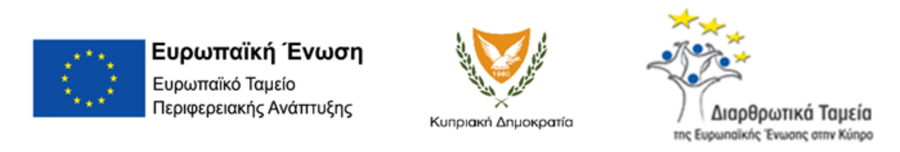
The Project is co-financed with 800 K Euro by the European Regional Development Fund and the Republic of Cyprus through the Research and Innovation Foundation with grant number INTEGRATED/0918/0046

Work Package ID: WP7

Work Package Title: Financial and Legal Frameworks

Deliverable ID: D23

Deliverable Title: Targeted finfish economic characteristics

Status: FINAL

Dissemination Level: Public

Partner Leader: Frederick Research Centre (FRC)

Disclaimer
Use of any knowledge, information or data contained in this document shall be at the user's sole risk. Neither the OS Aqua Consortium nor any of its members, their officers, employees or agents accept shall be liable or responsible, in negligence or otherwise, for any loss, damage or expense whatever sustained by any person as a result of the use, in any manner or form, of any knowledge, information or data contained in this document, or due to any inaccuracy, omission or error therein contained.
The OS Aqua project (INTEGRATED/0918/0046) has been partially funded under the RESTART 2016-2020 Programme, Integrated Projects Call, of the Cyprus Research and Innovation Foundation. This publication reflects the views only of the authors, and the Funding Agency cannot be held liable or responsible for any use which may be made of the information contained herein or of any consequences thereof.
Copyright notice
© Copyright 2020-2024, The OS Aqua Consortium
This document contains information that is protected by copyright. All Rights Reserved. No part of this work covered by copyright hereon may be reproduced or used in any form or by any means without the permission of the copyright holders.

Executive Summary
Deliverable 23 (D23), ‘Targeted finfish economic characteristics’, reflects the outcome of the Task 7.1 ‘Specifics of the finfish to be cultured’. This deliverable is of paramount importance for the economic analysis to be conducted in D28, ‘Economic Analysis & Business Plan’, since, as it will be shown in this deliverable, sixty percent (60%) of the operational costs of the targeted finfish aquaculture is governed by fish feed consumption and fingerling cost.
This deliverable follows, D19, during which sixteen (16) fish species were evaluated against multiple criteria and the outcome was reached to select four species, namely a) Gilthead seabream; b) European seabass; c) Meagre; and d) Red porgy (red seabream). The former two species are well established with considerable market share across the Mediterranean, whereas the latter two species are emerging and promising additions. To this end, the advice of the public authority (Department of Fisheries and Marine Research) was secured advocating this selection. The characteristics and the general information related to the biology and aquaculture performance have been studied in extended detail and presented in D19. The selection of the four species was based on total production in the Mediterranean, growth, Food Conversion Ratio (FCR), market prices as well as an expert judgement of the status of hatchery, on-growing technologies and fry availability.
In this report, all necessary data to provide an economic description for the aforementioned fish species selected are presented. In particular, Food Conversion Ratio (FCR), average feed cost, market harvesting size and juvenile acquisition cost are features that are of particular importance for this economic analysis. In addition, an overview of past production volumes in Cyprus and the wider Mediterranean basin are presented. A more detailed description of the aquaculture market structure is given in D25, ‘Market structure’.
Most of the information used in this report was extracted from literature review, the Food and Agriculture Organization of the United Nations (FAO) database, the Federation of European Aquaculture Producers (FEAP) database, data included in D19 and private interviews with a key market player in Cyprus, the company Kimagro. Information was also obtained from AMBIO SA, the largest aquaculture consulting firm in Greece, which was awarded the tender for market analysis within the context of OS Aqua project. Additional data was obtained from the Cyprus’ Department of Fisheries and Marine Research (DFMR), which is responsible to provide data statistics related to aquaculture in Cyprus.
Last, but not least, it should be noted that World markets experience lately very volatile prices in raw materials due various reasons, such as, the covid-19 pandemic, the war in Ukraine that brought increase in energy prices and the increase in prices of freight transport. Therefore, aquaculture products’ prices are on the increase and are expected to increase even further due to the fact that fish needs approximately eighteen (18) months to reach maturity and fish products sold today were reared with cheaper fish feed. Within this context, the decision was reached to link operational costs to the cost of fish feed price and at the risk analysis level during D27 to conduct a stochastic analysis with a spectrum of fish feed prices.
Contents
1 Introduction 4
2 Specifics of Finfish species 5
2.1 Gilthead seabream 5
2.1.1 Production Countries and Quantities 5
2.1.2 Economic Characteristics 7
2.2 European seabass 11
2.2.1 Production Countries and Quantities 11
2.2.2 Economic Characteristics 12
2.3 Meagre (Argyrosomus regius) 16
2.3.1 Production Countries and Quantities 16
2.4 Red porgy (Pagrus pagrus) and red seabream (Pagrus major) 19
2.4.1 Production Countries and Quantities 19
2.4.2 Economic Characteristics 20
3 Cyprus Aquaculture in Numbers 23
4 Conclusions 24
5 References 25

Introduction
The overall goal of WP7, Task 7.1, “Targeted finfish economic characteristics” is to clarify the economic characteristics of growing particular finfish species in the Cypriot offshore aquaculture industry.
Fish feed coupled with cost of fingerlings, as it will be shown in the following chapters, constitutes the biggest cost element of any aquaculture company, summing up to 60% of the operational cost. In addition, specific characteristics of targeted finfish species for the targeted area(s) have enormous economic implications. Thus, this task will take on from WP5 and describe the economics of finfish to be cultured. Food Conversion Ratio (FCR = feed supplied / weight gained), average feed cost, market harvesting size and juvenile acquisition cost are features that are of particular importance for this economic analysis.

OS-Aqua consortium partners’ consensus was reached in WP5, D19 (see section 2.7.9 in D19 and in particular Table 28), that this economic study will be performed for rearing following four fish species:
a) Gilthead seabream (Sparus aurata);
b) European seabass (Dicentrarchus labrax);
c) Meagre (Argyrosomus regius); and
d) Red porgy (Pagrus pagrus) and/or red seabream (Pagrus major).

It is underlined that the red porgy Pagrus pagrus (Linnaeus, 1758) is the indigenous Mediterranean species whereas the red seabream (Pagrus major, Temminck & Schlegel, 1843) has been introduced in the Mediterranean Sea by aquaculture companies (see D.19 for details). Red seabream (also known as Japanese red sea bream - Mandai) seems to have better adaptation in cage farming compared to the red porgy P. pagrus and most aquaculture companies in Greece (the main Mediterranean producer) prefer it over P. pagrus. The recent Commission Delegated Regulation (EU) 2022/516 of 26 October 2021, amended Annex IV to Council Regulation (EC) No 708/2007 concerning use of alien and locally absent species in aquaculture and therefore P. major can be now cultivated all over the Mediterranean Sea, including Cyprus.

In Chapter 2 we provide the economic characteristics for each species separately. At first, we give a brief overview of the main producer countries and then we use the individual cost factors to compute the total operation cost per harvested kilogram of fish. In Chapter 3, we report and discuss local economic data provided by the Cyprus Department of Fisheries and Marine Research (DFMR) [1]. These statistical data include total production quantities per species and their estimated value for all aquaculture companies operating in Cyprus, taking into consideration anonymity and confidentiality issues.

Specifics of Finfish species
An extensive study for the species under consideration regarding descriptions of the taxonomy, geographic range, population trend and ecology information took place in D19. For the computation of their main economic characteristics, we will use the following parameters and cost factors:

- Average Food Conversion Ratio (FCR) per species for the corresponding Harvesting size. FCR is defined as the dry weight of feed intake divided by live weight gained by the fish and its formula is:

$FCR=\frac{\sum{}Feed consumption}{\sum{}Live weight}×100$ [1]

- Average feed cost per kg.
- Harvesting size per species.
- Cost per juvenile per species.
- Mortality rate per species.

At this point it should be noted that Table 3, Table 6, Table 9 and Table 11 provide the FCR of the four selected fish species for various temperatures and various fish weights. However, the FCR used for each fish species is the weighted average of the table provided, as given by Kimagro fish farm and AMBIO SA.

Gilthead seabream

Production Countries and Quantities
Gilthead seabream (Sparus aurata), presented in Figure 1, is one of the most important and common aquaculture species in the Mediterranean Sea and is the 33rd most cultivated fish worldwide [2].
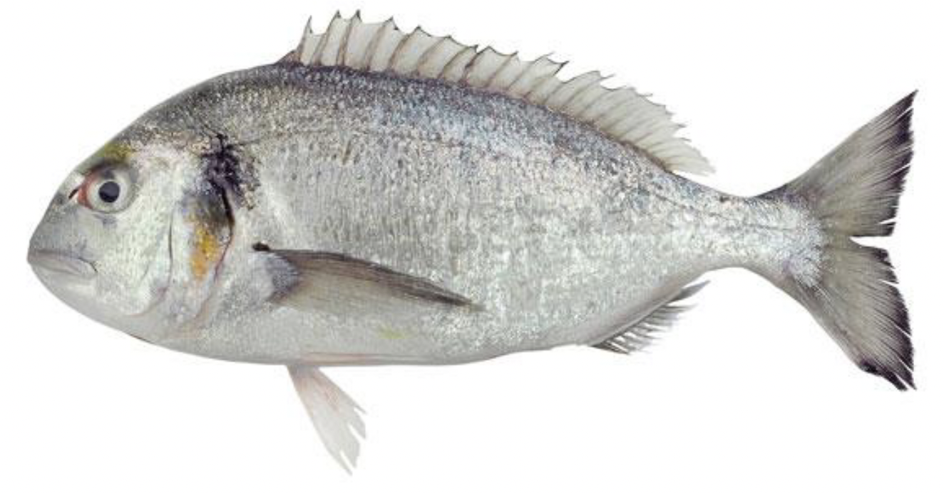
Figure 1: Gilthead seabream.
The total world production was estimated at 258,754 tons in 2019, with Turkey leading the world production with a 39% share, followed by Greece with 21%. More details are depicted in Table 1 that shows the top ten producer countries worldwide. The source for this data is the Food and Agriculture Organization of the United Nations (FAO). Table 2 includes similar information from a different source, the Federation of European Aquaculture Producers (FEAP).

Table 1: Gilthead seabream production (quantity in tons live weight). Source: FAO [3].
 | 2015 | 2016 | 2017 | 2018 | 2019 | Global Share % 2019
Turkey | 51 844 | 58 254 | 61 090 | 76 680 | 99 730 | 39
Greece | 47 713 | 49 621 | 55 948 | 56 203 | 55 452 | 21
Egypt | 16 092 | 26 663 | 35 221 | 29 994 | 35 880 | 14
Tunisia | 10 216 | 12 168 | 16 841 | 18 463 | 18 017 | 7
Spain | 16 005 | 12 397 | 17 005 | 13 810 | 12 475 | 5
Italy | 6 800 | 7 600 | 7 600 | 7 316 | 7 350 | 3
Croatia | 4 075 | 4 101 | 4 830 | 5 591 | 6 750 | 3
Cyprus | 3 656 | 5 039 | 4 949 | 4 885 | 5 168 | 2
Israel | 1 820 | 2 065 | 2 255 | 2 255 | 2 950 | 1
Albania | 1 800 | 1 900 | 2 400 | 2 300 | 2 450 | 1

Table 2: Gilthead seabream aquaculture production (quantity in tons live weight). Source: FEAP [4].
 | 2015 | 2016 | 2017 | 2018 | 2019 | Global Share % 2019
Turkey | 48 000 | 67 612 | 72 000 | 83 000 | 99 000 | 50
Greece | 65 000 | 59 000 | 51 000 | 61 000 | 65 300 | 33
Spain | 16 231 | 13 740 | 13 643 | 14 930 | 13 521 | 7
Italy | 7 360 | 7 600 | 9 000 | 9 700 | 9 100 | 4
Croatia | 4 488 | 4 101 | 4 830 | 5 591 | 6 774 | 3
Cyprus | 3 656 | 5 136 | 5 000 | 5 000 | 2 500 | 1
France | 1 502 | 1 671 | 1 853 | 1 879 | 2 081 | 1
Portugal | 1 099 | 1 196 | 1 038 | 1 081 | 1 200 | 1

The production reports from FAO and FEAP vary, sometimes considerably (see the different figures for Greece and Cyprus), due to different methodology of data collection and the sources of information. Nevertheless, we can extract similar information from both data sets.

Economic Characteristics
The cost of acquisition of Gilthead seabream juveniles for Cypriot fish farms is estimated at €0.20 per juvenile (Kimagro, personal communication 2022). The average harvesting size in Cyprus is 500 grams and the corresponding cost of fish feed, at the time this study took place (i.e. June 2022), is estimated at €1.4 per kilogram (Kimagro [5], AMBIO SA [6]). Expert opinion reports that fish feed and the cost of juveniles at this point in time is estimated to account for sixty percent 60% of the total operational costs. The remaining 40% of operating costs accounts for administrative expenses, fuel consumption, maintenance and packaging facilities. The latter is also verified in the literature from [7,8]. Figure 2 presents the average cost structure for cultivated Gilthead seabream and European seabream. The cost for feed and fingerlings is 60% of the total cost.

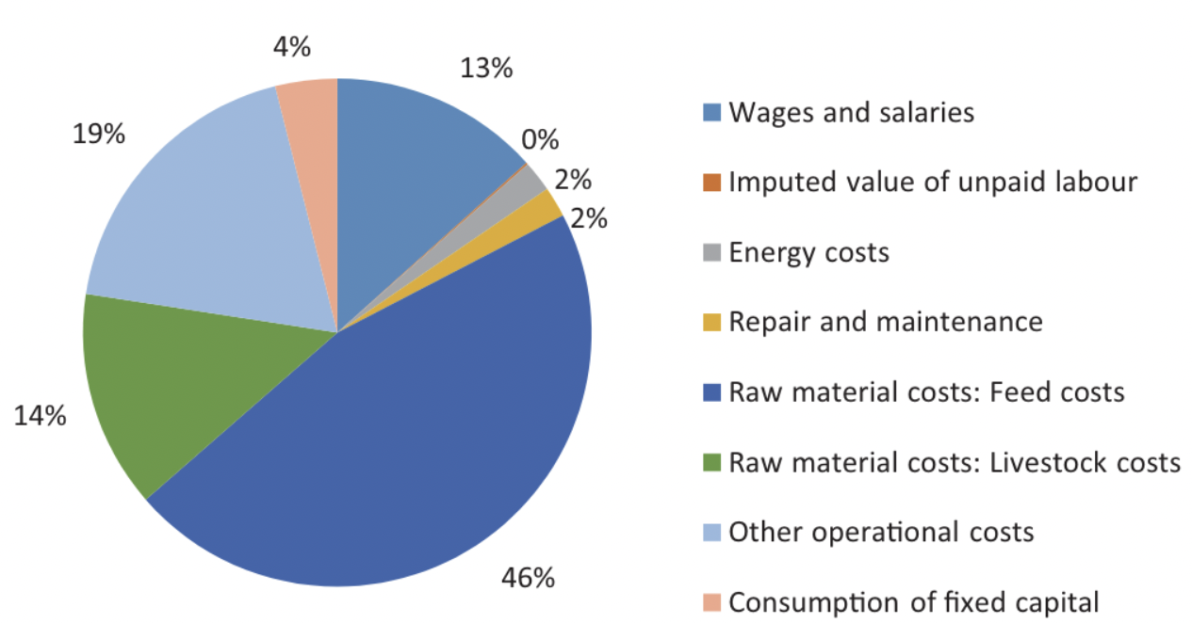
Figure 2: Average cost structure for Gilthead Seabream and European Seabass in 2020 in EU, for medium size: 400-600 g [7].

The Food Conversion Ratio (FCR) is the most critical factor affecting the operational cost of a fish farm. FCR is affected by a number of factors such as the harvesting size, farm feeding practices and water temperature. Table 3 gives the food conversion ratio of Sea Bream for different fish size and water temperature.

Table 3: Food Conversion Ratio for Sea Bream, [6].
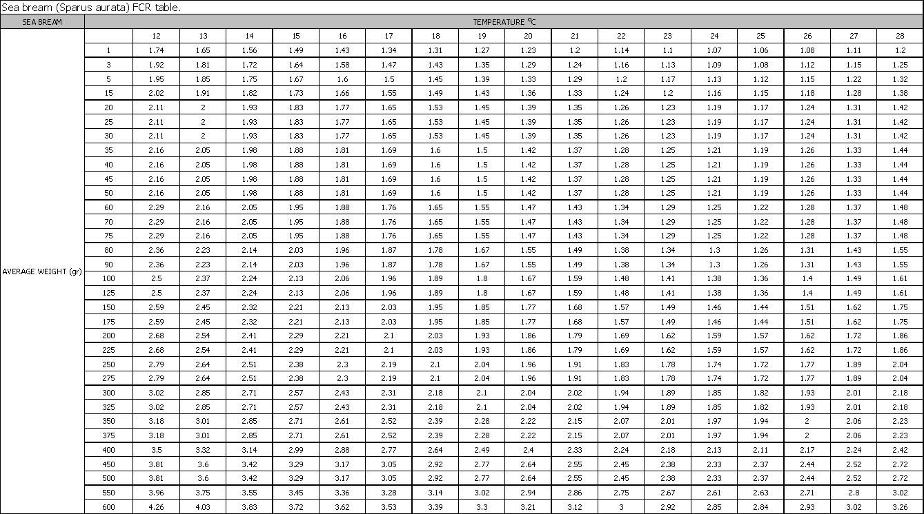
The food conversion ratio (FCR) for Gilthead seabream found in literature for harvesting size 500g is reported at 1.53 – 1.80:1 (Deliverable D19). Cypriot fish farms report an average FCR for Gilthead seabream 2.1:1 (Kimagro, 2022) for harvesting size of 500 grams. In our calculations we will use FCR estimated values reported in Cyprus.
Nowadays, production cost has notable increased and the final price increases day by day due to the Ukrainian crisis, inflation, pandemics, increased transport costs. Given the above, the total operational cost per harvested kilogram of Gilthead seabream that reached 500 grams is estimated by the following computation:

$$Total Operational Cost per harvested kg = \frac{Fish Feed per harvested kg +Cost of juveniles per harvested kg}{60\%} [1]$$

The cost of fish feed per harvested kilogram can be computed by the following formula:
$$Fish Feed per harvested kg=1 kg ×FCR ×Feed Cost per kg [2]$$
A simple computation then gives that:
$$Fish Feed per harvested kg=1 ×2.1 ×1.4= 2.94 €/kg$$
The cost of juveniles per kilogram can be computed by the following formula:
$$Cost of Juveniles per harvested kg=\frac{Cost per Juvenile ×Mortality factor ×1kg}{Harvesting size in kg} [3]$$

Assuming a mortality factor 1.05 (Kimagro, 2022) and cost per fingerling at $€$0.20, equation [3] gives:
$$Cost of Juveniles per harvested kg=\frac{0.20 ×1.05 ×1}{0.5}=0.42€/kg$$
Assuming that fish feed and juveniles’ costs account for 60% of the total operational cost for Cyprus fish farms, from equation [1] we have that:

$$Total Operational Cost per harvested kg=\frac{2.94+0.42}{60\%} = 5.6 €/k$$

European seabass

Production Countries and Quantities
European seabass (Dicentrarchus labrax), Figure 3, is the 31st most produced fish worldwide with Turkey accounting a share around 52%, followed by Greece with 16% of the total production worldwide [9].
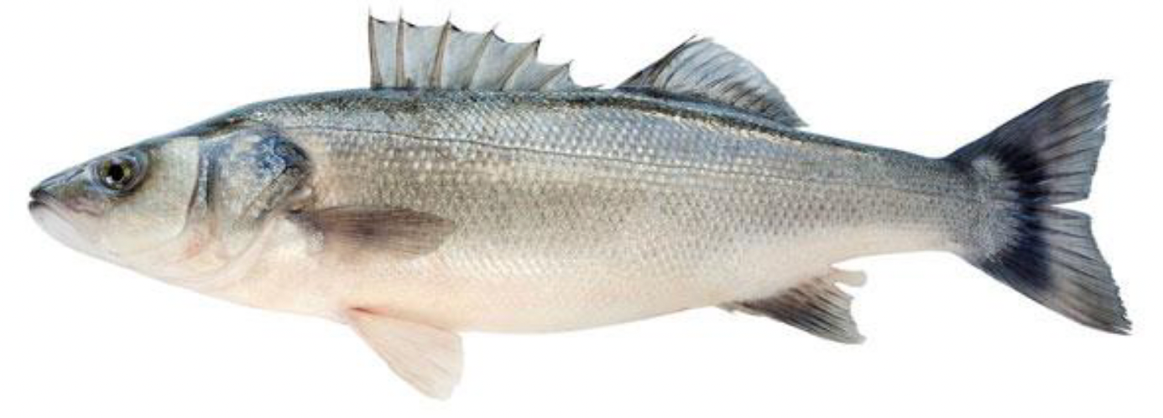
Figure 3: European seabass.

Tables 4 and 5 below summarize the production quantities of European seabass from FAO and FEAP databases.

Table 3. Aquaculture production (quantity in tons live weight) for European seabass. Source: FAO [3].
 | 2015 | 2016 | 2017 | 2018 | 2019 | Global Share % 2019
Turkey | 75 164 | 80 847 | 99 971 | 116 915 | 137 419 | 52
Greece | 36 600 | 42 479 | 44 285 | 46 911 | 41 237 | 16
Egypt | 14 343 | 24 498 | 30 720 | 24 914 | 30 313 | 12
Spain | 18 600 | 22 956 | 17 65 | 21 269 | 25 260 | 10
Croatia | 4 488 | 5 310 | 5 616 | 6 220 | 6 100 | 2
Italy | 5 800 | 6 800 | 6 800 | 5 738 | 5 720 | 2
Iran | - | - | - | - | 5 400 | 2
Tynisia | 2 802 | 2 564 | 3 448 | 2 288 | 3 331 | 1
Cyprus | 1 726 | 1 517 | 2 254 | 2 389 | 2 836 | 1
France | 2 156 | 1 750 | 1 400 | 1 722 | 2 461 | 1

Table 4: Aquaculture production (quantity in tons live weight) for European seabass. Source: FEAP [4].
 | 2015 | 2016 | 2017 | 2018 | 2019 | Global Share % 2019
Turkey | 77 000 | 72 342 | 84 000 | 75 000 | 105 000 | 50
Greece | 45 000 | 46 000 | 44 000 | 45 500 | 55 200 | 27
Spain | 21 324 | 23 445 | 21 269 | 22 460 | 27 335 | 13
Italy | 6 450 | 6 800 | 5 600 | 7 300 | 7 000 | 3
Croatia | 4 075 | 5 310 | 5 616 | 6 220 | 6 089 | 3
Cyprus | 1 725 | 1 442 | 1 500 | 1 500 | 5 000 | 2
France | 1 980 | 1 928 | 1 945 | 1 433 | 2 123 | 1
Portugal | 297 | 427 | 701 | 456 | 450 | 1

Once again there are notable differences, see for example the numbers for Turkey, Greece and Cyprus. Despite this, in both data sets Turkey, Greece, Spain and Croatia are among the top 5 producing countries, covering 92% of the total production.

Economic Characteristics
The cost of acquisition of European seabass juveniles for Cypriot fish farms is estimated at €0.22 per fish (Kimagro, personal communication, 2022). The average harvesting size for seabass in Cyprus is 550 grams and the corresponding cost of fish feed, at the time this study took place (i.e. June 2022), is estimated at €1.4 per kilogram (Kimagro [5], AMBIO SA [6]). Expert opinion reports that fish feed and the cost of juveniles at this point in time is estimated to account for sixty percent 60% of the total operational costs, as in the case of Gilthead seabream. The remaining 40% of operating costs accounts for administrative expenses, fuel consumption, maintenance and packaging facilities. The latter is also verified in the literature from [7,8]. Figure 4 presents the average cost distribution for European seabass. The cost for feed and fingerlings is 61% of the total operational cost. The latter is similar to the corresponding cost for Gilthead seabream (60% given in Figure 2). The two figures seem to have differences in the sense that the cost is distributed into fewer categories in Figure 4 than in Figure 2. Despite this, both sources verify that cost of juveniles and fish feed accounts approximately for 60% of the total operational cost for seabass and seabream, as reported by the Cypriot aquaculture farms (Kimagro).

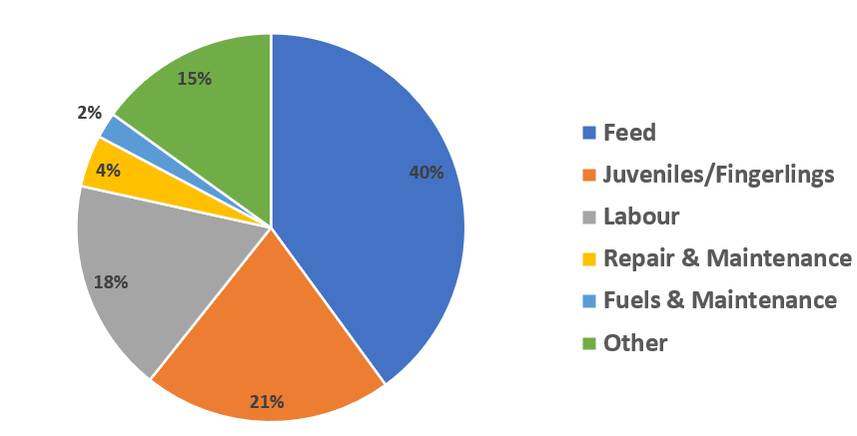
Figure 4: Average cost distribution for European seabass aquaculture [10]

Table 6 illustrates the Food Conversion Ratio of European seabass for different fish size and water temperature.
Table 6: Food Conversion Ratio for Seabass, [6].
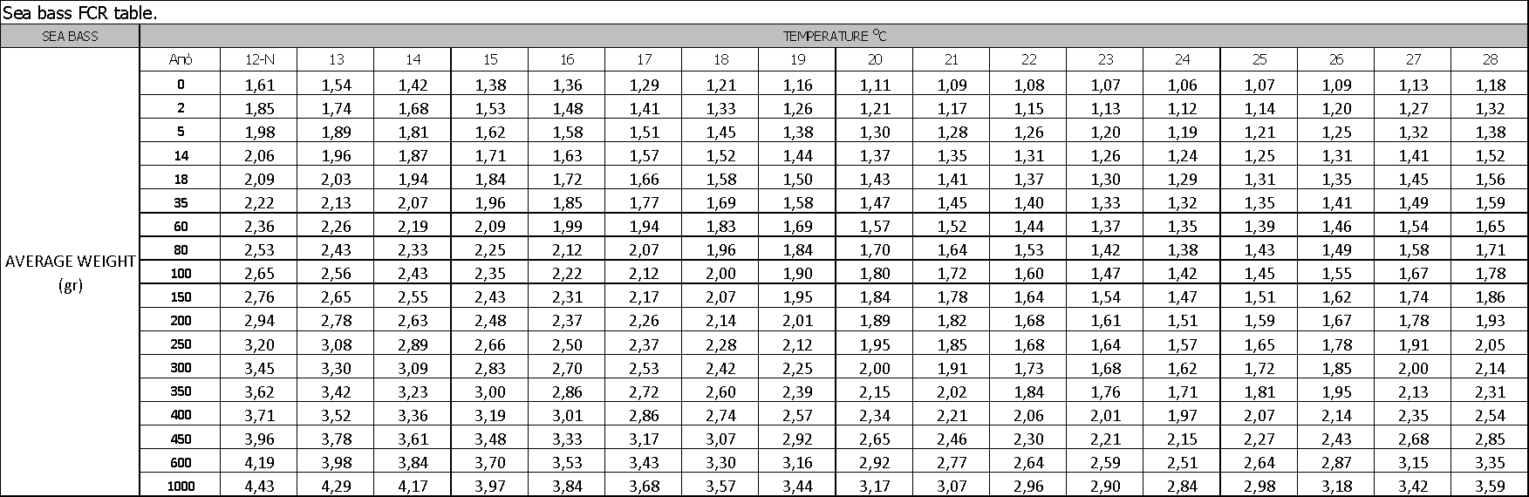
The average food conversion ratio (FCR) for European seabass in aquaculture is reported to be as 1.64 - 2.02:1 for harvesting size 400-450g (Deliverable 19). Cypriot fish farms also report an FCR for European seabass 2.3:1 (Kimagro, 2022, AMBIO SA) for harvesting size of 550 grams. In our calculations we will use FCR estimated values reported in Cyprus.
Given the above, the total operational cost per harvested kilogram of European seabass harvested at 550 grams is given by the following computation:

$$Total Operational Cost per harvested kg = \frac{Fish Feed per harvested kg +Cost of juveniles per harvested kg}{60\%} [1]$$

The cost of fish feed per harvested kilogram can be computed by the following formula:
$$Fish Feed per harvested kg=1 kg ×FCR ×Feed Cost per kg [2]$$
A simple computation then gives that:
$$Fish Feed per harvested kg=1 ×2.3 ×1.4= 3.22 €/kg$$
The cost of juveniles per kilogram can be computed by the following formula:
$$Cost of Juveniles per harvested kg=\frac{Cost per Juvenile ×Mortality factor ×1kg}{Harvesting size in kg} [3]$$

Assuming a mortality factor 1.05 (Kimagro, 2022) and cost per fingerling at $€$0.20, equation [3] gives:
$$Cost of Juveniles per harvested kg=\frac{0.22 ×1.05 ×1}{0.55}=0.42€/kg$$
Assuming that fish feed and juveniles’ costs account for 60% of the total operational cost for Cyprus fish farms, from equation [1] we have that:

$$Total Operational Cost per harvested kg=\frac{3.22+0.42}{60\%} = 6.07 €/kg$$

Meagre (Argyrosomus regius)

Production Countries and Quantities
Meagre (Argyrosomus regius), Figure 5, is a species that that appears more and more often in the Mediterranean aquaculture markets.

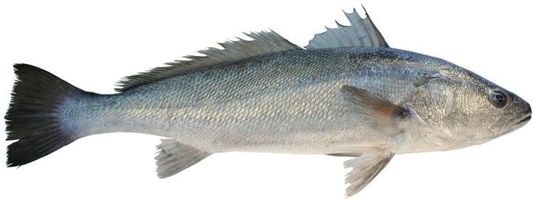
Figure 5: Meagre.

Starting commercially in France in 1997, the main producer countries are Egypt, Spain, Turkey and Greece, as presented in Table 7 and Table 8 from FAO and FEAP sources, respectively.

Table 5. Meagre production (quantity in tons live weight). Source: FAO [3].
 | 2015 | 2016 | 2017 | 2018 | 2019 | Global Share % 2019
Egypt | 9 317 | 16 162 | 25 013 | 25 130 | 25 320 | 68
Spain | 1 301 | 1 707 | 3 524 | 3 929 | 4 535 | 12
Turkey | 2 801 | 2 463 | 697 | 1 486 | 3 375 | 9
Greece | 5 | 2 204 | 1 634 | 1 639 | 2 415 | 6
Croatia | 67 | 125 | 253 | 808 | 700 | 2
France | 600 | 256 | - | 251 | 669 | 2
Tunisia | - | 40 | 42 | 10 | 330 | 1
Italy | 30 | 100 | 100 | 75 | 75 | 0
Portugal | 61 | 63 | 70 | 33 | 7 | 0
Cyprus | 14 | 3 | - | 1 | -

Table 6: Meagre production (quantity in tons live weight). Source: FEAP [4].
 | 2015 | 2016 | 2017 | 2018 | 2019 | Global Share % 2019
Spain | 1 642 | 1 798 | 1 932 | 2 500 | 3 650 | 36
Turkey | 2 000 | 2 500 | 0 | 0 | 3 300 | 33
Greece | - | - | - | 2 200 | 2 000 | 20
Croatia | 67 | 125 | 253 | 808 | 725 | 7
France | 226 | 236 | 326 | 289 | 390 | 4
Italy | 190 | 190 | 0 | 0 | 50 | 0
Cyprus | 28 | 10 | 10 | 0 | 0

Table 8 shows data acquired from FEAP. There is no information on Egypt, the main producer for meagre. Economic Characteristics

Since there is no large-scale meagre production in Cyprus we also combine indicative cost characteristics based on information from other neighbour/competitive countries such as Greece and Turkey. Since the number of production units is low, cost comparisons are difficult to make. In land-based systems costs depend mainly upon the size of the farm. However, in cage culture a major expense is the cost of juveniles; currently these must be bought from abroad This cost is estimated at €0.30. In addition, feed represents the other major cost during grow-out but it is lower than other marine fish species, since the FCR for meagre is generally better.

Feed is supplied by all the major aquafeed producers. Meagre feed is similar to that used for other Mediterranean marine species, with good results obtained in terms of FCR, which is the range of 1.7-3.0:1 [11,12]. Thus, we assume feed price at €1.4 per kilogram, at the time this study took place (i.e. June 2022), as in the case of Seabream and Seabass. In the Mediterranean Sea where water temperature is relatively high an FCR even lower than 1.7:1 was reported [11]. Since Cyprus farms do not have considerable production of meagre and they lack of reliable data, we will use in our study the FAO estimate an FCR value of 1.7 [11], for harvesting size of 1 kilogram. The time to reach the commercial size of 1Kg is estimated at 18 months which is quite impressive considering that seabass and seabream take at least 18 months to become half of this size. Table 9 illustrates the Food Conversion Ratio of meagre for different fish size and water temperature [6].
Table 9: Food Conversion Ratio for Meagre, [6].
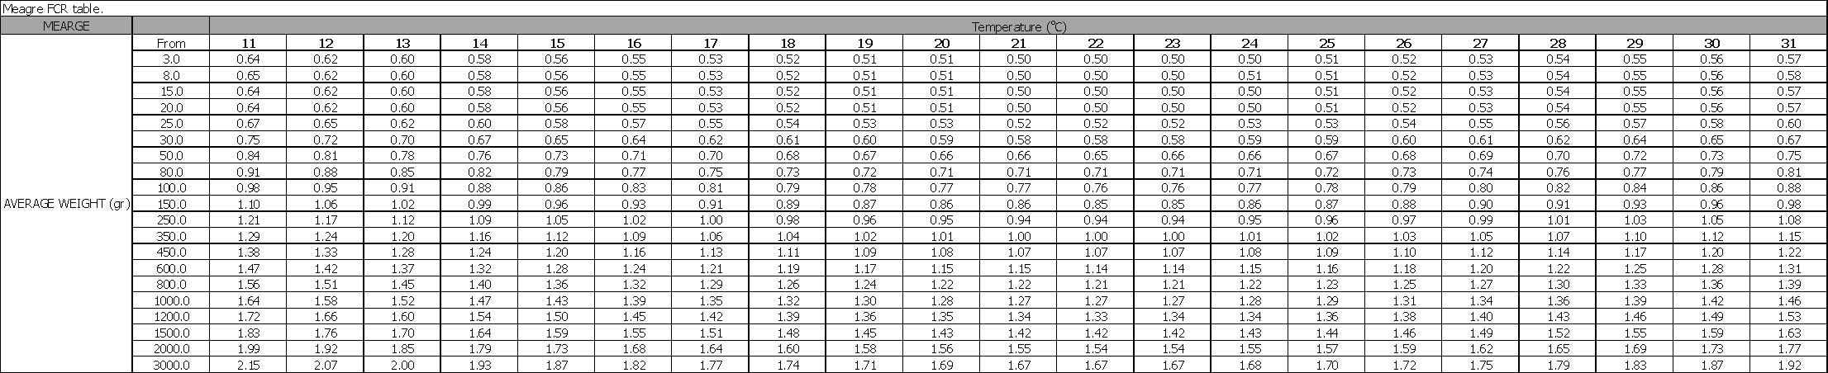
In this study we assume that the cost of juveniles and feed cost accounts for about 60% of the total operational cost as in the case of Seabream and seabass. As a result, the total operational cost per harvested kilogram of Meagre harvested at 1000 grams is given by the following computation:

$$Total Operational Cost per harvested kg = \frac{Fish Feed per harvested kg +Cost of juveniles per harvested kg}{60\%} [1]$$

The cost of fish feed per harvested kilogram can be computed by the following formula:
$$Fish Feed per harvested kg=1 kg ×FCR ×Feed Cost per kg [2]$$
A simple computation then gives that:
$$Fish Feed per harvested kg=1 ×1.7 ×1.4= 2.38 €/kg$$
The cost of juveniles per kilogram can be computed by the following formula:
$$Cost of Juveniles per harvested kg=\frac{Cost per Juvenile ×Mortality factor ×1kg}{Harvesting size in kg} [3]$$

Assuming a mortality factor 1.10 (Kimagro, 2022) and cost per fingerling at $€$0.30, equation [3] gives:
$$Cost of Juveniles per harvested kg=\frac{0.3 ×1.1 ×1}{1}=0.33€/kg$$
Assuming that fish feed and juveniles’ costs account for 60% of the total operational cost for Cyprus fish farms, from equation [1] we have that:

$$Total Operational Cost per harvested kg=\frac{2.38+0.33}{60\%} = 4.52 €/kg$$

Red porgy (Pagrus pagrus) and red seabream (Pagrus major)

Production Countries and Quantities

Red porgy (Pagrus major), Figure 6, is a relatively new species for aquaculture and fulfills some critical criteria for intensive fish farming such as high market price and demand, ability to grow fast and adaptability [13].

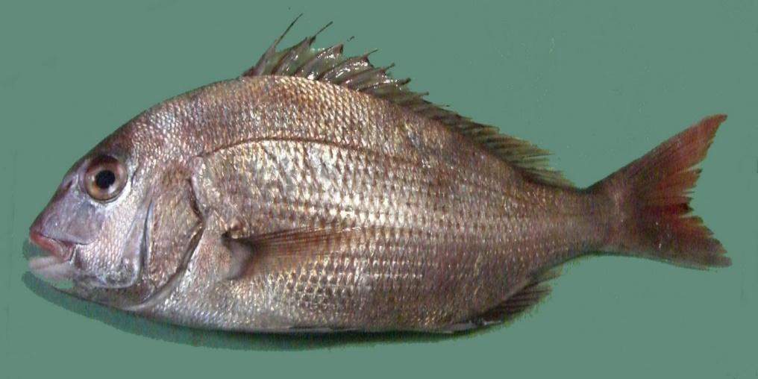
Figure 6: Red porgy Pagrus pagrus.

This species is found in the western Atlantic, in the Mediterranean and Adriatic Sea and Marmara, but not in the Black Sea.

Economic Characteristics
Table 9 summarizes the production figures from the FAO database. As one can observe, total production is very low compared to seabream and seabass.
Table 10. Global aquaculture production (quantity in tons live weight) for Red porgy and red seabream. Source: FAO [3].
 | 2015 | 2016 | 2017 | 2018 | 2019
Greece
Red porgy (Pagrus pagrus) | 781,6 | 3030,6 | 1291,7 | 2202,02 | 2927,7
Red seabream (Pagrus major) | 0 | 0 | 0 | 0 | 0
Turkey
Red porgy (Pagrus pagrus) | 143 | 225 | 20 | 2 | 5
Red seabream (Pagrus major) | 0 | 0 | 0 | 0 | 0

The on-growing technology currently adopted for red porgy is similar to the one applied for seabream. The optimal biological performance with respect to growth and feeding efficiency has not yet been found [14].
An Average FCR of 1.62 is reported for red porgy in [15] for harvesting size 280g and an FCR of 1.87 (D19) for harvesting size of 550g. Cyprus farms report an FCR of 2.1:1 for harvesting size of 500 grams. In our analysis we will the value reported by Cypriot farms.

Table 11 illustrates the Food Conversion Ratio of red porgy for different fish size and water temperature.
Table 11: Food Conversion Ratio of Red Porgy, [6].
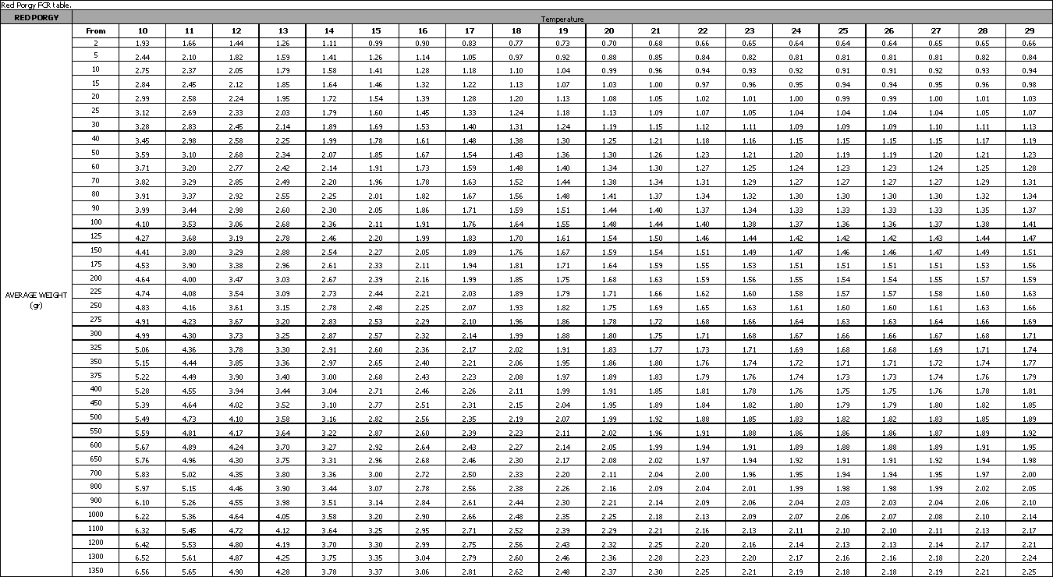
The cost of juveniles for Cypriot farms is estimated at €0.25 per unit (data 2022). The average cost of fish feed for harvesting at 500 grams is estimated at €1.4 per kilogram, at the time this study took place (i.e. June 2022). Similarly, with Gilthead seabream and European seabass, it is estimated that the cost of juveniles together with the feed cost account for 60% of the total operational cost of production.

Given the above, the total operational cost per kilogram of Red porgy harvested at 500 grams is estimated by the following computation:
$$Total Operational Cost per harvested kg = \frac{Fish Feed per harvested kg +Cost of juveniles per harvested kg}{60\%} [1]$$

The cost of fish feed per harvested kilogram can be computed by the following formula:
$$Fish Feed per harvested kg=1 kg ×FCR ×Feed Cost per kg [2]$$
A simple computation then gives that:
$$Fish Feed per harvested kg=1 ×2.1 ×1.4= 2.94 €/kg$$
The cost of juveniles per kilogram can be computed by the following formula:
$$Cost of Juveniles per harvested kg=\frac{Cost per Juvenile ×Mortality factor ×1kg}{Harvesting size in kg} [3]$$

Assuming a mortality factor 1.05 (Kimagro, 2022) and cost per fingerling at $€$0.20, equation [3] gives:
$$Cost of Juveniles per harvested kg=\frac{0.25 ×1.05 ×1}{0.5}=0.525€/kg$$
Assuming that fish feed and juveniles’ costs account for 60% of the total operational cost for Cyprus fish farms, from equation [1] we have that:

$$Total Operational Cost per harvested kg=\frac{2.94+0.525}{60\%} = 5.775 €/kg$$

Cyprus Aquaculture in Numbers
There are three types of licensed fish farms in Cyprus. One farm for shrimp on the land, nine aquaculture fish farms in near the coast open sea, mainly for Gilthead seabream and European seabass, and eight small units mainly producing trout and sturgeon.

The data related with aquaculture in Cyprus were adapted from the 2020 annual report of the Department of Fisheries and Marine Research. The total production of fish from aquaculture in 2019 was estimated to 7780 tons, worth about €41 million. The fingerlings production reached around 15.9 million, worth of €2.5 million.

Table 12 shows the 2020 total production for Cypriot aquaculture for Gilthead Seabream. European Seabass, Meagre and Red Porgy, in 2020 that was 10 624 tons having a total value of € 56 968 567, [1].

Table 12: Total aquaculture production for the four investigated species in Cyprus in 2020 [1].
Aquaculture Farms

 | Internal Market |  | Exports |  | Total
Species | Quantity | Value (€) | Quantity | Value (€) | Quantity | Value (€)
Gilthead Seabream | 4 170 | 19 466 247 | 2 656 | 11 991 945 | 6 826 | 33 103 502
European Seabass | 1 759 | 11 288 833 | 2 033 | 12 508 209 | 3 792 | 23 797 042
Meagre | 6 | 68 023 | 0 | 0 | 6 | 68 023
Red Porgy | 0 | 0 | 0 | 0 | 0 | 0

The total fingerlings production for the four species in 2020 is presented on Table 13 and was 18 655 119 with a total value of € 2 817 539, [1].
Table 13: Fingerlings production for the four investigate species in Cyprus in 2020 [1].
Fingerlings Production

 | Internal Market |  | Exports |  | Total
Species | Quantity | Value (€) | Quantity | Value (€) | Quantity | Value (€)
Gilthead Seabream | 10 740 237 | 1 619 260 | 2 244 205 | 309 480 | 12 984 442 | 1 928 740
European Seabass | 3 741 990 | 566 723 | 0 | 0 | 5 363 501 | 826 289
Meagre | 50 000 | 10 000 | 257 176 | 52 500 | 307 176 | 62 500
Red Porgy | 0 | 0 | 0 | 0 | 0 | 0

Conclusions
The objective of this deliverable is to provide the economic characteristics for the four fish species considered within the context of the OS-Aqua project. Following work carried out at deliverable 19 and consensus reached by the consortium, these four fish species are Gilthead seabream, European seabass, Meagre, and Red porgy. The economic characteristics addressed are:
- Aquaculture activity/ production level per Country per fish species;
- The food conversion ratio (FRC) at various fish sizes and water temperature;
- Estimation of overall operational costs per fish species;
- Cyprus aquaculture yield in figures.
It is well known that Gilthead seabream and European seabass are two fish species whose rearing into captivity came to maturity, whereas Meagre and Red porgy have recently been introduced in aquaculture, at least in Cyprus. For the last two fish species there is no local production of fingerlings.
The World COVID-19 pandemic and the recent war in Ukraine bear an impact on World trade size and goods’ prices. Prices of fish feed, aquaculture companies’ hardware and consumables realized significant increase constituting past figures irrelevant. Therefore, past figures are presented for only informative reasons and up to date figures should be used in the forthcoming economic analysis.

References
[1] DFMR, Http://Www.Moa.Gov.Cy/Moa/Dfmr/Dfmr.Nsf/Page07_gr/Pag07_gr?OpenDocument&Start=1&Count=1000&Expand=1. (n.d.). http://www.moa.gov.cy/moa/dfmr/dfmr.nsf/page07_gr/pag07_gr?OpenDocument&Start=1&Count=1000&Expand=1 (accessed September 5, 2022).
[2] J.M. Hernández, E. Gasca-Leyva, C.J. León, J.M. Vergara, A growth model for gilthead seabream (Sparus aurata), Ecol Modell. 165 (2003) 265–283. https://doi.org/10.1016/S0304-3800(03)00095-4.
[3] https://www.fao.org/fishery/en/culturedspecies/Sparus_aurata, FAO, (n.d.).
[4] https://feap.info/wp-content/uploads/2020/10/20201007_feap-production-report-2020.pdf, FEAP, (n.d.).
[5] https://interfishmarket.com/en/company.aspx?id=11563, Kimagro, (n.d.).
[6] https://ambio.gr/, AMBIO SA, Market Research Deliverable Report, 2022, (n.d.).
[7] R. Nielsen, I. Ankamah-Yeboah, I. Llorente, Technical efficiency and environmental impact of seabream and seabass farms, Https://Doi.Org/10.1080/13657305.2020.1840662. 25 (2020) 106–125. https://doi.org/10.1080/13657305.2020.1840662.
[8] Fisheries and Aquaculture - Cultured Aquatic Species - Sparus aurata, (n.d.). https://www.fao.org/fishery/en/culturedspecies/Sparus_aurata/en (accessed July 12, 2022).
[9] Enhanced Reader, (n.d.).
[10] Enhanced Reader, (n.d.).
[11] Fisheries and Aquaculture - Cultured Aquatic Species - Argyrosomus regius, (n.d.). https://www.fao.org/fishery/en/culturedspecies/Argyrosomus_regius/en (accessed July 13, 2022).
[12] N.J. Duncan, A. Estévez, H. Fernández-Palacios, I. Gairin, C.M. Hernández-Cruz, J. Roo, D. Schuchardt, R. Vallés, Aquaculture production of meagre (Argyrosomus regius): Hatchery techniques, ongrowing and market, Advances in Aquaculture Hatchery Technology. (2013) 519–541. https://doi.org/10.1533/9780857097460.3.519.
[13] (9) (PDF) Culture of the red porgy, Pagrus major , in Crete. Present knowledge, problems and perspectives, (n.d.). https://www.researchgate.net/publication/284294639_Culture_of_the_red_porgy_Pagrus_pagrus_in_Crete_Present_knowledge_problems_and_perspectives (accessed July 18, 2022).
[14] Culture of the red porgy, Pagrus major , in Crete. Present knowledge, problems and perspectives, (n.d.). https://agris.fao.org/agris-search/search.do?recordID=QC9665567 (accessed July 10, 2022).
[15] Marine Aquaculture in Turkey, n.d.
[16] B. Hosu, A.Y. Korkut, S. Salnur, Investigation on feeding tables for sea bass (Dicentrarchus labrax L.,1758 ) in net-cage (Pinar Marine Company) culture, Cahiers Options Méditerranéenes. 63 (n.d.).

