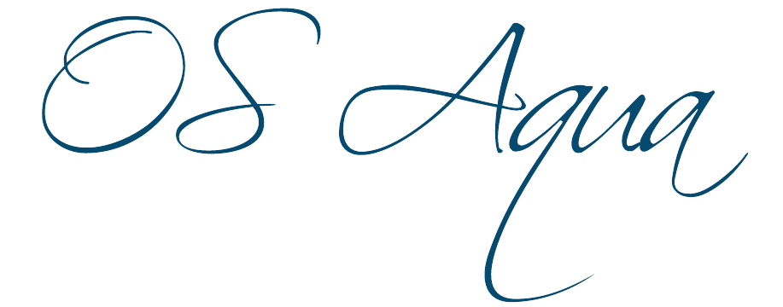
Open Sea Aquaculture
in the Eastern Mediterranean

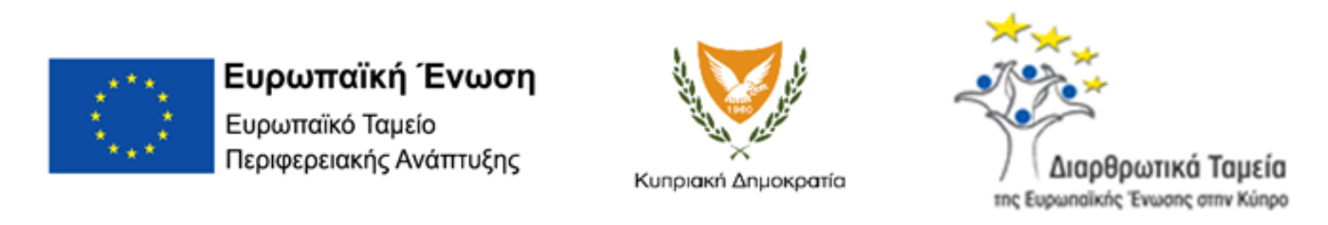
The Project is co-financed with 800 K Euro by the European Regional Development Fund and the Republic of Cyprus through the Research and Innovation Foundation with grant number INTEGRATED/0918/0046

Work Package ID: WP2

Work Package Title: Dissemination Activities

Deliverable ID: D7

Deliverable Title: Information day for the Public

Dissemination Level: Public
Partner Leader: OC - UCY
Disclaimer
Use of any knowledge, information or data contained in this document shall be at the user's sole risk. Neither the OS Aqua Consortium nor any of its members, their officers, employees or agents accept shall be liable or responsible, in negligence or otherwise, for any loss, damage or expense whatever sustained by any person as a result of the use, in any manner or form, of any knowledge, information or data contained in this document, or due to any inaccuracy, omission or error therein contained.
The OS Aqua project (INTEGRATED/0918/0046) has been partially funded under the RESTART 2016-2020 Programme, Integrated Projects Call, of the Cyprus Research and Innovation Foundation. This publication reflects the views only of the authors, and the Funding Agency cannot be held liable or responsible for any use which may be made of the information contained herein or of any consequences thereof.
Copyright notice
© Copyright 2020-2024, The OS Aqua Consortium
This document contains information that is protected by copyright. All Rights Reserved. No part of this work covered by copyright hereon may be reproduced or used in any form or by any means without the permission of the copyright holders.

Contents
Introduction 4
Dual Use Marine Technologies Workshop 5
Thalassa Festival 2022 6
Thalassa Festival 2023 7
Final Event OS Aqua 8
APPENDIX 1 – FINAL EVENT AGENDA 14
APPENDIX 2 – FINAL EVENT REGISTRATION SHEET 15

Introduction
This report documents the participation of project in events, discussions, and presentations showcasing the dedication and commitment of the consortium members in outreach to the public. From the Dual Use Marine Technologies Workshop to our presence at the Thalassa Festivals and culminating in the Final Event at the University of Cyprus, each engagement of the project participants with the public highlighted the project's progress and outcomes and has secured invaluable feedback that has enriched the project’s results. The following sessions are identical with part of the D6 Stakeholder meeting minutes.

Dual Use Marine Technologies Workshop
OS Aqua took part in the two-day annual workshop, organized by Maritime Institute of the Eastern Mediterranean and Cyprus Subsea Consulting and Services C.S.C.S. Limited. The workshop was in an online format, delivered via Zoom. At the event, a total of 50 attendees were present. The attendees originated from diverse backgrounds, as shown in Figure 1.
Figure SEQ Figure \* ARABIC 1: Participants background
Day One Highlights (Wednesday, December 9th, 2020, 09:00 AM Nicosia)
Introduction to OS Aqua The workshop commenced with an introduction to the OS Aqua project, emphasizing its role in promoting collaboration within the quadruple helix framework. Attendees were enlightened about the project's connections to other initiatives like MARI-Sense and STEAM, particularly within the context of Marine Spatial Planning.
Project Overview The Project Coordinator delivered a comprehensive overview of the OS Aqua project, elucidating its goals and significance.
Marine Spatial Planning Mr. Stephanos Charalampous provided a detailed presentation on the GIS marine spatial planning map, offering insights into the project's considerations regarding existing facility limitations. This presentation stimulated constructive discussions among participants, who shared their observations and opinions regarding these constraints.

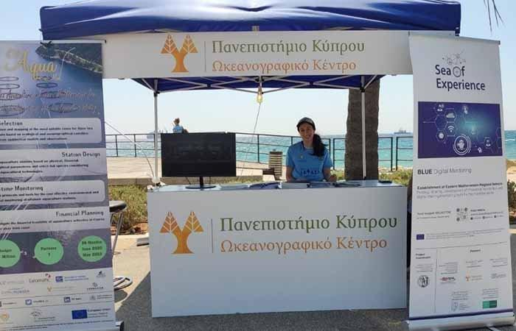
Thalassa Festival 2022
Figure 2: Participation at the THALASSA Festival 2022
The Thalassa Festival 2022 unfolded on the 20th and 21st of May in Limassol. At this event, the Oceanography Center was invited to exhibit various ocean-related activities. Moreover, the OS AQUA project received valuable exposure as information was disseminated to the intrigued general public.

Thalassa Festival 2023
Similarly, the Thalassa Festival in May 2023, held at Limassol, welcomed the Oceanography Center once again to demonstrate ocean activities. Information pertaining to the OS AQUA project was shared with the interested general public, building upon the outreach efforts initiated in the previous year.
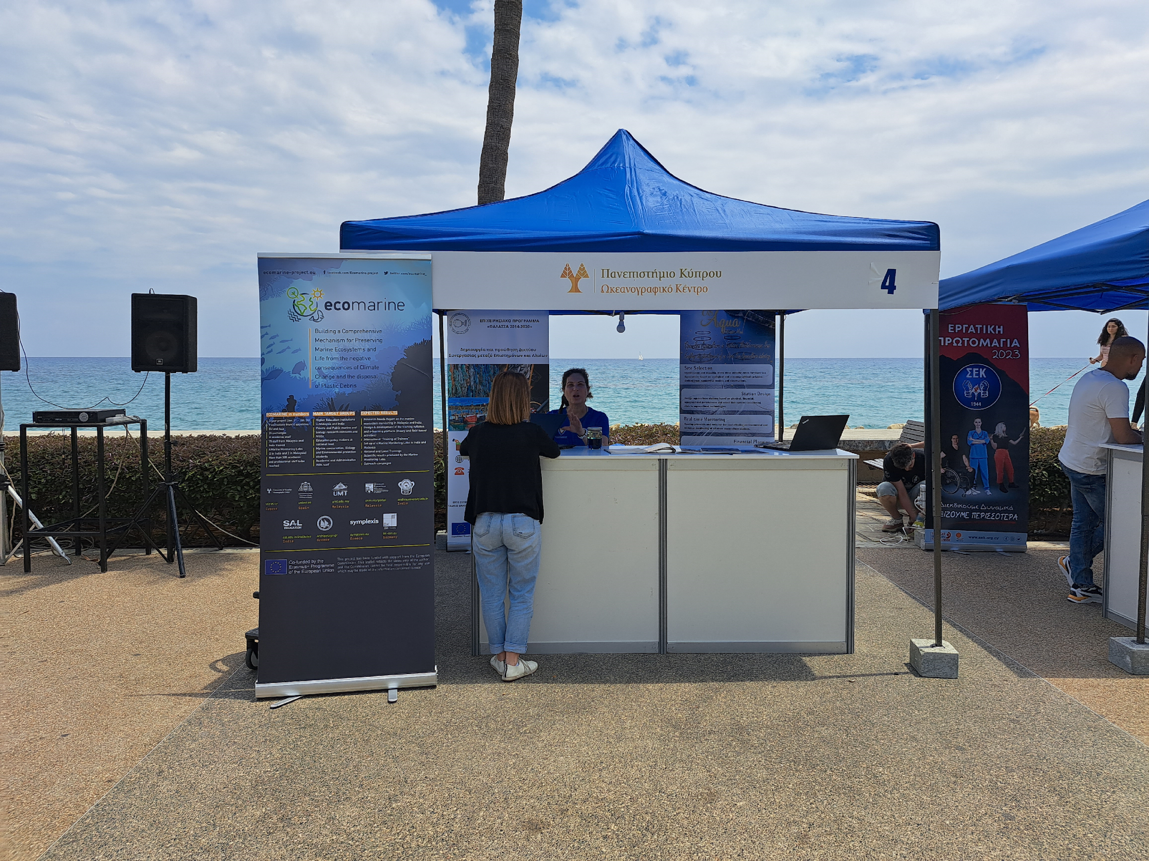
Figure 3: Participation at the THALASSA Festival 2023

Final Event OS Aqua

The concluding event of the OS Aqua project took place on the 12th of September 2023 at the University of Cyprus. The event was strategically advertised through local online news media channels, successfully drawing a crowd of 30 participants. Among the attendees were local aquaculture professionals, environmental protection companies, and research organizations.
The event commenced with a warm welcome by Project PI, Dr. Ioannis Kyriakides. In his opening address, he provided a brief yet informative introduction to the OS Aqua project, setting the stage for the sessions that followed.
The first session focused on Aquaculture Zone Selection. Mr. Stephanos Charalambous delivered the first presentation, focusing on the selection procedure for aquaculture zones around the island. He elaborated on the criteria used for excluding unsuitable areas, and stimulating discussions among the audience.
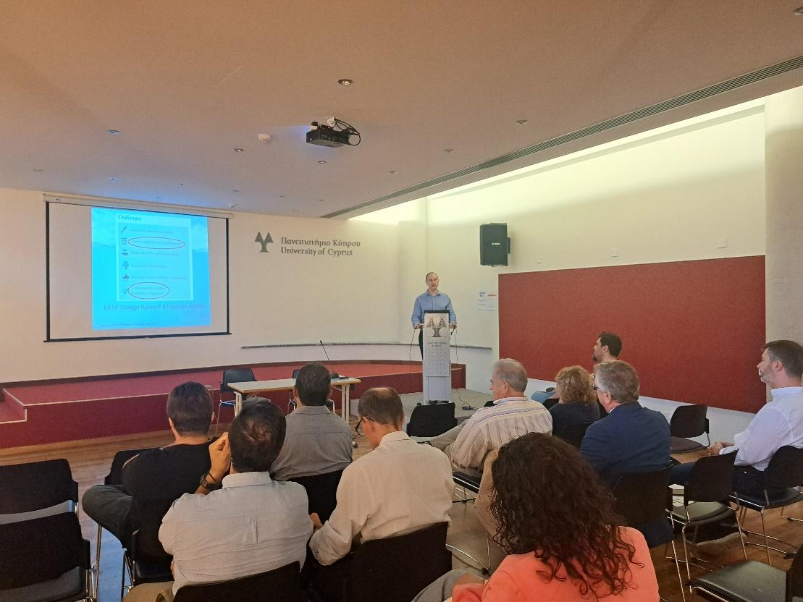
The second presentation, led by Dr. Triantaphylou, Dr. Trianataphillidis, and Dr. Pollani, delved into the tools and methods employed for modelling water quality near Cyprus and assessing the impact of new aquaculture units. Mr. Nikolaidis concluded the first session with a presentation on the results of the Environmental Impact Assessment, shedding light on the most suitable areas identified for aquaculture.
The second session focused on Technologies and Fish Species. In the following session, Mrs. Abu Alhaija discussed technologies and sensors suitable for open sea aquaculture and introduced a specially designed cage developed as part of the project. Dr. Triantafyllidi presented findings on the fish species viable for such aquaculture units.
The final session focused on Aquaculture Governance, Market Analysis and business plan presentation. Mr. Constantinos Moustakas outlined the Aquaculture governance and development landscape in Cyprus, explaining current licensing procedures. Dr. Charalambides discussed the market analysis for fish export, while Dr. Menikou covered the economic characteristics of the market. The final presentation focused on economic and risk analysis for open sea aquacultures, concluding with the business plan of the aquaculture farm.
Figure : Introduction by Principal investigator

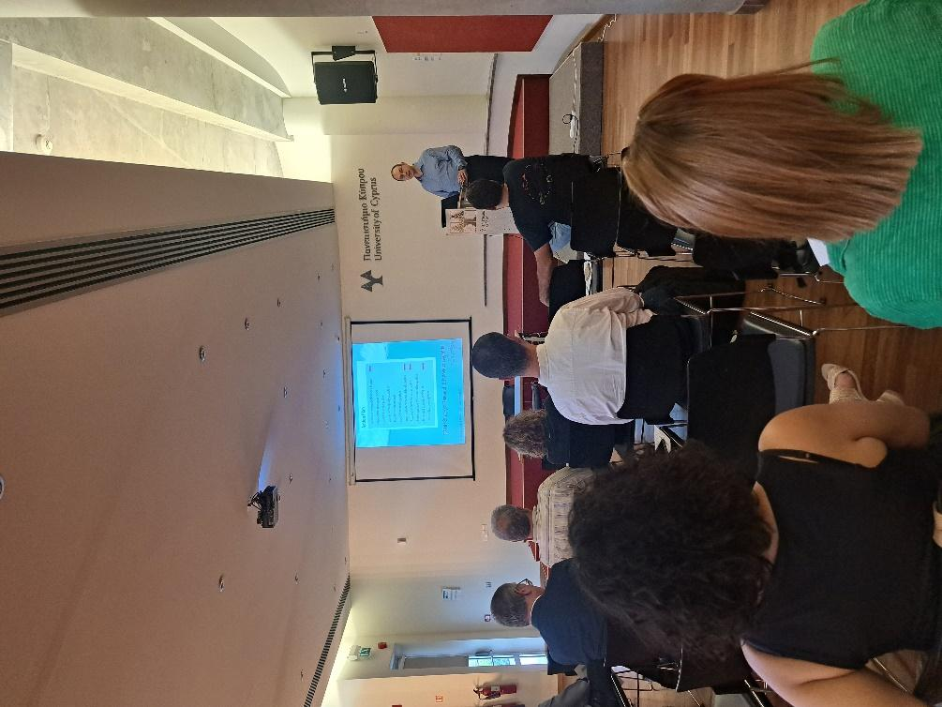
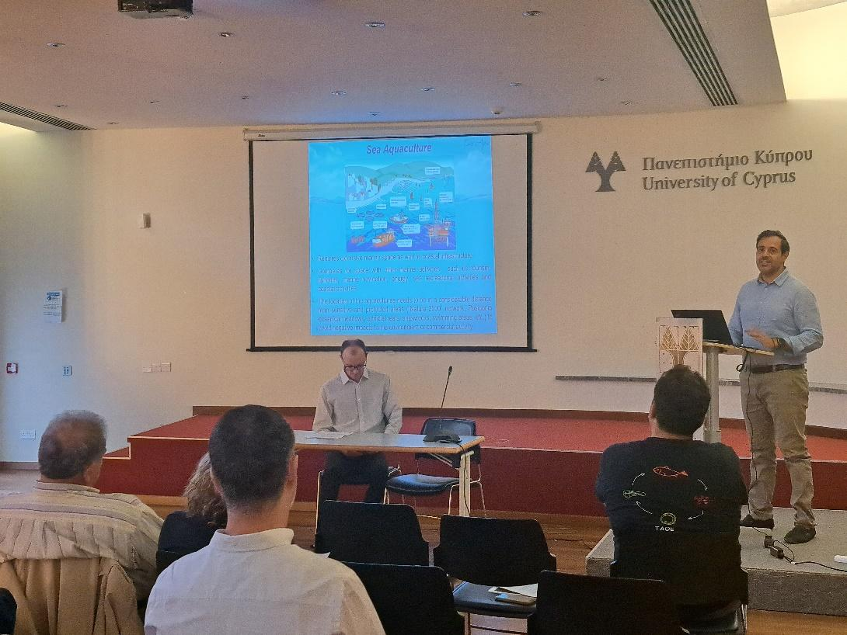
At the end of the presentations, a stakeholder engagement session took place. The discussions held during the OS Aqua project event were instrumental in fostering collaboration, sharing expertise, and enhancing stakeholder engagement. These interactions not only clarified aspects of the project but also provided a platform for participants to contribute their knowledge and perspectives. The rich dialogue reaffirmed the importance of stakeholder involvement in shaping the project's future direction and highlighted the commitment of all participants to sustainable aquaculture in the region.
Figure : Introduction by Principal investigator
Participants engaged in discussions for different parts of the event. For the Aquaculture allocation Zones topic, discussion focus upon the specific criteria used to determine suitable areas, the exclusion of unsuitable regions, and potential challenges faced during the selection process. Participants discussed about previous studies that have also identified suitable areas for new aquaculture farms. The discussion focused on the reasons that an area selected by previous studies has been excluded in this site selection. The reason of exclusion was the shift of the marine shooting range that is been used by the military, hence the area was excluded as a possible site from the consortium.
The stakeholder engagement regarding water quality assessment focused on the numerical model utilized for evaluating water quality around Cyprus and assessing the environmental impact of new aquaculture units. Discussions revolved around the accuracy of these models, potential improvements, and possible additional inputs that may be taken into consideration for improving the model outcomes. Such additional inputs may be the runoffs that have a significant impact on the water quality. It was mentioned that for those inputs the relevant authority may be the Water Development Department.
Figure : Presentation of spatial planning criteria
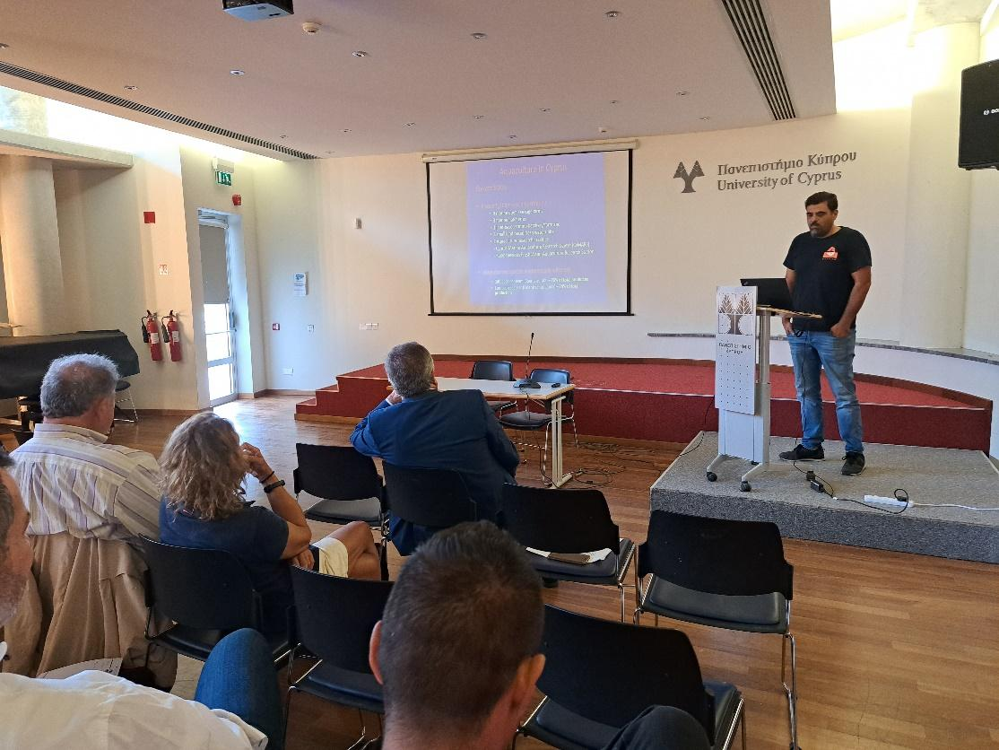
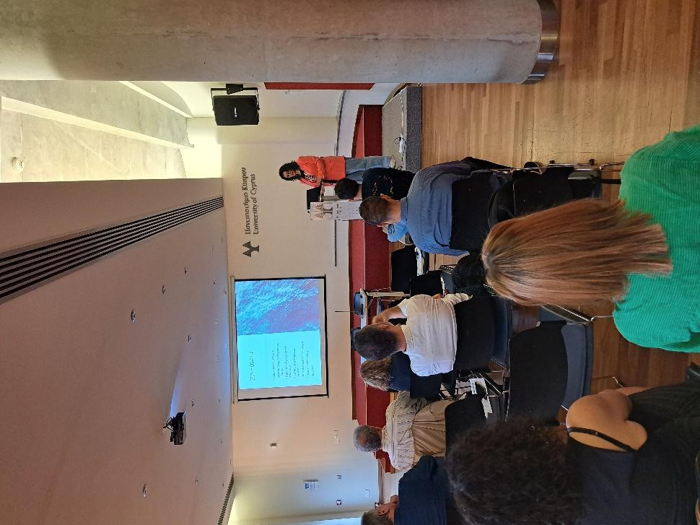
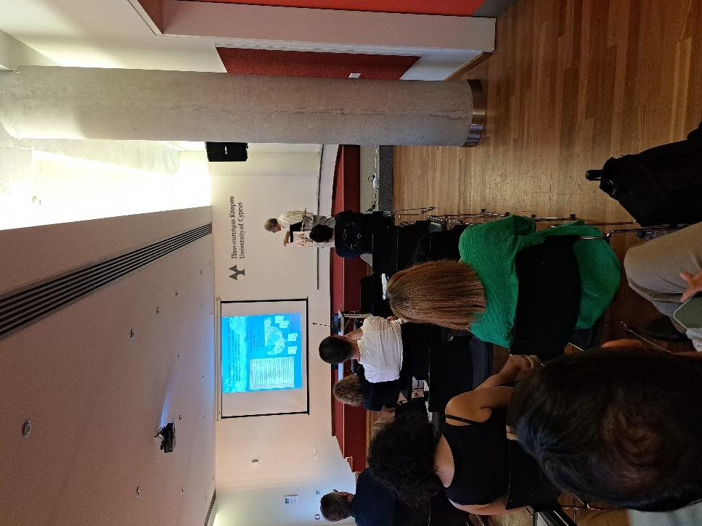
Attendees discussed the outcomes of the Environmental Impact Assessment (EIA) presented by Mr. Nikolaidis. A point was raised about not including the possible impacts of the aquacultures on Poseidonia meadows. An explanation was given that the proposed locations are beyond the depth that Poseidonia meadows can be found and hence no environmental impact will be made.
Figure : Presentation of Water quality projections
Figure : PResentation of Aquaculture technologies and sensors
Figure : Presentation of current legislation and governance status
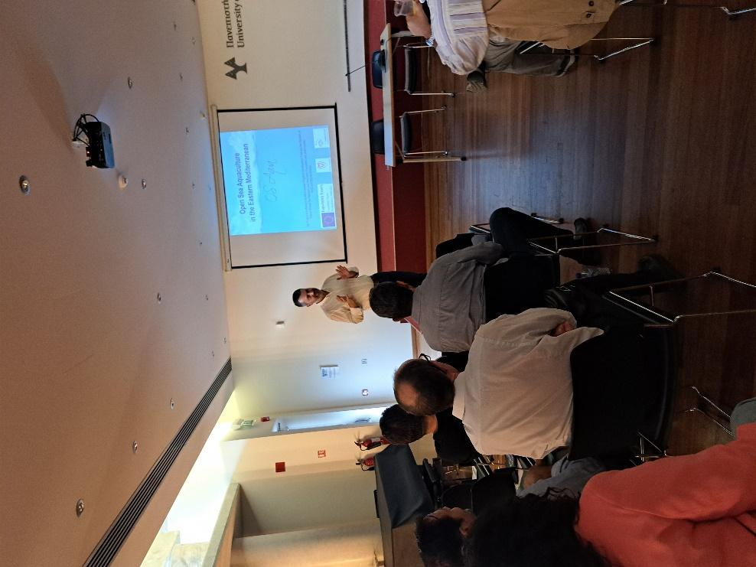
The presentation on technologies and sensors suitable for open-sea aquaculture sparked discussions on their practicality, effectiveness, and potential integration into aquaculture practices. A discussion started with a local aquaculture regarding the effectiveness of the proposed OS Aqua design and the usage of the other proposed technologies in the global market. More specifically they ask if the proposed technologies are currently in the market and if they perform well. Participants also mentioned that the implementation of an open sea station in Cyprus can attract researchers and investments like the PLOCAN project in Gran Canaria, Spain. CMMI can use it as a test site for offshore and open sea technologies whereas automation can be tested and improved. It can be combined with research for renewable energy from currents and wind.
Figure : Presentation of Market analysis
Figure :Presentation of Economic risk analysis and business plan

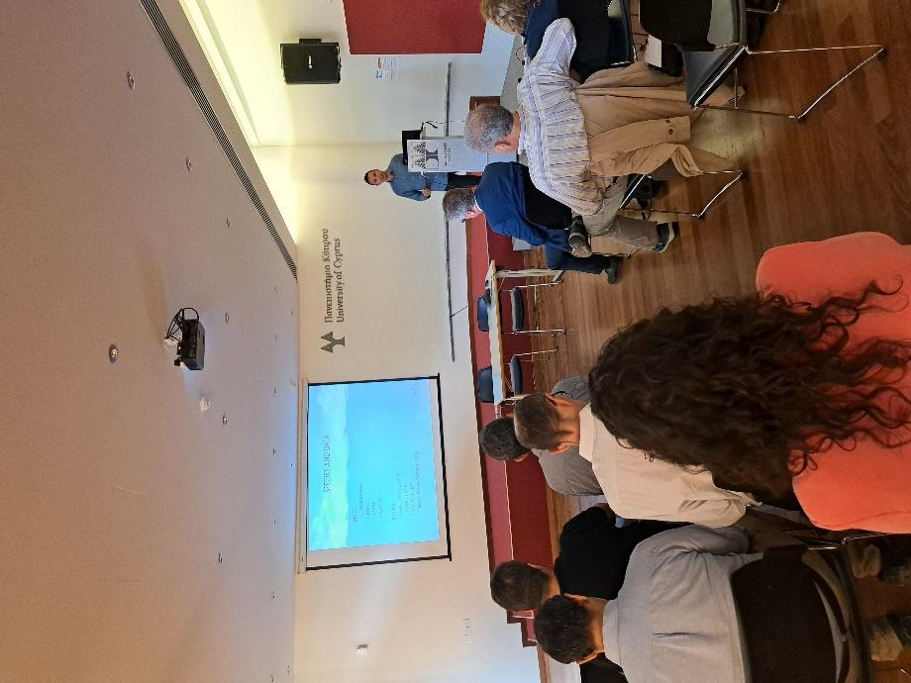
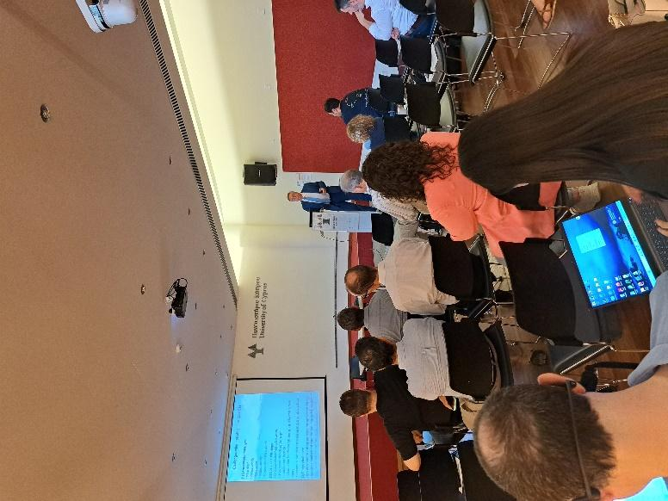
Dr. Triantafyllidi's presentation gave insights on fish species suitable for open-sea aquaculture were discussed alongside economic implications. Attendees analyzed the economic viability and potential market impacts of cultivating specific fish species in the targeted open sea areas. Comments were made focusing on the species scoring system and the final ranking of the suitable fish species. At the end of the discussion the stakeholders agreed on the species ranking. Another comment focused on the new species (other than seabass and seabream) proposed and to the readiness of the market. The answer was that if Cyprus manages to cultivate fast-growing species there are tremendous possibilities to offer a series of new products, including fillets and other processing methods (e.g. smoked etc).
Figure : Presentation of species research analysis
Sessions dedicated to aquaculture governance and development landscape in Cyprus, current licensing procedures, market analysis for fish exports, and the economic characteristics of the market prompted discussions on regulatory challenges, market opportunities, and economic sustainability. Participants discussed the current licensing procedure and asked the officials about the possibility of issuing new licenses for offshore aquaculture units. The official responded that there are no plans for new licenses at the moment but if new proposals arrive at their department regarding deeper units they are more than happy to assess the possibility.
The final discussion revolved around the economic and risk analysis for open sea aquaculture. Attendees explored the business plan, economic potential, and risk assessments related to aquaculture activities, emphasizing financial feasibility and sustainability. It was also discussed that proper marketing is needed to open markets Cyprus is isolated from the EU markets and emphasis must be given to Israel and Jordan. The consumption in Jordan is still low so there is a good chance to increase seafood consumption there. The investment of know-how to fast-growing species like cobia or greater amberjack is of strategic importance. On top of this, Cypriot aquaculture products seem to maintain a good reputation as qualitative products versus Turkish production and can still attract a premium price for that. This premium quality must be maintained as it is an important element that can differentiate the Cypriot products from the competition.

APPENDIX 1 – FINAL EVENT AGENDA
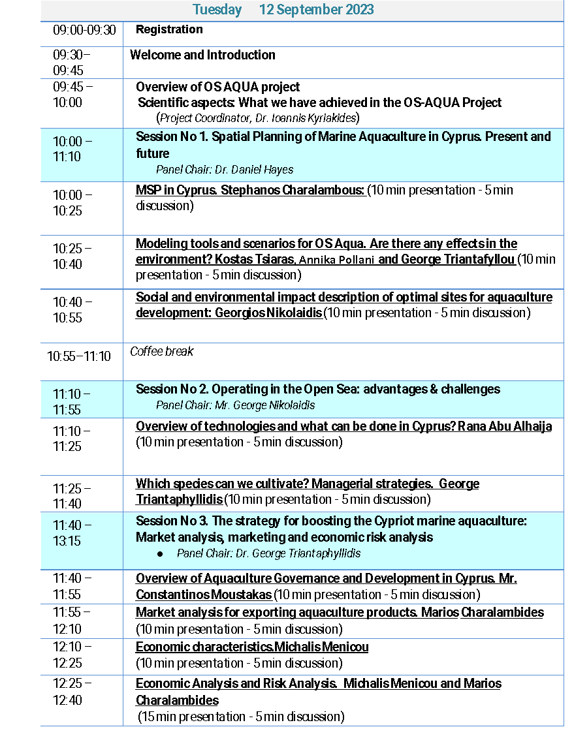

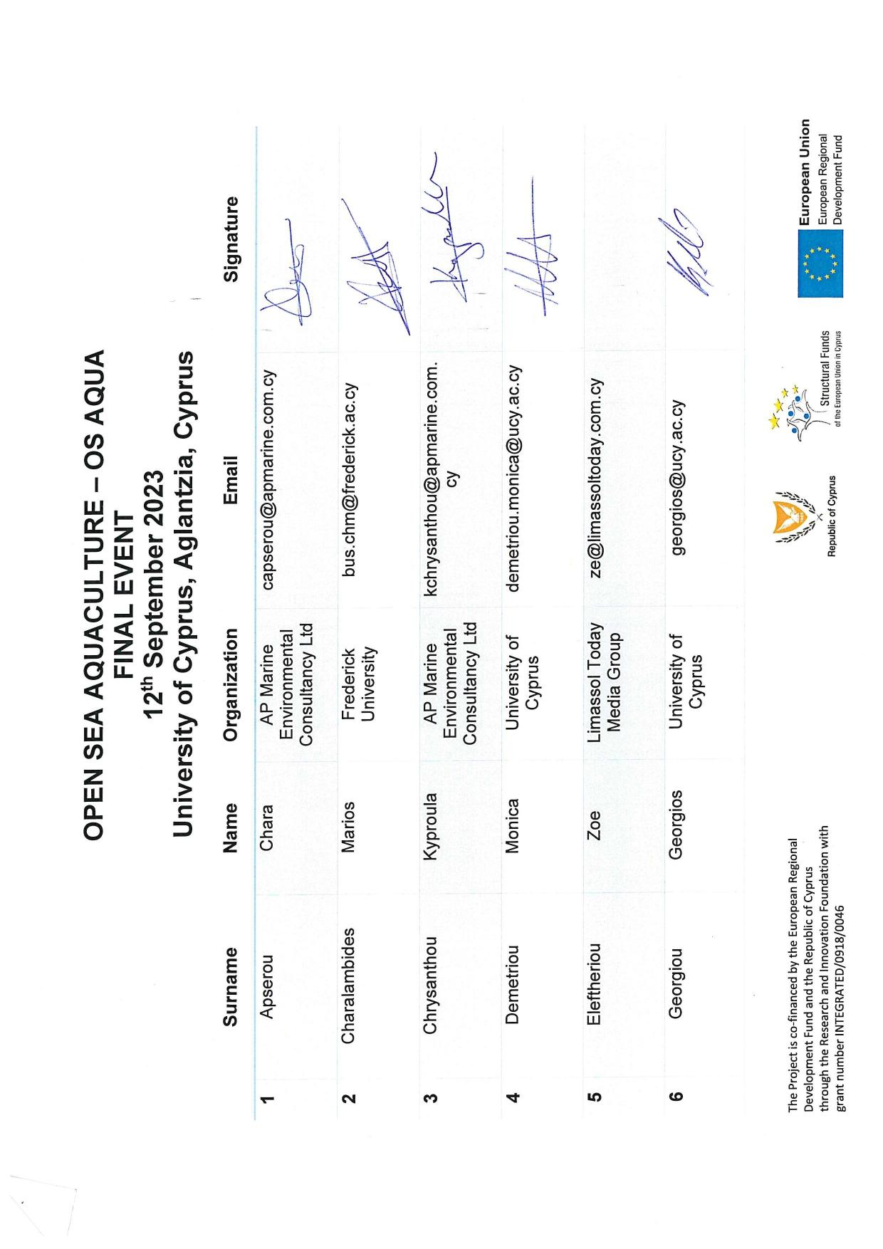
APPENDIX 2 – FINAL EVENT REGISTRATION SHEET
