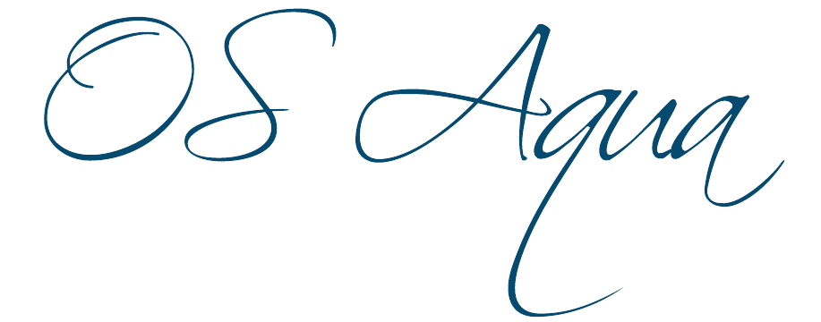
Open Sea Aquaculture
in the Eastern Mediterranean

The Project is co-financed with 800 K Euro by the European Regional Development Fund and the Republic of Cyprus through the Research and Innovation Foundation with grant number INTEGRATED/0918/0046

Work Package ID: WP4

Work Package Title: Spatial Planning of Marine Aquaculture

Deliverable ID: D15

Deliverable Title: Proposal for Allocated Zones

Dissemination Level: Public

Partner Leader: Geomatic

Disclaimer
Use of any knowledge, information or data contained in this document shall be at the user's sole risk. Neither the OS Aqua Consortium nor any of its members, their officers, employees or agents accept shall be liable or responsible, in negligence or otherwise, for any loss, damage or expense whatever sustained by any person as a result of the use, in any manner or form, of any knowledge, information or data contained in this document, or due to any inaccuracy, omission or error therein contained.
The OS Aqua project (INTEGRATED/0918/0046) has been partially funded under the RESTART 2016-2020 Programme, Integrated Projects Call, of the Cyprus Research and Innovation Foundation. This publication reflects the views only of the authors, and the Funding Agency cannot be held liable or responsible for any use which may be made of the information contained herein or of any consequences thereof.
Copyright notice
© Copyright 2020-2024, The OS Aqua Consortium
This document contains information that is protected by copyright. All Rights Reserved. No part of this work covered by copyright hereon may be reproduced or used in any form or by any means without the permission of the copyright holders.

Executive Summary
OS Aqua project is a dynamic project that takes into account any related information feed that becomes available and utilizes the information to contribute to the determination of open sea aquaculture zones in Cyprus.
The outcomes of the OS Aqua project, including the results of the Marine Spatial Study (MSP) (see D13. Identification of AZAs and AMAs and estimation of their carrying capacity), i.e. the candidate areas identified as suitable for the establishment of open sea Allocated Zones for Aquaculture (AZAs), were communicated to the authorities responsible for the Maritime Spatial Planning of the Republic of Cyprus, in the framework of the public consultation from March 31st 2022 to May 31st 2022.
The results of this public consultation and the final outcome of the Maritime Spatial Planning of the Republic of Cyprus, as far as the areas allocated for aquaculture are concerned, were taken under consideration in the final evaluation and determination of the proposed allocated zones by OS Aqua.
For the final round of selection, the opinions of society were also taken into consideration. Members of the consortium visited the Ayia Napa Marina, Ayia Napa municipality, and the Federation of Environmental organizations.
The proposed allocated zones by OS Aqua, from the most preferable to the least one, are 1) Governor’s Beach, 2) Larnaka (Faros), 3) Xylofagou West and 4) Pafos (Avdimou & Aphrodite Hills).

Contents
1 Introduction 5
2 Evaluation of Selected AZAs 7
2.1 Department of Fisheries and Marine Research (DFMR) Comments 7
2.2 Stakeholders & Society Opinions 8
2.3 The Draft Maritime Spatial Plan of the Republic of Cyprus 9
2.3.1 General 9
2.3.2 Maritime Spatial Plan and OS Aqua 10
3 Final Proposed Allocated Zones for Aquaculture 17
4 References 19

Introduction
The identification of justified zones for allocation of OS aquaculture zones requires first a Marine Spatial Planning Study (MSP) to identify areas in Cyprus waters as potential OS aquaculture zones. This was succeeded in Deliverable 13 (Identification of AZAs and AMAs and estimation of their carrying capacity), utilizing a GIS approach and by considering the prediction of the environmental impact effort while staying within the framework of national and European legislation and directives.
The MSP was conducted in Phases:
- Identification of the available areas suitable for OS Aquaculture by adopting exclusion criteria related to conflicts with other activities and high impact to the natural environment
- Proximity Criteria for AZAs designation
- Further investigation after taking into consideration the opinions of relevant Governmental Departments and Services, the involved partners and stakeholders
The outcome of the MSP was the selection of four candidate areas suitable for the establishment of Allocated Zones for Aquaculture (AZAs), based on an important number of techno-economic, environmental and proximity criteria, all described in spatial terms. The selected AZAs for further investigation and assessment are (Figure 1):
- Point 2 - Xylofagou West
- Point 3 - Larnaka
- Point 6 - Governor's Beach Center East
- Point 7 - Aphrodite Hills
As the project progressed to completion, candidate areas were in constant evaluation and alterations, aiming to provide solid solutions for OS Aquaculture Zone Areas.
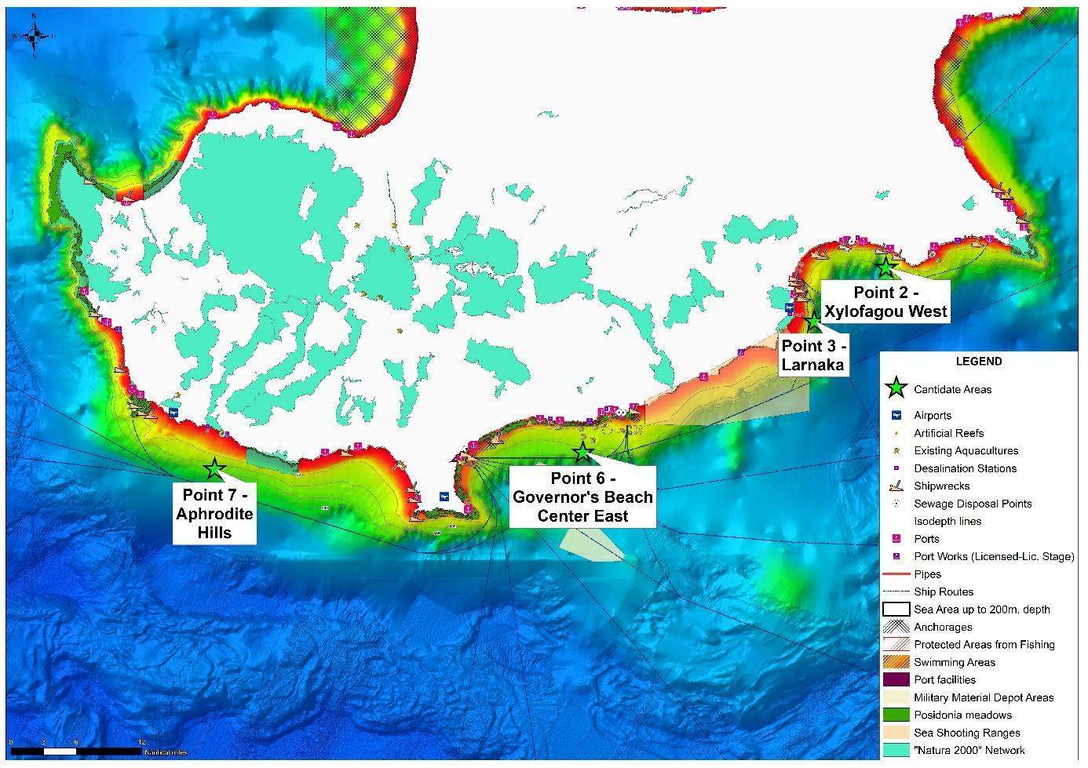
Figure 1. The four candidate areas for OS AZAs

Evaluation of Selected AZAs
The reasons why the four areas aforementioned were selected are:
- Point 2 - Xylofagou West was selected to explore and investigate a new area where an aquaculture zone could be allocated. It is not within the exclusion areas, has favorable weather conditions, the currents there are non-zero, which will help refresh water, and there are no major tourist attractions there, military or industrial activity. It is also very close to a fishing shelter (about 3 km) and to Potamos Liopetriou harbor, however, is needed to be evaluated if the fishing shelter can accommodate the needs of the proposed OS Aqua. An aquaculture unit also exists very close to Potamos Liopetriou harbor
- Point 3 – Larnaka Area was selected even though it was close to the boundaries of the exclusion area due to the proximity of the Larnaka International Airport. This area is generally considered very satisfactory both based on environmental and technical criteria that have been set. The main advantage of this zone is the presence of the port of Larnaka as well as the possibility of exploiting the existing infrastructure of the city of Larnaka. However, it should be noted that a basic condition for the development and proper operation of this aquaculture zone is the existence of suitable facilities within the port of Larnaka.
- Point 6 - Governor’s Beach, is situated near numerous existing nearshore farms, and there are adequate land-based facilities, including the construction of the new aquaculture port facility to accommodate the relevant needs for OS aquaculture.
- Point 7 – Aphrodite Hills was selected for research purposes.

Department of Fisheries and Marine Research (DFMR) Comments
The DFMR comments on these four areas, as mentioned in D13, were:

CANDIDATE AZA | PRIORITY  (High, Medium, Low) | DFMR COMMENTS
Point 2- Xylofagou West | VERY LOW / NO | There are no available appropriate infrastructures to accommodate the needs of aquaculture Activity.  The existing fishing shelter cannot be used for this purpose
Point 3- Larnaka | HIGH (Under Conditionality) | This is only an option if the Port Authorities will provide an appropriate area / space within Larnaka Port to accommodate the supporting needs of this activity.
Point 6 - Governor's Beach (Center East selected) | HIGH | The construction of the new aquaculture port facility is ideal to accommodate the relevant needs in this area  *All Governor’s Beach area is of High Priority for the same reasons
Point 7 - Aphrodite Hills | VERY LOW / NO | In general, all the sites west of Limassol are very exposed to the weather and are of much higher risk for damages due to wave action. Also in the area there in no appropriate fishing shelter to accommodate the needs of aquaculture.

Stakeholders & Society Opinions
For the final round of selection, the opinions of society were taken under consideration. Members of the consortium visited the Ayia Napa Marina, Ayia Napa municipality, and the Federation of Environmental organizations.

Ayia Napa Municipality (30/11/2022)
Ayia Napa municipality’s concerns focus on the tourism industry and the possible impacts that a nearby facility may have. Furthermore, during the preparation of the draft Maritime Spatial Plan of Cyprus carried out by the “THAL-CHOR 2” project (see more in 2.3) the two municipalities of Ayia Napa and Paralimni as well as other stakeholders and individuals of the area disagreed with the creation of specific aquaculture zone in Section V of the area of Liopetri-Xylofagou, due to the already burdened marine environment in the area but also the future tourism development as it affects the strategic objective of the municipality of Ayia Napa for future tourism development as well as urban planning development in the region.

Ayia Napa Marina (09/08/2022)
Agia Napa Marina raised similar concerns as Ayia Napa Municipality. To be more precise, there was hesitation in promoting aquaculture in Agia Napa Marina surroundings as there would be a negative visual impact on the Marina.

The Federation of Environmental Organizations (27/07/2022)
The Federation of Environmental Organizations is concerned more about the monitoring of the area and not to include areas that are already heavily loaded and areas that belong to the Natura2000 network or other Marine Protected areas. Some general comments/concerns of the federation are noted below:
- OS Aqua must have in mind for Marine protected areas that are now in the process of creation.
- The Marine Protected areas of Natura 2000 Network are not satisfactory. Coverage needs to go to 30% from 8-10%. EU also is asking for a protected area from 0 to 60 meters depth
- Bird protection areas and Birds migration paths needs to be kept in mind when an aquaculture facility is to be constructed
- Additionally, seals have to be also protected, thus the effect that an aquaculture facility might have on the paths they follow in the sea or in the places they give birth needs to be examined
- Faros Area, an area in Pervolia, Larnaka, where AZA “Point 3 – Larnaka” is located, is considered a sensitive area, thus a solid environmental study is required before an aquaculture facility is constructed within this AZA
- In this area, Pervolia municipality objected on the creation of an AZA due to the negative visual impact.
- Governor’s Beach, and in general Moni area, is a recommended area, that will benefit by future harbor facilities creation for aquaculture
- Xylofagou is an acceptable area for AZA. In the SBA area, already an aquaculture facility exists. In addition, the environmental impact due to aquaculture is considered small. It is noted that in this area, there is a nest of rest for seals (not reproduction)
As a result of the above meetings the ranking of the four selected areas is:
- Point 6 - Governor’s Beach
- Point 2 - Xylofagou West
- Point 3 - Larnaka Area
- Point 7 – Aphrodite Hills

The Draft Maritime Spatial Plan of the Republic of Cyprus

General
The preparation of the draft Maritime Spatial Plan was carried out through the strategic project "Cross-border Cooperation for the Implementation of Maritime Spatial Planning" with acronym “THAL-CHOR 2”, under the framework of the Interreg V-A Cooperation Program "Greece-Cyprus 2014-2020" and is co-funded by the European Regional Development Fund (ERDF) and national funds of Cyprus and Greece.
The Maritime Spatial Plan determines the spatial and temporal distribution of relevant current and future activities and uses in the marine waters of the Republic. The aim of the Plan is to contribute to supporting and promoting sustainable development at sea, applying an ecosystem approach and taking into account economic, social, environmental and cultural aspects, as well as promoting the coexistence of related activities and uses. Through the Maritime Spatial Plan, the Republic aims to contribute to the sustainable development of the energy sector at sea, maritime transport, fishing and aquaculture, tourism and the extraction of raw materials, as well as the protection of marine antiquities and the protection, preservation and improvement of the environment, including resilience to the effects of climate change
(https://www.dms.gov.cy/dms/shipping.nsf/All/FCD4E14C14CC2F05C22588BF001F29AA?OpenDocument&highlight=msp)
The draft of the Maritime Spatial Plan takes into account the main priorities, goals and strategic guidelines for the marine waters of the Republic, as defined in the Policy Statement on MSP (Policy Statement on MSP.pdf).

Maritime Spatial Plan and OS Aqua
OS–AQUA participated in the Public Consultation for the MSP by providing information and knowledge gained for OS Aquaculture Zones allocation as well as the outcomes in terms of MSP.
Specifically, OS Aqua communicated on the 30/05/2022 to the related authorities a document in Greek with title “Συμβολή του Έργου «Υδατοκαλλιέργεια Ανοιχτής Θάλασσας στην Ανατολική Μεσόγειο» (OS Aqua - INTEGRATED/0918/0046) στη δημόσια διαβούλευση για το Θαλάσσιο Χωροταξικό Σχεδιασμό της Κυπριακής Δημοκρατίας”, providing information about OS Aqua project, the knowledge gained for OS Aquaculture Zones allocation as well as the outcomes in terms of MSP, emphasizing on the justification for the selection of the four areas for AZAs.
In this way, OS Aqua aimed to contribute to Maritime Spatial Planning, as the inclusion of the Open Sea Aquaculture Organized Development Areas that have been identified/recognized within the framework of the OS Aqua project in the Maritime Spatial Planning of the Republic of Cyprus,
- will contribute decisively and strategically to the strengthening of Cyprus's position in European Fish Farming as well as in the exploitation of proximity to Eastern Mediterranean markets,
- will increase production and jobs,
- boost the export character of fish farming products and
- attract new investment.
Furthermore, the socio-economic benefits and by ensuring social acceptance and environmental sustainability, Cyprus can become an important pole of research and development in technologies, facilities and automation and monitoring systems for Open Sea Aquaculture, attracting scientists and highly qualified personnel to the region, contributing even more in strengthening its scientific and technological status
For this document, maps were prepared in which the OS Aqua selected areas were placed on top of the Maritime Spatial Plan areas aiming to compare the OS Aquaculture Zones with the Cyprus MSP areas intersected (Figure 2. – 5.)
As can be seen from the maps:
- Point 6 - Governor’s Beach, is aligned with the Aquaculture Zone proposed by the Cyprus MSP.
- Point 2 - Xylofagou West have no conflicts with other activities
- Point 3 - Larnaka Area has no conflicts with other activities but the broader area is a bit crowded
- Point 7 – Aphrodite Hills has a conflict with a recent Natura 2000 Marine Protected Area.
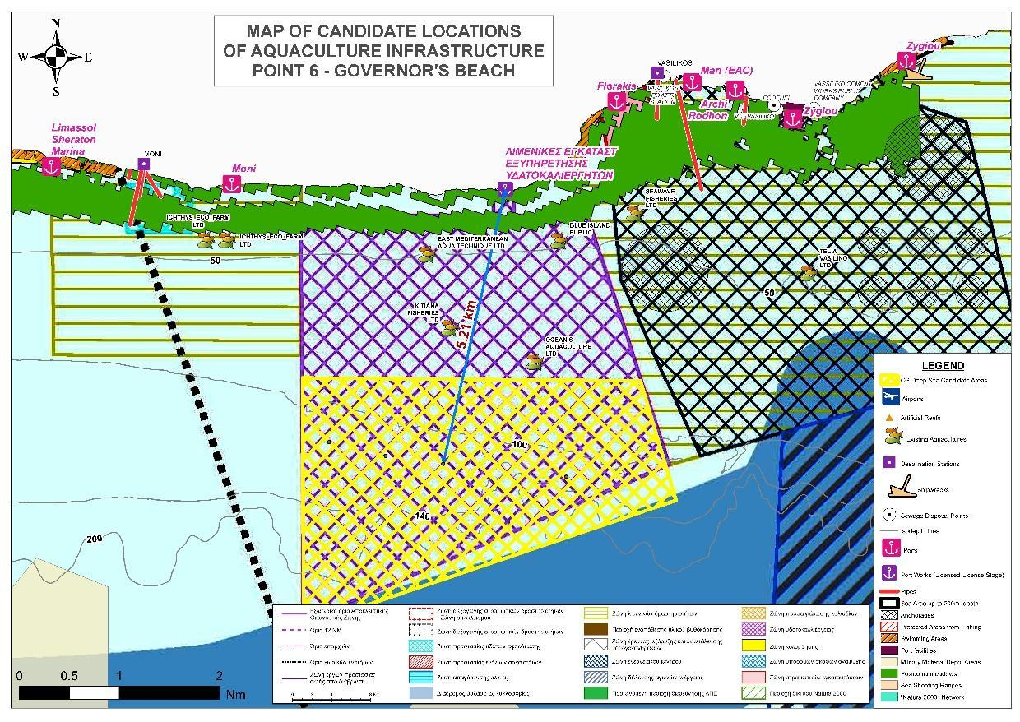
Figure 2.
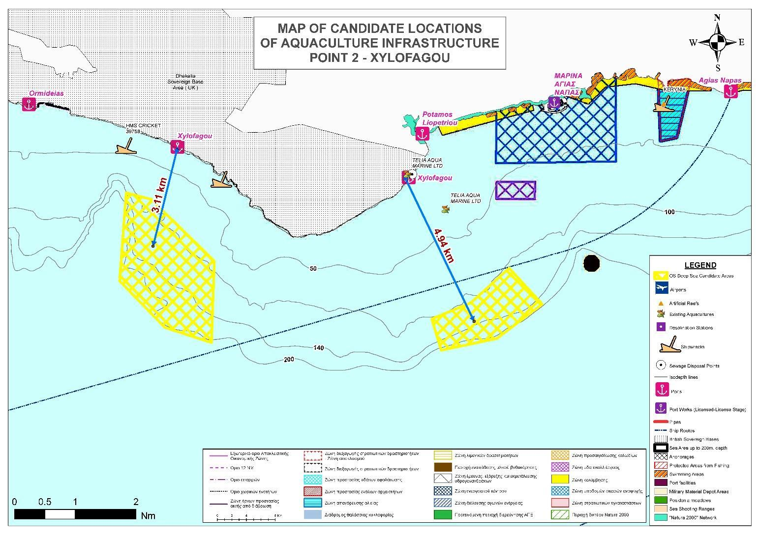
Figure 3.
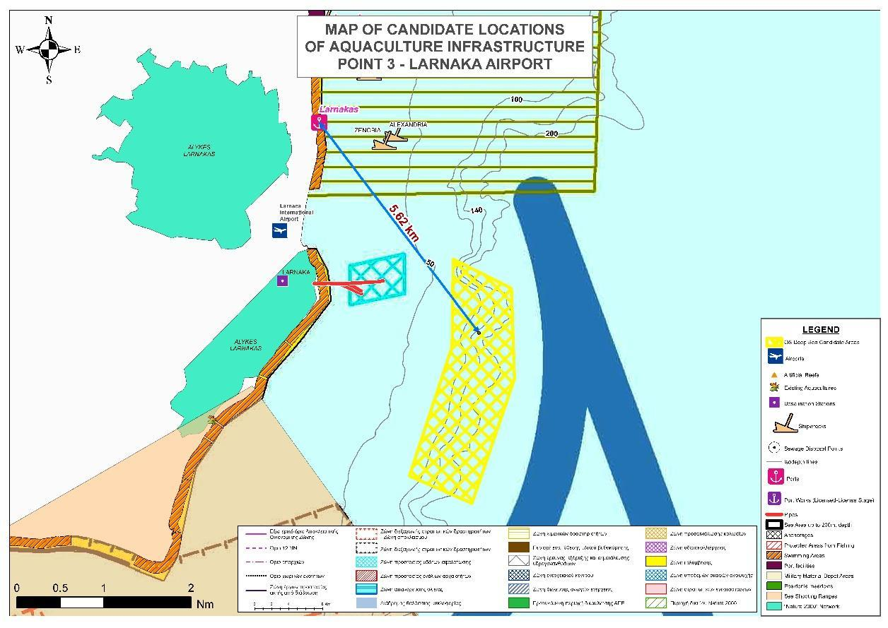
Figure 4.
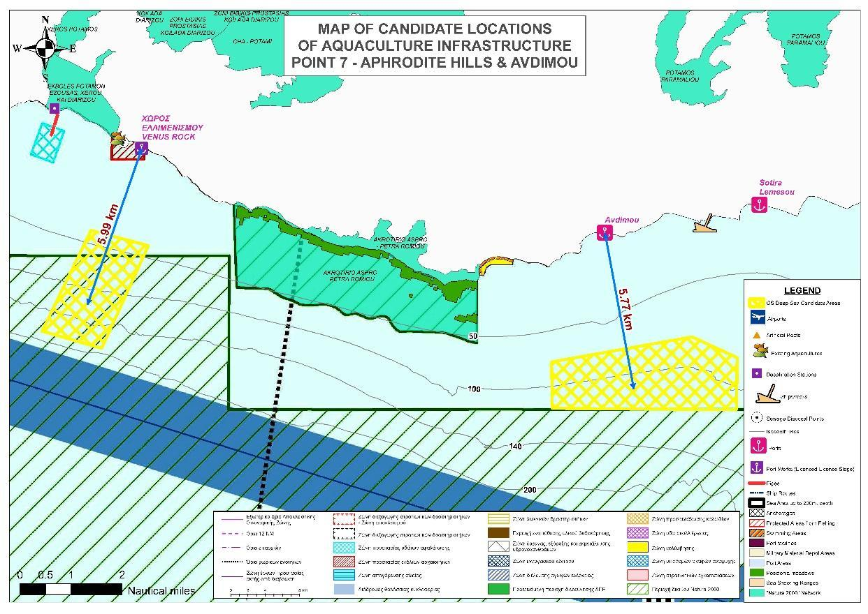
Figure 5.
The Summary table of all the opinions of stakeholders and individuals recorded during the public consultation for the MSP as well as the response of the authorized committee can be found at the website of the Deputy Ministry of Shipping, at this link
The specific response of the Republic of Cyprus to OS–AQUA opinions is displayed in Greek in the following Figure 6.

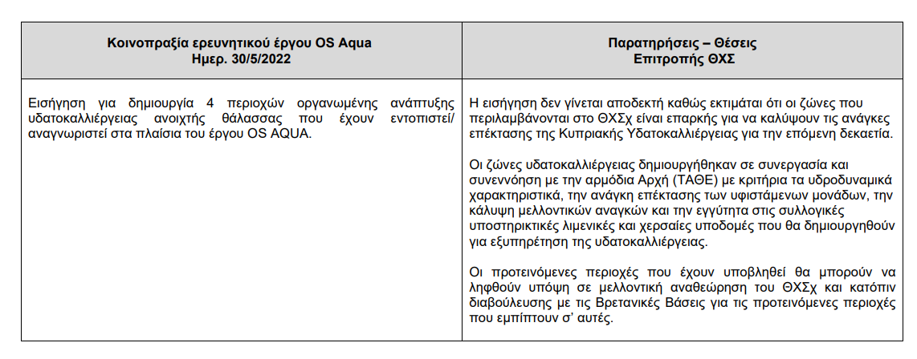
Figure 6. The response of the MSP’s authorized committee to OS Aqua opinions

Interpretation of the committee response to OS Aqua suggested aquaculture zones:
- The committee says that the four suggested zones are not accepted as it is estimated that the aquaculture zones which are included in the MSP are sufficient to cover the needs for the expansion of Cypriot Aquaculture for the next decade. We must note that the suggested zone of Governor’s Beach lies within the boundaries of the maritime area allocated for aquaculture according to the MSP, thus, the committee clearly refers to the other three suggested zones
- However, there is a positive side as well, as the committee comments that the proposed areas that have been submitted will be able to be taken into consideration in a future revision of the MSP. In that context, it would be crucial that open sea aquaculture zones could be included in a future revision of the MSP.

Final Proposed Allocated Zones for Aquaculture
The final proposed allocated zones for OS aquaculture, from highest to lower priority are:
As a result of the above meetings the final ranking of the four selected areas is:
- Point 6 - Governor’s Beach
The area of Governor’s Beach, i.e. the area between Moni-Governor’s Beach and Zygi, was proposed as a very promising location with logistical, economic and environmental advantages. This is the most prevalent location among the rest examined. It is noted that there is already planning for the creation of port infrastructure to serve the area's aquaculture. Even though the area has a substantial number of aquaculture facilities, an OS Aquaculture unit has no conflict with them, and any environmental impact will not be accumulated to the existing environmental status.
An OS Aquaculture unit in the area can be installed and accessed easily since the development depth (at the 80 m isobath) is relatively close to the coast (5 km). After discussions with experts such as DFMR and local aquaculture stakeholders and considering the combination of these advantages and the lack of any current disadvantages, the Governor's Beach area was selected for further study through field sampling. In general, this area could be extended to the south up to the limit of 200m with a corresponding displacement of the shipping line.
- Point 2 - Xylofagou West
The Xylofagou West Area was selected for investigation of a new area where an OS aquaculture zone could be allocated. It is not within exclusion zones, has favorable weather conditions, currents are sufficient for water renewal, and there are no major tourist attractions, military or industrial activity. It is also very close to the Xylofagou fishing shelter (about 3 km.) and to the fishing shelter of Potamos Liopetriou. Although at the moment, there is no space available in the Xylofagou fishing reserve, a possible future expansion could also provide for the coverage of the specific needs. Lastly, the potential use of the Ormidia fishing shelter could be considered and evaluated.
- Point 3 - Larnaka Area
The area of Larnaca was chosen even though it was close to the borders of the exclusion zone, due to its proximity to Larnaca International Airport. The area is generally considered very satisfactory based on both the environmental and technical criteria that have been set. The main advantage of this zone is the presence of the Larnaca fishing shelter as well as the possibility of exploiting the existing infrastructure of the city of Larnaca. Although there is currently no space available, a possible future expansion could also provide for meeting specific needs
On the other hand, caution must be taken regarding future Marine Protected Areas, how much the migratory birds could be affected and the concerns of the affected municipality of Pervolia-Meneou must be addressed.
- Point 7 – Avdimou. As Aphrodite Hills AZA has a conflict with a Marine Protected Area, Avdimou AZA can be selected for research purposes.
In general, all locations west of Limassol are very exposed to the weather and are at a much higher risk of damage due to wave action. Also, in the area there is no suitable fishing shelter to meet the needs of aquaculture. However, the area was selected for further study as there is no conflict with other users of the marine space and modern methods make aquaculture in exposed areas possible. Also, the increased demand for marine space from tourism, shipping and other sectors, makes the expansion, or transfer, of aquaculture units west of the island a possible future scenario. Despite the fact that there is no existing port infrastructure, the adjacent land area has mostly agricultural use so there is potential for port infrastructure to be created in the future.

References
Pavlogeorgatos G., Aliouris K., Ioannou N., Hadjimitsis D. 2023. Θαλάσσιος Χωροταξικός Σχεδιασμός στην Ελλάδα και την Κύπρο (https://www.propobos.gr/wp-content/uploads/2023/02/Thalassios_xwrotaxikos_sxediasmos_DIGITAL.pdf)
OS Aqua, 2022, Συμβολή του Έργου «Υδατοκαλλιέργεια Ανοιχτής Θάλασσας στην Ανατολική Μεσόγειο» (OS Aqua - INTEGRATED/0918/0046) στη δημόσια διαβούλευση για το Θαλάσσιο Χωροταξικό Σχεδιασμό της Κυπριακής Δημοκρατίας

