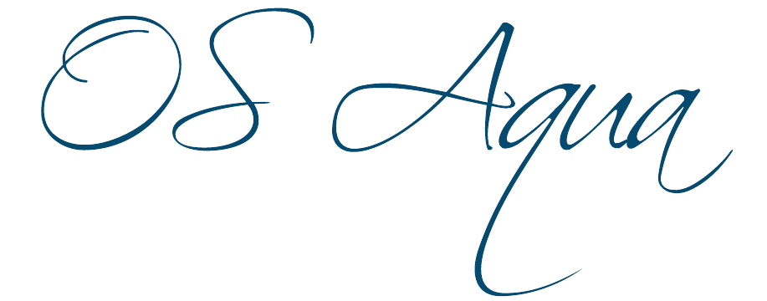
Open Sea Aquaculture
in the Eastern Mediterranean

The Project is co-financed with 800 K Euro by the European Regional Development Fund and the Republic of Cyprus through the Research and Innovation Foundation with grant number INTEGRATED/0918/0046

Work Package ID: WP7

Work Package Title: Financial and Legal Frameworks

Deliverable ID: D24

Deliverable Title: Operations/ mooring scenarios economic characteristics

Status: Final

Dissemination Level: Public

Partner Leader: FRC

Disclaimer
Use of any knowledge, information or data contained in this document shall be at the user's sole risk. Neither the OS Aqua Consortium nor any of its members, their officers, employees or agents accept shall be liable or responsible, in negligence or otherwise, for any loss, damage or expense whatever sustained by any person as a result of the use, in any manner or form, of any knowledge, information or data contained in this document, or due to any inaccuracy, omission or error therein contained.
The OS Aqua project (INTEGRATED/0918/0046) has been partially funded under the RESTART 2016-2020 Programme, Integrated Projects Call, of the Cyprus Research and Innovation Foundation. This publication reflects the views only of the authors, and the Funding Agency cannot be held liable or responsible for any use which may be made of the information contained herein or of any consequences thereof.
Copyright notice
© Copyright 2020-2024, The OS Aqua Consortium
This document contains information that is protected by copyright. All Rights Reserved. No part of this work covered by copyright hereon may be reproduced or used in any form or by any means without the permission of the copyright holders.

Executive Summary
Deliverable 24 (D24), “Operations / Mooring Scenarios Economic Characteristics”, reflects the outcome of Task 7.2, “Mooring Scenarios & operations description”. This deliverable will identify and clarify economic issues relating to mooring requirements and aquaculture operations. This piece of work is governed by multiple preceding deliverables, reports and interviews, such as:
- Deliverable 15: Proposal for allocated zones for open sea (offshore) aquaculture;
- Deliverable 18: Summary of current market for open sea aquaculture subsystems and analysis of best value for money;
- Deliverable 21: Provide best practice guidelines for environmental monitoring of offshore aquaculture;
- Deliverable 23: Targeted finfish economic characteristics;
- Deliverable 26: Legal/ regulatory framework and existing financial incentives;
- AMBIO SA report on Market Research on Fish Feed and Aquaculture Equipment;
- Interview with KIMAGRO fisheries’ financial controller and
- Interview with the Department for Fisheries and Marine Research (DFMR) aquaculture chief officer.
In order to fulfil the requirements of Task 7.2 on "Mooring Scenarios & operations description," the work in this deliverable has been organized as follows:
a) A brief overview of aquaculture operations is given;
b) The process for obtaining Licenses, Permits and Approvals in Cyprus is presented;
c) The equipment and infrastructure needs for offshore operations are detailed;
d) The equipment and infrastructure needs for onshore operations are explained;
e) The anticipated operational expenses are provided;
f) Based on the above, predominant business case scenarios are described and
g) Details of the expected funding for investments in coastal aquaculture and other budgetary considerations are included.

The outcomes of this report will be a major contributor to the risk analysis (D27) and the economic analysis and business plan (D28).

Contents
1 Introduction 6
2 Brief overview of aquaculture operations 8
3 Licenses, Permits and Approvals 9
4 Sea Operations 11
4.1 Selected Cage, Net and Mooring technologies 11
4.1.1 Cyprus Prototype Design 11
4.1.2 InnovaSea 12
4.1.3 Conventional design 12
4.2 Fish Feed 20
4.3 Feeding Systems 25
4.4 Boats/ vessels/ platforms 26
4.5 Cranes/ Lifting mechanisms 27
4.6 Automation in Open Sea Aquaculture 29
5 On-Shore Operations 30
5.1 Packaging Plant Equipment 30
5.2 Distribution 32
6 Operational Expenses (OpEx) 33
6.1 Personnel needs / 2,000 tons annual production. 33
6.2 Certification 33
6.3 Environmental Monitoring 33
6.4 Utilities, Fuel and other consumables Costs 34
6.5 Fish Feed, Fingerlings and Total Operational Costs 34
6.6 Annual maintenance of Capital Expenditure infrastructure 35
6.7 Marketing Expenses 35
7 Business cases scenarios 36
7.1 Admissions for scenario 36
7.2 Capital Expenditure (Equipment Cost) 37
7.3 Operational Expenditure 39
8 Funding mechanisms and budgetary considerations 40
9 Conclusions 41
10 References 42

List of Figures

Figure 1: A brief overview of the aquaculture operations. 8
Figure 2: The procedure to obtain an aquaculture license in Cyprus. 10
Figure 3: A typical mooring system (Source: FAO-Aquaculture operations in floating HDPE cage). 17
Figure 4: Main parts of an anchoring system (FAO-Aquaculture operations in floating HDPE cage). 18
Figure 5: Estimated annual fish feed consumption (kg) -x axis, by fish feed size (mm)-y axis, for a production of 3.200 tons in a fish farm with a ratio of 60% sea bream - 40% sea bass, 400 gr harvesting and an average of 3 gr imported fry size (Source: AMBIO S.A. analysis). 23
Figure 6: Estimated average fish feed sale price per year (2022-AMBIO S.A. estimation based on 2022 fish feed cost data, 2008-2016 ICAP GROUPA.E – Market Estimates. 25
Figure 7: Installed feeding barge system ((Source: AMBIO S.A.). 25
Figure 8: Visual presentation of basic packaging line (Ambio 2022, Thema Automation SA). 29

List of Tables
Table 1: Estimated structure/mooring/net cost of 3000 tons plant with AP Marine Design….11
Table 2: Estimated structure/mooring/net cost of 3200 tonne plant with InnovaSea SeaStation Technology. 12
Table 3: Main cages indicative prices (2022 data), Unit Price (VAT is not included). 13
Table 4: Basic net-type indicative cost. 15
Table 5: Cost of auxiliary nets equipment (2022 data, Source: ΑΜΒΙΟ personal contact with net producers in Greece, *Unit Price (VAT is not included)). 15
Table 6: Main mooring equipment indicative cost (2021 data, Vat is not included in price). 19
Table 7: Estimated cage, net and mooring cost for a 3.000tn growing unit using the conventional design. 20
Table 8: Typical feed formulation in relation to its size for sea bream (Source: ΒΙΟΜAR S.A (2011) fish feeding guide. Typical fish feed formulation per size). 21
Table 9: Indicative cost per feed type and feed size (€/kg)-2022 data. [6] 23
Table 10: Indicative cost for Feeding systems (2021 data, Vat is not included in price). 26
Table 11: Indicative cost of floating equipment used in aquaculture. 27
Table 12: Indicative cost of lifting equipment. 28
Table 13: Packing plant equipment indicative cost. 30
Table 14. Annual Personnel Costs for 2,000 tons production capacity 32
Table 15: Business Scenarios 35
Table 16: Estimated equipment cost for a 2250/3.000/5.000 tonne on a growing unit with packing plant. 36
Table 17: Estimated equipment cost for a 3.000/5.000 tn on a growing unit with packing plant according to prices analyzed above. 37
Table 18. Annual Operational Expenses for varying production capacities 38

Introduction
Deliverable 24 describes the economic characteristics of aquaculture companies’ operations and alternative mooring scenarios. In detail, it addresses the work described in Task 7.2. Mooring Scenarios and operations description. As described in this task, expanding aquaculture activities in Cyprus will probably occur even further from the coast. This fact will bring new aquaculture companies additional costs compared to existing ones operating in shallower waters.

The outcomes of the preceding work govern this deliverable, this being:
- Work Package 4: Spatial Planning of Marine Aquaculture, particularly DE15: Proposal for allocated zones for open sea (offshore) aquaculture. This deliverable identified potential new zones for new aquaculture units and respective operating depths [1].
- Work Package 5: Design of offshore marine aquaculture station, particularly DE18: Summary of the current market for open sea aquaculture subsystems and analysis of best value for money. This work identified and described technologies for open sea aquaculture coupled with their expected cost [2].
- Work Package 6: Ongoing monitoring of offshore mariculture stations, particularly DE21: Provide best practice guidelines for environmental monitoring of offshore aquaculture. This deliverable described best practices for environmental monitoring of offshore aquaculture and automations [3].
- Work Package 7: Financial and Legal Frameworks, and in particular, DE26: Legal/ regulatory framework and existing financial incentives. This work identified the regulatory framework for environmental monitoring and described the bidding process for a license to use the marine space [4]. In addition, it described passed funding programs for aquaculture companies.
- Work Package 7: Financial and Legal Frameworks, and in particular DE23: Targeted finfish economic characteristics. This work identified the economic characteristics, such as fish feed required per kg, fingerling cost required per kg, and theoretical total operational cost required per kg [5], for the promising finfish species selected.
- AMBIO S.A. report on Market Research on Fish Feed and Aquaculture Equipment [6]; and

Based on the above, and according to Task 7.2 requirements, this report:
- Identifies economic issues relating to mooring requirements (parts’ costs, cost of deployment, cost of decommissioning, maintenance costs).
- Reports operating costs (boats, fuel, warehouse needed, fish packaging, HCCP) and personnel costs.
- Builds upon WP5 where the economics of prevailing mooring scenarios are described.
- Draws upon the AMBIO SA report on Market research on fish-feed and aquaculture equipment where potential providers, purchasing costs, deployment costs, dismantling costs at project end, and maintenance costs are discussed.
Building on the previous work, this deliverable aims to develop comprehensive business cases that incorporate the selected Open Sea technologies. These business cases will take into account the available funding options and assess the budgetary impacts of each funding mechanism. Each business case will include the activities involved, decision points, review processes, required resources (both internal and external), and specific skills. It will also include the acquisition of sites, procurement of equipment and materials, consultation with stakeholders, planning approval processes, tender process timetables, and securing committed funding/finance

To address the requirements of the work described above, this deliverable is organized as follows:

- A brief overview of aquaculture operations is given;
- The process for obtaining Licenses, Permits and Approvals in Cyprus is presented;
- The equipment and infrastructure needs for offshore operations are detailed;
- The equipment and infrastructure needs for onshore operations are explained;
- The anticipated operational expenses are provided;
- Based on the above, predominant business case scenarios are described, and
- Details of the expected funding for investments in coastal aquaculture and other budgetary considerations are included.

Work completed on this deliverable contributes to the following:
- Deliverable 28 Economic Analysis and Business Plan, where critical economic parameters and business scenarios are used in economic analysis; and
- Deliverable 27 Risk Analysis, where sensitivity analysis and stochastic analysis are conducted in critical economic parameters.

Brief overview of aquaculture operations
Aquaculture operations can be divided in three main categories: Sea operations, packaging and distribution and others, [6]. Sea operations include placement and maintenance of cages, mooring systems and nets. In addition, they include placement of fingerlings, fish feed as well as feeding and harvesting processes and monitoring activities. Packaging and distribution operations, on the other hand, take place on shore, usually at the packaging facility of the farm, from where distribution vehicles deliver the harvested fish to customers. In the absence of a self-owned packaging facility, aquaculture farms can seek to outsource this process to the private sector. Lastly, personnel needs, proper certification processes and environmental monitoring should also be taken into account. This information is also described in Figure 1.

Sea Operations

Cages, Nets

Mooring systems

Monitoring / Automation

Feed and Feeding Systems

Harvesting

Packaging & Distribution

Packaging

Distribution

Other

Personnel

Certification

Environmental Monitoring

Figure 1: A brief overview of the aquaculture operations.
The following section provides an overview of the process that needs to be followed to get a license for an aquaculture farm in Cyprus and a detailed description of the characteristics of the main aquaculture operations.

Licenses, Permits and Approvals
The following information was obtained from the Interview of KIMAGRO fisheries’ financial controller that took place on the 23/ 02/ 2022 and the Interview with Mr. Vassilis Papadopoulos, officer for Aquaculture at Department for Fisheries and Marine Research (DFMR), Ministry of Agriculture, Cyprus that took place on the 19/ 10/2022. There are several requirements and activities that need to be undertaken during the process to set up and run a conventional marine aquaculture company in Cyprus. First, permission is needed to be granted by the Council of Ministers to the successful tenderer after a bidding contest, as foreseen in the provisions of the relevant public sector Tender Legislation. As part of this process, the Director of DFMR announces a public bidding procedure in which it states the intention of the Republic of Cyprus to lease a marine area for aquaculture purposes, as well as other relevant information such as the approximate location / marine area of the farm (the precise location will be determined by the Environmental Impact Assessment Study), the production capacity, the species that may be cultivated, etc. Then, upon completion of the tender process, the successful tenderer (legal or natural person) must obtain the following required permits and approvals:

- Environmental Approval by the Department of the Environment.
- Permit for the use of marine space from the Council of Ministers (the proposal is prepared and submitted to the Council by the Minister of Agriculture, Rural Development and the Environment).
- License for the Establishment and Operation of a Fish Farm by DFMR.
- Veterinary License for the Production of Aquaculture Products by the Veterinary Services
Figure 2 offers a visual description of the process that needs to be followed in order to obtain a license to set up an aquaculture farm. According to an interview of Mr. Vasilis Papadopoulos, an officer at the Cyprus Department for Fisheries and Marine Research, an initial cost of 1 million euro is estimated to start such activity (1000 tonnes), and that is just the tender, licenses and approval costs. This cost is considerably high compared to relevant costs in main competitor countries [6].

Tender Process

Permits and Approvals

Establishment and Operation Lisence

Veterinary Production Licence

Environmental Permit
Permit for Marine Space Usage

Figure 2: The procedure to obtain an aquaculture license in Cyprus.

Sea Operations

Selected Cage, Net and Mooring technologies
The different types of aquaculture cages, nets and mooring technologies were presented and described in D18, and designed based on their purpose, e.g. location, operation, environment and so on. Briefly, we can categorize cages based on their material: whether they are open net cages or a closed containment tank system, rigid or flexible, floating, submerged, or submersible. The five main types include [2], p.7:
- Surface-oriented
- Anchor-tensioned
- Self-tensioned
- Semi-rigid submersible
- Barge-type
Based on the findings of D18 [2] and report [6], we have chosen three aquaculture technologies that will be considered for the scope of this deliverable:

- Cyprus Prototype Design
- InnovaSea Design (Submersible Cages) [2];
- Conventional design [6].

Next, we provide an evaluation of the economic aspects of each technology based on the information reported in Deliverables D18, [2] and the market research report on infrastructure conducted by AMBIO [6].

Cyprus Prototype Design
The target is to design a proposal for a rigid fish cage and the relevant mooring system. For comparison purposes, we have considered a farm of 3,000 tons capacity. For the particular design, fifteen (15) rigid structures will be needed together with the corresponding mooring systems and nets. The corresponding estimated cost for this plant, is presented in Table 1.

Table 1: Estimated structure/mooring/net cost of 3000 tons plant with AP Marine Design.
 | Units | Unit Price
Structures and mooring (150m) | 15 | €3,000,000
Nets  (200 tonnes capacity) | 15 | €45,000
Total Cost |  | €45,675,000

The cost of more than 45 million euros make the technology not economically feasible as the selling prices of Cypriot aquaculture products provided in Deliverable D23 cannot justify such an investment [5].

InnovaSea
InnovaSea is a company specializes in open sea aquaculture, providing end-to-end solutions. A brief description of their technology can be found at Deliverable D18 [2]. The leading solution that InnovaSea offers is the SeaStation. The cost of cages, mooring and nets for a 3,200 tons plant is summarized in Table 2, [2].

Table 2: Estimated structure/mooring/net cost of 3200-tonne plant with InnovaSea SeaStation Technology.
 | Units | SeaStation  80m depth | SeaStation  150m depth
2x8 grid with mooring system | 1 | $820,000
 | 1 |  | $1,056,000
Pens and nets  (200 tonnes per net) | 16 | $720,000 | $720,000
Total Cost |  | $12,340,000 | $12,576,000  (equivalent to €11,819,050)

The total cost of the InnovaSea SeaStation technology for a 3,200 tons aquaculture plant at a depth of 150 meters is estimated at €11,819,050. Although this cost is four times less than the prototype solution discussed earlier, it is still considerably high to be considered for a complete solution for Cypriot aquaculture farms.

Conventional design
What is referred to as Conventional Design is the technology currently used in coastal aquaculture farms. This technology has already been used successfully in depths up to 150 meters in Greece, and as a result, the technology is a significant candidate for the offshore Cyprus case. The aim is to give a detailed description of its main characteristics and apply suitable modifications in our model scenarios to use it in offshore aquaculture farms. As it will be shown, this solution has a considerably lower infrastructure cost, so a much more detailed analysis of its features will be presented.

Cages
High-density polyethylene (HDPE) pipes are widely used as the main material for the construction of floating cages [6]. High-density polyethylene is a class of plastic resins obtained by polymerizing ethylene gas. Pipes made of HDPE are widely available because they are commonly used for liquid and gas transfer (irrigation systems, gas pipelines, etc.). Moreover, HDPE pipes are an excellent material for cage construction because they are durable, flexible, shockproof, resistant to ultraviolet (UV) light, and require relatively little maintenance if installed correctly.
An aquaculture cage's price is first determined by its perimeter and then by specific characteristics:
- Pipe thickness (inner-outer).
- Number of brackets, [6].
- The installed pipe of a smaller diameter (C) in between the larger pipes, increases the cage’s structural strength.
Small square cages are not common anymore, and the two most widely used cage designs are P60-P120 or P60-P80. This practice lowers production costs and simplifies logistical budget management.
According to the information above, the basic models' cost per cage category depends on the cage's perimeter. Other than the basic model characteristics (additional brackets, intermediate pipe reinforcements) were not taken into consideration. Table 3, [6], illustrates the indicative cost per cage category as emerged from the data analysis.

Table 3: Main cages indicative prices (2022 data), Unit Price (VAT is not included).
CAGE PERIMETER (m) | PRICE  (€)/piece
60 | 7,500
80 | 10,500
120 | 15,950

Nets
Nets are essential to the aquaculture industry as they define the region in which the primary product of aquaculture develops. Net details must be designed according to the common structure of the main cage components (floating collar, stanchion/brackets, sinkers, sinker tube, etc.) to which the net will be fixed. Nets for circular floating cages generally consist of a vertical wall, mounted on a base net (the cage floor). The vertical area is further divided into a submerged part (more or less corresponding to the net depth) and a jump net, which is the portion of the wall out of the water from the waterline to the handrail.
A net cage is mainly made by assembling the netting with ropes and should be conceived as a rope frame structure containing the netting. All the weight of the cage should be borne by the ropes; while the netting only has to keep the fish confined inside it, and should have no structural functions. The robustness of the whole structure should be appropriate according to the site exposure. The ropes must be of an appropriate length, size, material, and type to meet the demands of the specific site.
As with the ropes, the netting attributes (as described above) must be chosen according to the site’s characteristics and the size and species of fish. In more exposed sites, a greater twine number (or breaking load) of the netting is required.
In this report [6], the indicative cost was calculated according to:
- Fiber type
- Cage size
- Νet size and net mesh size
As a result, we examine the nets that share all of the aforementioned characteristics.
Farms may develop net designs that are almost unique to the individual site. These specific designs are based on overall cage design, site characteristics, production plans, and the operator experience at that location. In this case, the evaluation is difficult.
Table 4 presents the price per net type, [6]. The indicative cost was determined by averaging the prices of nets with the same characteristics (size, mesh eye, net type, net length) produced by several suppliers. As shown, the cost of a given size net varies depending on the type of net used; for instance, Dyneema nets cost twice as much per kg as nylon nets. A detailed description of the two types of nets is provided in the report, [6].
Other incidental elements that raise the price of net production include:
1. Addition of antifouling
2. Protective net addition in parts of the net that get damaged (Bottom and surface)
3. Addition of ropes
4. The net twine type (eg 210/60)

Table 4: Basic net-type indicative cost.

MATERIAL | NET SIZE (perimeter) m | NET MESH  (mm) | LENGTH  (m) | PRICE  (€) | Comments
NYLON | P40 | 6 | 7+1 | 2,875 | 2020 prices
 |  | 9 | 10_1 | 3,220 | 2020 prices
 |  | 12 | 10+1 | 3,347 | 2020 prices
 | P60 | 6 | 7+1 | 4,485 | 2020 prices
 |  | 9 | 10+1 | 5,175 | 2020 prices
 |  | 12 | 10+1 | 5,635 | 2022 prices
 |  | 14 | 10+1 | 4,830 | 2022 prices
 |  | 16 | 10+1 | 4,945 | 2022 prices
 | P80 | 12 | 10+1 | 10,695 | 2022 prices
 |  | 14 | 10+1 | 9,200 | 2022 prices
 |  | 16 | 10+1 | 8,625 | 2022 prices
 | P120 | 14 | 10+1 | n/a | 2022 prices
 |  | 16 | 10+1 | 14,950 | 2022 prices
DYNEEMA | P40 | 9 | 10+1 | n/a
 |  | 12 | 10+1 | n/a
 |  | 14 | 10+1 | n/a
 |  | 16 | 10+1 | n/a
 | P60 | 9 | 10+1 | n/a
 |  | 12 | 10+1 | 14,835 | 2022 prices
 |  | 14 | 10+1 | 14,145 | 2022 prices
 |  | 16 | 10+1 | 13,455 | 2022 prices
 | P80 | 12 | 10+1 | 17,940 | 2022 prices
 |  | 14 | 10+1 | 17,595 | 2022 prices
 |  | 16 | 10+1 | 17,250 | 2022 prices
 | P120 | 14 | 10+1 | 31,050 | 2022 prices
 |  | 16 | 10+1 | 28,750 | 2022 prices
 |  | 20 | 15+1 | 24,150 | 2022 prices

The price of auxiliary equipment, presented in Table 5, which protects fish stock from predator attacks and maintains the farm's efficient operation, must be added to the cost of the nets, [6].

Table 5: Cost of auxiliary nets equipment (2022 data, Source: ΑΜΒΙΟ personal contact with net producers in Greece, *Unit Price (VAT is not included)).
DESCRIPTION | (INDICATIVE VALUE) (€)/PIECE*
Anti-predator nets P80 | 770
Anti-predator nets P60 | 432
Anti-predator nets P40 | 192
Anti-predator nets P120 | 1,100
Anti-predator P120 nets with beams | 1,800
Harvesting Net for p120 cage | 1,820
Health treatment bag ( for p120 cage) | 7,500
Health treatment bag (for p80 cage) | 4,500
Shading Net p120 (for pagrus) | 800
Shading Net p80 for Pagrus | 550

Although the cost appears to be much lower than the cost of net cages, this equipment presented in Table 5 is considered to be essential for running a fish farm effectively.

Mooring System
The design and installation of mooring systems for fish farms is a critical element for reliable and effective production systems. Based on a careful assessment of site conditions (depth, sediment type, wave exposure) and an evaluation of cage system characteristics and farm operating requirements, suitable mooring specifications can be developed. These mooring characteristics vary according to the specific needs of each farm. A typical mooring system is presented in Figure 3, [6].

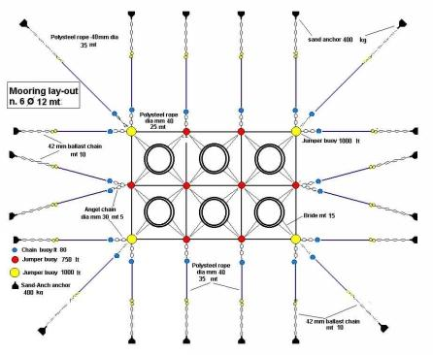
Figure 3: A typical mooring system (Source: FAO-Aquaculture operations in floating HDPE cage).

The main parts of an anchoring system, presented in Figure 4, [6] are the following:
- Anchor
- Shackle
- Anchor chain
- Anchor indication buoy
- Anchor-indication buoy connector
- Anchor rope
- Shackle
- Grid mooring wheel connector (quadrant)
- Shackle
- Mooring wheel
- Anchor buoy
- Rope or chain link to wheel
- Shackles
- Shackle or rope connection to mooring wheel
- Cage-mooring wheel rope connection

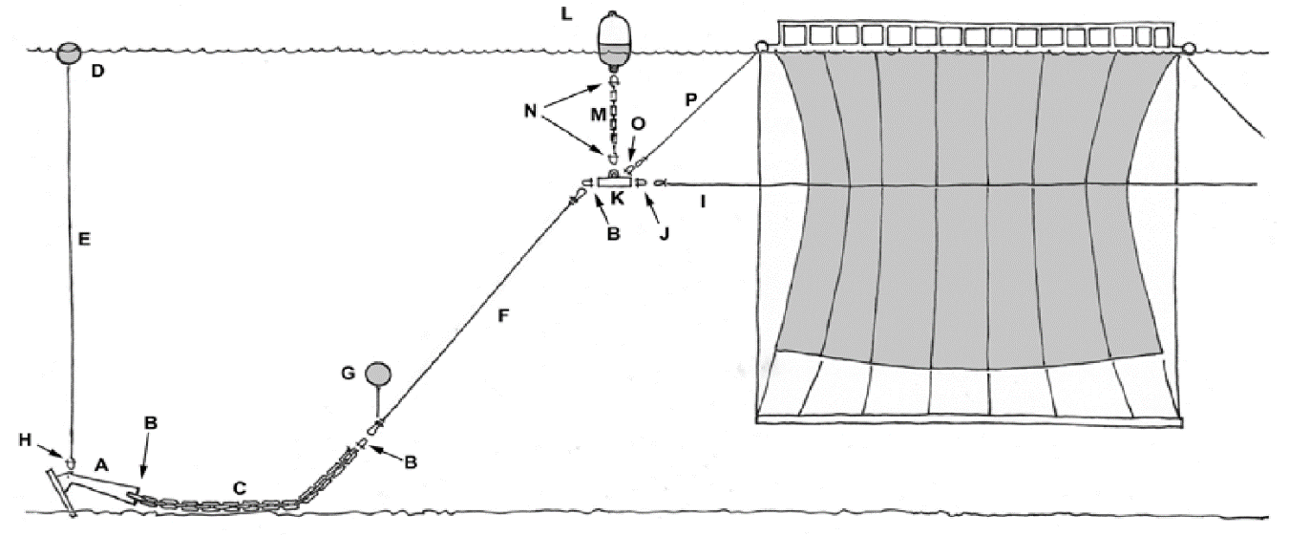
Figure 4: Main parts of an anchoring system (FAO-Aquaculture operations in floating HDPE cage).
The indicative cost for mooring supplies has been determined by category as shown in Table 6, [6].

Table 6: Main mooring equipment indicative cost (2021 data, Vat is not included in price).
Equipment | Unit | Price (€)/unit | Comments
Rope 14mm polypropylene | m | 1.8 | For weights that maintain the shape of the cage
Rope 28mm diameter polypropylene | m | 2 | Attaching a lighting buoy to a concrete block
Rope 32mm diameter polypropylene/ nylon | m | 2.5 | Attaching a cage to a wheel
Rope 36mm diameter polypropylene | m | 3.37 | Attaching a float to a wheel
Rope 38mm diameter polypropylene | m | 3.5 | For cage rid
Rope 40mm diameter polypropylene | m | 3.5 | For cage rid for mooring
Rope 42mm diameter polypropylene | m | 4 | For mooring (anchor connection to rope)
Chain 20mm | m | 28 | For mooring (anchor connection to rope)
Chain 28mm | m | 30
Chain 40mm | m | 58
Chain 48mm | m | 79 | For mooring (anchor connection to rope)
Buoys 500 tn | pcs | 230
Buoys 1000 lt | pcs | 330
Buoys 1300 tn | pcs | 470
Buoys 2000 lt | pcs | 1,100
Mooring wheels | pcs | 120
Anchor 250 kg | pcs | 320
Anchor 500 kg | pcs | 700
Anchor 1000 kg | pcs | 1,500
Anchor 1500 kg | pcs | 2,500
Concrete blocks 2tn-7tn | pcs | 100 | These are usually self-made constructions from concrete which is inserted into ready-made molds
Nautical Keys (shackles) 4,5 ton | Pcs | 3.5 | Connecting chain to float
Nautical Keys 9,5 (shackles) ton | pcs | 11 | Connecting chain-mooring rope, wheel, cage
Nautical Keys 12 (shackles) ton | pcs | 15 | Cconnecting chain-mooring rope, wheel, cage
Nautical Keys (shackles) 13,45 ton | pcs | 21
Thimbles | pcs | 9

Total Estimated cost of nets, cages and mooring systems for an indicative 3000 tons capacity aquaculture farm

For price comparison with other technologies proposed we present in Table 7 an estimate for the cost of nets, cages and mooring systems for an indicative 3000 tons capacity aquaculture plant. This cost was estimated at about 2.8 million euros at 150 meters depth [6]. Observe the drastic reduction in cost between the conventional technology and the previous two solutions. For this reason, we have decided to use this solution in the proposed business plan for the Cyprus offshore aquaculture program.

Table 7: Estimated cage, net and mooring cost for a 3.000tn growing unit using the conventional design.
Type of equipment | Estimated cost  (3,000-ton 50m) (€) | Estimated cost  (3,000-ton 100m) (€) | Estimated cost  (3,000-ton 150m) (€)
Cages | €608,280 | €608,280 | €608,280
Netcages | €1,161,500 | €1,161,500 | €1,161,500
Mooring equipment and supportive net equipment | €406,852 | €523,944 | €700,000  (estimate)
Other equipment | €337,450 | €337,450 | €337,450
Total estimated cost (€) | €2,514,082 | €2,631,174 | €2,807,230

Fish Feed
Any ingredient of plant or animal origin that contains nutrients that the animal can use for its various metabolic functions is referred to as "fish feed." The nutritional needs of each species are completely met by "Industrially compounded feeds" in fish farming systems, where high fish growth rates are necessary and high fish loads are applied. These feeds contain all necessary nutrients and provide the required energy in the right amounts and proportions. The fish feed is produced using sophisticated gear and production techniques and is given to the fish as compact granules or cylinders known as "bundles" or "pellets."
The main raw materials of fish feed (fish oil and fish meal) are mostly imported from South America (Peru), Northern Europe (Denmark), and Africa. Fish feed in the European market carries strict certifications regarding the sustainability of the raw materials used as well as their environmental footprint.
The price of fish feed is the major cost factor of the operational costs of an aquaculture fish farm. It accounts for 55–65% of a farm's total operational cost and it is expected that this percentage will increase as fish feed cost is continuously on the rise.
As with all living organisms, fish require a diet that contains the following five groups of nutrients:
- Proteins
- Lipids
- Carbohydrates
- Vitamins
- Minerals
- Macronutrients
The development stage of the fish, is the main factor affecting the corresponding fish price. For example, in early development stages when smaller-sized feed is needed, price is higher because of high protein composition requirements.

Fish feed price also depends on a number of additional factors such as:
- Environmental area factors that may inspire the formulation of special, unique recipes.
- Feed composition changes with the addition of nutrients.
- The requirement for antibiotic additives in feed to address potential ailments.
- Particularities about the improvement of external qualities.
- The necessity to add substances that improve the aforementioned attributes (e.g. coloring of fish).
- The type of fish to which they are intended; (in recent years, depending on the species, tailor-made fish feed lines have been launched).
The physicochemical qualities of the feeds, such as relative buoyancy and the proportion of quintile energy related to the type of protein employed and transformed into biomass, are additional qualitative parameters that should be considered when choosing the suitable fish feed. (FAO (1978). - Fish Feed Technology.) Feeds with a high quintile energy content are typically more expensive.
According to the bream species' developmental stage, the composition of a typical fish meal is shown in Table 8 below, [6].

Table 8: Typical feed formulation in relation to its size for sea bream (Source: ΒΙΟΜAR S.A (2011) fish feeding guide. Typical fish feed formulation per size).
FISH FEED SIZE | UNITS | 3.0mm | 4.5 mm | 6.0 mm | 8.0 mm
Digestible energy | MJ/kg | 17.00 | 17.5 | 17.75 | 17.75
Digestible protein | g/MJ | 23.80 | 22.00 | 20.70 | 20.70
Crude protein | % | 45.3-47.3 | 43-45 | 41-43 | 41-43
Crude lipid | % | 14-16 | 15.4-17.4 | 17.4-19.4 | 17.4-19.4
Nitrogen free extract | % | 19.4-27.4 | 21.4-29.4 | 21.7-29.7 | 21.7-29.7
Crude Cellulose | % | 1.9-3.9 | 2.1-4.1 | 1.9-3.9 | 1.9-3.9
Ash | % | 6.4-8.4 | 5.1-7.1 | 5-7 | 5-7
Total phosphorus | % | 1.1-1.3 | 0.8-1.0 | 0.7-0.9 | 0.7-0.9
Gross energy | MJ/kg | 21.3-21.5 | 21.7-21.9 | 22-22.3 | 22-22.3
Classical Digestible Energy | MJ/kg | 18.9 | 19.2 | 19.5 | 19.5
Vitamin C (added) | mg/kg | 300 | 275 | 250 | 250
Vitamin D3 (added) | IU/kg | 500 | 500 | 500 | 500
Vitamin E (added) | Mg/kg | 245 | 220 | 195 | 195
Number of pellets | Pellets/kg-indicative | 38,500 | 10,800 | 4,700 | 2,400

The graph presented in Figure 5 shows a typical annual percentage of feed consumption for a fish farm with a 3,200-ton annual production, [6].

Figure 5: Estimated annual fish feed consumption (kg) -x axis, by fish feed size (mm)-y axis, for a production of 3.200 tons in a fish farm with a ratio of 60% sea bream - 40% sea bass, 400 gr harvesting and an average of 3 gr imported fry size (Source: AMBIO S.A. analysis).
Fish feed prices are very unstable, as was already established especially this period due to Russian invasion in Ukraine. Cost of energy has affected production in many industries and sectors and especially energy consuming activities as fish feed production. The relative cost strategy used in this study was thus based on the feed size of the producers' core products due to the numerous aspects indicated that have an impact on costs (cost per feed type and feed size). Table 9 presents an estimation of the average cost per fish feed for 2022, according to data received from aquaculture fish producers in Greece in 2022.

Table 9: Indicative cost per feed type and feed size (€/kg)-2022 data. [6]
STAGE | FISH FEED SIZE | PRICE  (€/kg)
Hatchery | 100-200 μm | 23.5
 | 200-300 μm | 20.33
 | 200- 400 μm | 18.19
 | 300-500 μm | 10.18
 | 550-800 μm | 5.2
 | 800-1200 μm | 3.15
 | 1.1mm | 2.7
 | 1.5mm | 2.42
 | 1.9mm | 2.13
On growing | 1.5mm | 2.42
 | 1.9mm | 2.13
 | 3mm | 1.34
 | 4.5mm | 1.36
 | 6.0mm | 1.31
 | 8.0mm | 1.22

According to the data in Figure 5 (the average fish feed usage per size) and Table 9 above, the price of fish feed for the aforementioned fish farm is uniformly fixed at 1.41 euros per kilogram of feed, Figure 6. (The average cost was calculated using a weighted average between the different fish feed types.) It should be emphasized that this anticipated cost is significantly higher than in previous years when the estimated average cost ranged between 1.1 and 1.15 euros per kilogram.

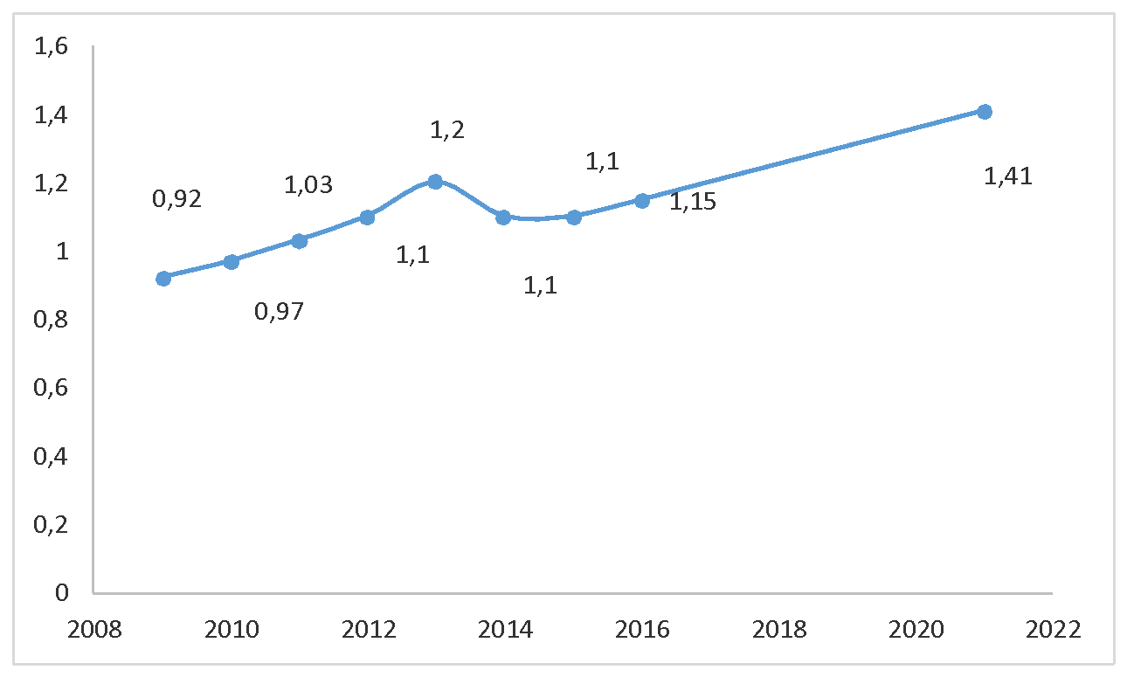
Figure 6: Estimated average fish feed sale price per year (2022-AMBIO S.A. estimation based on 2022 fish feed cost data, 2008-2016 ICAP GROUPA.E – Market Estimates.

The prices listed above are for fish feed purchased from Greek businesses, which meet 95% of the demand from fish farms operating in Greece. Corresponding shipping costs should be added to the above price for imported fish feed.

Feeding Systems
There are three types of available feeding systems:
- Feeding barges
- Central feeding systems
- Feeding canons
In recent years, with the prevalence of the use of larger cages P80-P120 that support larger biomass, it is estimated that feeding barges as shown in Figure 7 will prevail in the production process, [6]. Only in cases where the farm has sufficient space on land, then central feeding systems in cages can be installed but again this is only possible for coastal aquaculture and not offshore.
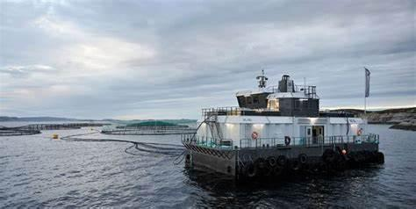

Figure 7: Installed feeding barge system ((Source: AMBIO S.A.).
The main parameter determining the price of a feeding barge is its capacity and secondary the accompanying innovations. The capacity is determined depending on the farm’s breeding biomass. It is estimated that a sufficient capacity ensures autonomy for 10-15 days during the peak feeding period in the summer-autumn months. These systems are usually placed on boats and allow the feed to be distributed through a blower at high and constant flow rates, which are user-adjustable. Despite the convenience and flexibility feeding barges offer, many farms still use feeding cannons in big cages because of their high.
Table 10 presents the indicative cost for feeding systems based on their type and capacity, [6]. In regard to the barges’ cost, the cost of the required feeding equipment (automatic feed system, generators, crane, etc.) is also included. Special systems such as surveillance cameras, dispensers, and feeding tubes, are calculated separately.

Table 10: Indicative cost for Feeding systems (2021 data, Vat is not included in price).
Equipment | Unit | Indicative cost (€)/unit
Feeding tubes 90 mm diameter, 16 atm | m | 5
Rotating dispenser | pcs | 1,300
Mooring cost | Labour | 70,000
Cage feeding monitoring system | pcs | 60,000
Feeding barge 100tn | pcs | 400,000
Feeding barge 150tn | pcs | 650,000
Feeding barge 200tn | pcs | 700,000
Feeding barge 300tn | pcs | 1,100,000
Feeding barge 400tn | pcs | 1,500,000
Steel Feeding boat with blower 17x8,5 50 tons capacity (4 silos) | pcs | 500,000
Feeding canon with 10 hp engine | pcs | 6,000
Feeding canon with a double feeding system | pcs | 10,500
Central feeding system on land installation with 5x5 tons silo with software | pcs | 150,000

Boats/ vessels/ platforms
Floating vessels are part of the main pieces of equipment for a fish farm and are divided into the following categories:

- Big aquaculture vessels with one or more cranes installed for:
- Fish harvesting
- Net replacement
- Treatment processes
- Transportation of feed and other supplies

- Platforms with a crane installed are usually used for net replacement, harvesting, and feeding.
- Boats that are mainly used for the transportation of the employees and feeding canons.
Depending on the size and location of the fish farm, different numbers and types of boats are required. This study examines the cost of some very basic boat models, that are widely used in aquaculture. Depending on the requirements of a company, the specific characteristics of each vessel vary.
For the boats examined, the cost of the marine engines needed shall be calculated accordingly.
Table 11 illustrates the indicative cost for the floating equipment used in aquaculture as well as the main types of marine engines [6].

Table 11: Indicative cost of floating equipment used in aquaculture.
EQUIPMENT | UNIT | INDICATIVE COST (€)/UNIT | EQUIPMENT USAGE
Outboard motor engine 15 HP | pcs | 1,800 | For Boats
Outboard motor engine 25 HP | pcs | 3,200 | For Boats
Outboard motor engine 30 HP | pcs | 3,400 | For Boats
Outboard motor engine 60 HP | pcs | 5,900 | For Boats / Feeding platforms
Outboard motor engine 115 HP | pcs | 8,500 | For Feeding platforms
Platform 9x4 m | pcs | 27,000
Catamaran boat 5,9x2 m | pcs | 3,500
Shipbuilding study for Aquaculture vessel 15x8 m | pcs | 25,000
Aquaculture vessel with installed crane 15x8 | pcs | 200,000

Cranes/ Lifting mechanisms
The lifting equipment used in aquaculture mainly consists of fixed pneumatic cranes and clarks.
The main types of fixed cranes used in fish farming for the completion of the basic tasks related to harvesting, nets replacement, and transporting cargo (mainly harvesting tanks and fish feed) are the following:
1.8 tnm capacity
2.12 tnm capacity
3.18 tnm capacity
4.20 tnm capacity
5.32 tnm capacity
Cranes are usually installed on aquaculture vessels (some have two, a small 8 tm and a bigger 20 tm) and they are used to assist in P120 nets removal. They are also installed on freight trucks and more rarely on-land facilities, mainly on piers.
Forklifts (clarks) are used in many transport operations, mainly in the transport of feeding and harvesting tanks. Other important pieces of equipment are the electric pallet trucks, which are used due to their flexibility and lifting capacity for operations inside the packaging plants.
Table 12 illustrates the indicative cost for the lifting equipment used in aquaculture as well as the main types of marine engines, [6].

Table 12: Indicative cost of lifting equipment.
Type | Capacity | Type of work | Unit of Measurement | Price (€) /unit
Fixed crane | 10 tm-5tons max lifting capacity | On growing | piece | 17,300 | P60 Nets replacement/ transportations
Fixed crane | 18 tm-10 tons max lifting capacity | On growing | piece | 37,000 | P120 Nets replacement/ transportation of fish feed, harvesting tanks, supplies
Fixed crane | 32 tm | On growing | piece | 70,000
Telescopic forklifts masts | 3tm | On growing | piece | 59,000 | Transportation of fish feed, harvesting tanks, supplies
Forklifts with canopy | 3 tm | On growing  Packing plant | piece | 37,000 | Transportation of fish feed, harvesting tanks, supplies
Electric pallet lifting machine with refolded platform | 2t | Packing plant | piece | 5,300 | Transportation of harvesting tanks, pallets, packed fish, ice tanks, fish feed
Electric pallet lifting machine | 1.3tn | Packing plant | piece | 1,500-4,000
Electric pallet lifting machine | 1.8 tn | Packing plant | piece | 3,250 | Transportation of harvesting tanks, pallets, packed fish, ice tanks, fish feed
Electric pallet lifting machine | 1.5 tn | Packing plant | piece | 1,900-4,300 | Transportation of harvesting tanks, pallets, packed fish, ice tanks, fish feed
Pallet lifting machine (Not electric) | 3 tn | Packing plant/ On growing | piece | 500 | Transportation of harvesting tanks, pallets, packed fish, ice tanks, fish feed

Automation in Open Sea Aquaculture
Operating under open-sea conditions presents significant challenges in terms of cost-efficiency. One paramount solution to mitigate these challenges is the introduction of automation. Specific needs for automation in open-sea aquaculture encompass:
Automation in Feeding: Feeding management is a critical component of successful aquaculture. Automating this process ensures a precise and timely distribution of feed, fostering healthier and faster-growing fish.
Operational Efficiency: The introduction of robotics and autonomous systems in automating routine tasks like net cleaning and maintenance can lead to a substantial reduction in operational costs while enhancing worker safety. These systems can execute tasks with a level of consistency and efficiency that is challenging to achieve manually.
Environmental monitoring: Environmental monitoring is another facet of automation, can provide continuous data collection, beneficial for operational insights and advancing scientific research.
As stated in the current literature, currently there is little proof that costs outweigh the benefits [7]. Moreover, the article from [8] provide further insights into the evolving landscape of open-sea aquaculture and the integration of automation technologies. The European Commission has recognised the need to invest in intelligent automated systems to reduce food production costs and protect the environment is currently funding several relevant projects.
While automation offers a promising avenue for improving operations in open-sea aquaculture, reviewed in Deliverable 21, it's crucial to understand that these mechanisms must be tailored to the distinct requirements of each aquaculture project, underscoring the necessity of a detailed business plan. This customization lies outside the purview of the project. However, the consortium possesses the capability and expertise to undertake specific aquaculture projects, offering bespoke automation solutions as a continuation and expansion of the current project.

On-Shore Operations

Packaging Plant Equipment
The basic packaging line consists of the following components:
1. Fish washing machine
2. Lifting Roller conveyor
2. Weigher and line with sorting doors and label machines on each door
3. Machine with ice supply to styrofoams
4. Line Box Weight Control Line with Disposal
5. Strapping machine
6. Stretch Film Machine
7. Ice Storage Chamber
8. Final product storage compartment refrigerant
This study determines the cost for the basic packing line (1-5) and separately the cost for the supporting mechanical equipment for stages 6-8.
Figure 8 presents a typical aquaculture packaging line, [6].
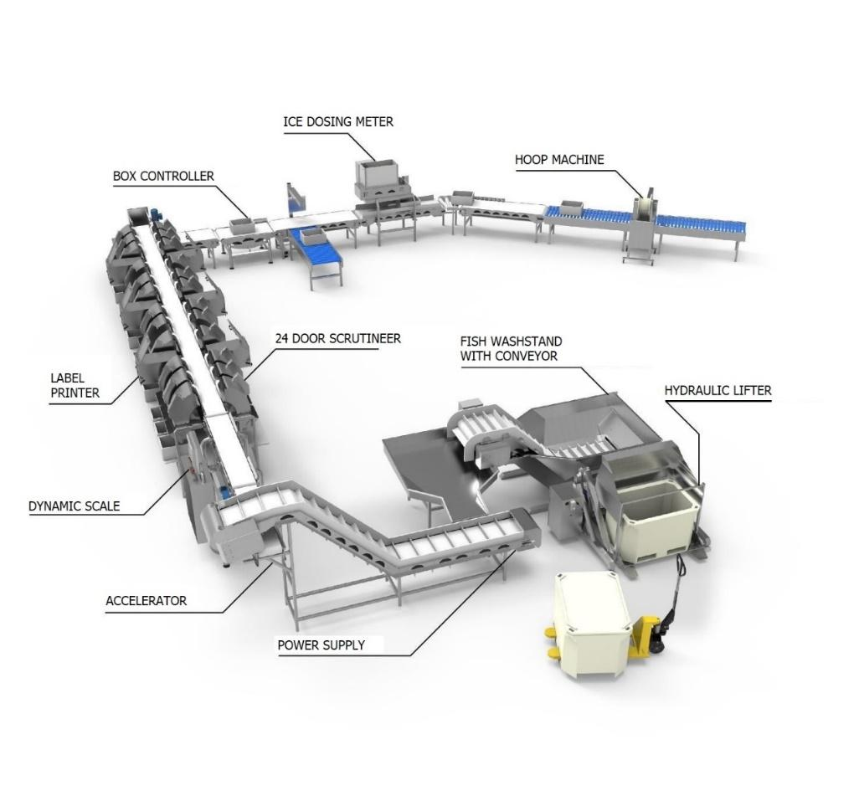
Figure 8: Visual presentation of basic packaging line (Ambio 2022, Thema Automation SA).
The average cost of the basic equipment for a packaging plant was calculated based on the above information as well as a conducted study. A 24-seat production line is considered the most appropriate arrangement and is estimated to cover a range of production capacities (average and large capacities 2,500-10,000 tons per year)
It should be noted that the above prices are average and refer to the mechanical equipment. Besides the main features of a machine, there are additional technical characteristics that cannot be assessed currently and might affect the final cost.
Table 13 below shows the indicative cost for the packing plant equipment [6].

Table 13: Packing plant equipment indicative cost.
Type | Capacity | Type of work | Measurement unit | €/unit | Comments
Harvesting tank | 1000 lt |  | piece | 800
Air transport system for styrofoam packages |  |  | piece | 68,000 | Optional
Ice supply dosing system |  |  | piece | 137,000 | Integrated Styrofoam Storage, Management, and Filling System via Ice Dosing System
24-door grading machine with software |  |  | piece | 280,000 | It includes: Hydraulic tipper, fish washers, sorting table, feed film, propulsion, and acceleration tape, Weighing unit, Electric table, Door sorting tape, Styrofoam conveyor tape, Weight control table, Software, trench machine
Ice dosing machine |  |  | piece | 30,000 | Optional equipment
Secondary package Weigh check with abortion line. |  |  | piece | 47,000
Biological packaging plant cleaning |  |  | piece | 130,000
50 kg industrial weighing scale |  |  | piece | 1,000
Ice maker machine | 4.9tn/24h |  | piece | 55,000
Stretch film machine |  |  | piece | 5,500
Fridge |  |  | piece | 40,000
Closed type Generator 109 KVA |  |  | piece | 18,000
1.000 lt belt driven Air compressor |  |  | piece | 3,700
1700 lt screw-driven Air compressor |  |  | piece | 5,000

Distribution
The dominant distribution channels for aquaculture products in Cyprus involve:

- Direct distribution from the aquaculture farms to the local fish markets and supermarkets using their owned distribution vehicles;
- A small number of intermediaries for the local market;
- Intermediaries for the export market and;
- A number of intermediaries, especially for the domestic market.
The main capital expenditure in distribution is distribution cars (vans). The cost of each of these vans, according to 2022 estimates, is of the order of 40,000 euros with a life expectancy of ten (10) years. For a company of 2,000 tonnes production capacity, ten (10) of these vans are expected to be needed.

Operational Expenses (OpEx)
The following operational expenses have been identified according to an interview of KIMAGRO fisheries’ financial controller that took place on the 23/02/2022, [9]. KIMAGRO fisheries (https://www.levantinafish.com/) is the biggest aquaculture company in Cyprus with breeding capacity exceeding 2,000 tons per year.

Personnel needs / 2,000 tons annual production.
Personnel needs were given for 2,000 tons annual production as it can be seen in Table 14.

Table 14. Annual Personnel Costs for 2,000 tons production capacity
Annual Personnel cost per 2,000 tons production (as per 23/02/2022)
Description | Number | Annual Cost per employee | Annual Total Cost
Administration
Manager | 1 | €39,000 | €39,000
Accounting employees | 4 | €19,500 | €78,000
Sea Operations
Managers | 2 | €32,500 | €65,000
Sea operations employees | 20 | €19,500 | €390,000
Packaging & Distribution
Managers | 2 | €26,000 | €52,000
Packaging & Distribution employees | 25 | €16,900 | €422,500
TOTAL |  |  | €1,046,500

Certification
Aquaculture packaging plants in Cyprus need to comply with HACCAP certification requirements. The current initial cost of this certification, according to the interview of KIMAGRO’s fisheries financial controller (23/02/2022), is of the order of ten thousand euros (€10,000) [9].

Environmental Monitoring
According to Cyprus’ legislation [4], every six (6) months an environmental monitoring study needs to take place. The current cost of this study, according to the interview of KIMAGRO’s fisheries financial controller (23/02/2022), is of the order of ten thousand euros (€10,000) [9].

Utilities, Fuel and other consumables Costs
As it was pointed out during the interview of the financial controller of KIMAGRO (https://www.levantinafish.com/), a major source of costs are the fuel and utilities’ expenses [9]. The term utilities refer to electricity, water, waste disposal, heating & sewage.

Annual Fuel, Utilities & other consumables cost per 2,000 tons production (as per 23/02/2022)
Description | Annual Total Cost
Administration
Electricity cost | €36,000
Water | €20,000
Municipality Taxes | €5,000
Cleaning | €20,000
Insurance (employees/ building/ other) | €70,000
Telecommunications | €5,000
Sea Operations
Fuel for Boats | €180,000
Service for Boats | €12,000
Net Replacements | €200,000
Divers' gear | €12,000
Divers' clothing | €6,000
Water (ice making, cleaning) | €6,000
Electricity (ice making, cleaning) | €6,000
Packaging & Distribution
Fuel for Distribution Cars | €180,000
Maintenance Distribution Cars | €12,000
Electricity (ice making, cleaning, lighting premises) | €84,000
Water (ice making, cleaning) | €24,000
Overall Cost of Packaging Boxes | €280,000
Cleaning | €24,000
Clothing | €6,000
TOTAL | €1,188,000

Fish Feed, Fingerlings and Total Operational Costs
A major source of operational expenses is the cost of fish feed. Deliverable 23: Targeted finfish economic characteristics, investigates in detail operational expenses related to targeted finfish [5]. In short, these are:

- Gilthead seabream (Sparus aurata);
  - Fish Feed per harvested kg: € 2.94/kg
  - Cost of juveniles per harvested kg: € 0.42/kg
  - Theoretical Total Operational cost per harvested kg: €5.6 /kg

- European seabass (Dicentrarchus labrax);
  - Fish Feed per harvested kg: € 3.22 /kg
  - Cost of juveniles per harvested kg: €0.42 /kg
  - Theoretical Total Operational cost per harvested kg: €6.07 /kg

- Meagre (Argyrosomus regius);
  - Fish Feed per harvested kg: €2.38 /kg
  - Cost of juveniles per harvested kg: € 0.33 /kg
  - Theoretical Total Operational cost per harvested kg: € 4.52 /kg

- Red porgy (Pagrus pagrus) and/or red seabream (Pagrus major).
  - Fish Feed per harvested kg: €2.94 /kg
  - Cost of juveniles per harvested kg: €0.525 /kg
  - Theoretical Total Operational cost per harvested kg: €5.775 /kg

Annual maintenance of Capital Expenditure infrastructure
Annual maintenance of capital expenditure infrastructure is expected to be quite substantial for companies operating at sea. To advocate this argument, the financial controller of KIMAGRO said there is an annual cost of €200,000 merely for nets replacement [9]. To add on these, considerable cost is required for boats’ servicing and distribution cars’ servicing. To sum up, a figure of the order of €500,000 is expected as annual maintenance expenses of an aquaculture company having a production capacity of 2,000 tonnes.

Marketing Expenses
Marketing expenses figure, as given by KIMAGRO fisheries’ financial controller (23/ 02/ 2022), is of the order of 4% to 5% of total operational expenses [9]. According to the aforementioned person, a figure of the order of €500,000 is expected as annual marketing expenses of an aquaculture company having a production capacity of 2,000 tonnes.

Business cases scenarios
In this section an economic summary of the costs of predominant business case scenarios is given. These scenarios refer to two operating depths, i.e. an average depth of fifty (50) meters, which is the current situation, and an average operating depth of 100 meters, which is proposed in Deliverable 15: Proposal for allocated zones for open sea (offshore) aquaculture [1]. Table 15 gives an overview of these scenarios. For each of these scenarios an estimation of the required Capital Expenditure (CapEx) and Operational Expenditure (OpEx) is calculated in the forthcoming sections.

Table 15: Business Scenarios
BUSINESS AS USUAL SCENARIO - OPERATING DEPTH (average depth 50m )
TECHNOLOGY | CAPACITY (Tonnes)
Conventional Design | -- | 3000 | 5000
OFFSHORE - PROPOSED OPERATING DEPTH (average depth 100m)
Capacity | CAPACITY (Tonnes)
Conventional Design | 2250 | 3000 | 5000

Based on the above values and the production model analyzed in section 4, an estimated cost was determined for three equipment logistic scenarios with Business as usual at an average operating depth of 50m. These scenarios include capacity of 3,000 and 5,000 tonnes. Additionally, three (3) estimated costs scenarios also calculated for fish farms with packing plant for a production of 2,250, 3,000, and 5,000 in an area with average depth of 100 m (offshore scenarios).

Admissions for scenario
Species
Sea bass 40%
Sea bream 60%

Management module: Fry is kept within a 60 m perimeter cage until it grows to 55-70 gr, when it’s transferred to a 120 m perimeter cage.

Imported fry average weight: 9 gr
Sea bass average Transfer weight on a cage with a 120-meter perimeter: 55 gr
Sea bream average Transfer weight on a cage with a 120-meter perimeter: 70 gr
Imported Sea bream to a cage with a 60-meter perimeter: 195,000 pcs
Imported Sea bream to a cage with a 120-meter perimeter: 400,000 pcs
Imported Sea bass to a cage with a 60-meter perimeter: 220,000 pcs
Imported Sea bass to a cage with a 120-meter perimeter: 450,000 pcs
The average harvesting weight: 550 gr
Sea bream breeding cycle: 16-20 Months
Sea bass breeding cycle: 18-23 Months
Juveniles import profile: see table 4.9 in AMBIO report [6]
Temperature profile: see table 4.10 in AMBIO report [6]
Survival rate: 70-80%
Area depth: 50m or 100m
Capacity: 3000 and 5000 tonnes for 50m / 2250, 3000 and 5000 tonnes for 100m

Capital Expenditure (Equipment Cost)
Table 16 presents the total equipment cost for the three scenarios with average depth of 100 meters. For the 2250 tonnes the estimated cost is about €5,136,389, for 3000 tonnes it is €6,306,382 and for 5000 tonnes €10,908,121. Notice that the total equipment cost in the conventional design is much less that the cage-mooring-nets cost of the InnovaSea and AP Marine solutions.

Table 16: Estimated equipment cost for a 2250/3.000/5.000 tonne on a growing unit with packing plant.
Type of equipment | Estimated cost (2.250 tn production unit) (€) | Estimated cost (3.000 tn production unit) (€) | Estimated cost (5.000 tn production unit) (€) | Comments
Cages | 531,340 | 608,280 | 1,083,240
Netcages | 1,067,400 | 1,161,500 | 2,337,950
Vessels/feeding equipment/Forklifts | 1,258,500 | 2,174,000 | 4,085,000
Mooring equipment and supportive net equipment | 498,186 | 523,944 | 1,004,334
Other equipment | 386,100 | 337,450 | 478,050
Packing Plant equipment | 927,900 | 927,900 | 927,900
Emergency expenses/Unspecified expenses | 472,693 | 522,000 | 991,647 | 10% of total cost
Estimated park coverage (m²) | 73.000 | 90.000 | 180.000
Estimated leased area (m²) | 100.000 | 100.000 | 200.000 | In Greece the maximum leased area must not overcome 100.000 m² so in this case two permits must be issued
Total estimated cost €) | 5,136,389 | 6,306,382 | 10,908,121

For comparison reasons, Table 17 gives the total equipment cost for 3000 and 5000 tonnes at an average depth of 50 meters. Comparing these values, observe that the depth change from 50 meters to 100 meters results to a 5% increase of the total equipment cost.

Table 17: Estimated equipment cost for a 3.000/5.000 tn on a growing unit with packing plant according to prices analyzed above.

Type of equipment | Estimated cost (3.000 tn production unit) (€) | Estimated cost (5.000 tn production unit) (€) | Comments
Cages | 608,280 | 1,083,240
Netcages | 1,161,500 | 2,337,950
Vessels/feeding equipment/Forklifts | 2,174,000 | 4,085,000
Mooring equipment and supportive net equipment* | 406,852 | 813,134
Other equipment | 337,450 | 478,050
Packing Plant equipment | 927,900 | 927,900
Emergency expenses/Unspecified expenses | 420,000 | 950,000 | 10% of total cost
Estimated park coverage (Acres) | 90 | 180
Estimated leased area (m²) | 100.000 | 200.000 | In Greece the maximum leased area must not overcome 100.000 m² so in this case two permits must be issued
Total estimated cost (€) | 5,986,172 | 10,525,654
*Cost is estimated for an Area with average depth 50m.

Operational Expenditure
Operational expenditure varies insignificantly due to depth distinction between fifty (50) and a hundred (100) meters operating depth. Based on the interview of KIMAGRO fisheries’ financial controller that took place on the 23/02/2022 [9], the key operating costs have been calculated and a summary of these is presented in Table 18. In addition, these costs are compared with the theoretical value of operational expenses provided in Deliverable 23: Targeted finfish economic characteristics. As it can be seen, the variation between actual figures and the theoretical model is negligible.

Table 18. Annual Operational Expenses for varying production capacities
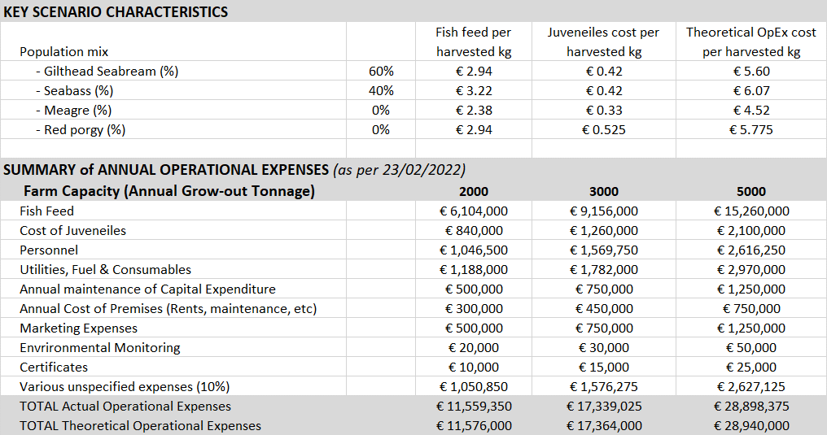

Funding mechanisms and budgetary considerations

Existing and foreseen subsidies for aquaculture companies was presented in Deliverable 26: Legal/ regulatory framework and existing financial incentives. These subsidies are existed for the past twenty (20) years. Programs are valid for six (6) years and during these years’ aquaculture companies can get up to fifty percent (50%) subsidy for investments made in infrastructure and marketing of aquaculture products. During recent years, total investments could not be more than €600,000 within each six-year period.
It is expected that during the period 2021 – 2027 new subsidy programs will also run. According to Department of Fisheries and Maritime Research (DFMR) the total cost of investments per aquaculture company can reach the order of €800,000 [10].
It needs to be stated here that most of the existing aquaculture companies in Cyprus, operating as back as 2000, started with a license of production capacity of 200 tonnes and reached today production capacities of more than 1,000 tonnes. Therefore, during these twenty (20) years, due to gradual expansion, most of their infrastructure investments was subsidized. This might not be the case of new companies with a license of the order of 1,000 tonnes or more.
Another parameter to be taken into consideration is the cost of capital. Existing aquaculture companies enjoyed borrowing rates over the past years of the order of 3%-4% due to the economic/ pandemic crisis since 2010. Nowadays, interest rates begun to pick up with a current cost of 5.5% to 7%. Therefore, the cost of capital is expected to be substantial for new companies entering the aquaculture industry.

Conclusions
The objective of this deliverable (D24) is to describe the economic characteristics of aquaculture companies’ operations and alternative mooring scenarios. This piece of work proves pivotal in the overall aim of the OS AQUA project to assess the feasibility of expanding Cyprus’ aquaculture activities in new marine sites.
This work package in closely intertwined with a number of deliverables and reports of the OS AQUA project, as described in detail during the introduction of this deliverable. It also heavily affects the outcomes of the economic analysis (D28) and risk analysis (D27) of this project.
Describing the economic characteristics of aquaculture companies proved to be a challenging task since a large number of operations/ various equipment are involved. In addition, there is a significant cost involved due to the license to use the marine space bidding process and legislation compliance requirements.

References

- D15: Proposal for allocated zones for open sea (offshore) aquaculture
- D18: Summary of current market for open sea aquaculture subsystems and analysis of best value for money
- D21: Provide best practice guidelines for environmental monitoring of offshore aquaculture
- D26: Legal/ regulatory framework and existing financial incentives
- D23: Targeted finfish economic characteristics
- AMBIO S.A. report on Market Research on Fish Feed and Aquaculture Equipment
- Afewerki, S., Asche, F., Misund, B., Thorvaldsen, T., & Tveterås, R. (2023). Innovation in the Norwegian aquaculture industry. Reviews in Aquaculture, 15(2), 759-771
- H. Jhang, F. Gui, ‘’The Application and Research of New Digital Technology in Marine Aquaculture.’’ J. Mar. Sci. Eng. 2023, 11(2), 401 (https://doi.org/10.3390/jmse11020401)

