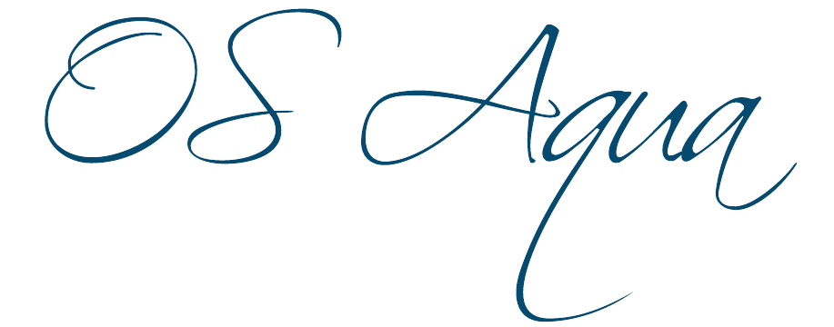
Open Sea Aquaculture
in the Eastern Mediterranean

The Project is co-financed with 800 K Euro by the European Regional Development Fund and the Republic of Cyprus through the Research and Innovation Foundation with grant number INTEGRATED/0918/0046
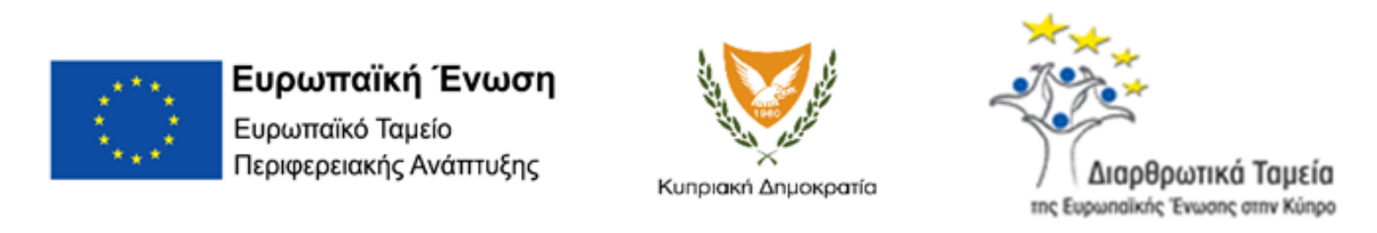

Work Package ID: WP6

Work Package Title: Ongoing monitoring of Offshore Mariculture stations

Deliverable ID: D21

Deliverable Title: Provide best practice guidelines for environmental monitoring of offshore aquaculture

Status: Final

Dissemination Level: Public

Partner Leader: UCY-Oceanography Centre

Disclaimer
Use of any knowledge, information or data contained in this document shall be at the user's sole risk. Neither the OS Aqua Consortium nor any of its members, their officers, employees or agents accept shall be liable or responsible, in negligence or otherwise, for any loss, damage or expense whatever sustained by any person as a result of the use, in any manner or form, of any knowledge, information or data contained in this document, or due to any inaccuracy, omission or error therein contained.
The OS Aqua project (INTEGRATED/0918/0046) has been partially funded under the RESTART 2016-2020 Programme, Integrated Projects Call, of the Cyprus Research and Innovation Foundation. This publication reflects the views only of the authors, and the Funding Agency cannot be held liable or responsible for any use which may be made of the information contained herein or of any consequences thereof.
Copyright notice
© Copyright 2020-2024, The OS Aqua Consortium
This document contains information that is protected by copyright. All Rights Reserved. No part of this work covered by copyright hereon may be reproduced or used in any form or by any means without the permission of the copyright holders.

Executive Summary
Open Sea Aquaculture (OS - Aqua) is a multidisciplinary project that aims at creating decision support tools for marine spatial planning of open sea aquaculture. This document is dedicated to deliverable D21 “Provide best practice guidelines for environmental monitoring of offshore aquaculture”. Information was gathered from a literature review and from the personal knowledge of different consortium members.

This deliverable, D21, will utilize the outlined environmental challenges that have arisen in D20 from moving the existing aquaculture industry into deeper waters. D21 aims to deliver the best practice guidelines and tools for the ongoing environmental monitoring of offshore aquaculture stations, aiming to promote the viability of the investment and ensure a good ecological standard and sustainable expansion in Cyprus and the Eastern Mediterranean. In addition, the deliverable lays down the procedure of large-scale monitoring due to the enlargement of the aquaculture units.

This document first identifies the impacts of small-scale aquaculture farms on the environment. Such impacts are dissolved organic matter, solid organic waste, dissolved nutrients, and anti-fouling materials. Furthermore, it identifies the impact of environmental variables that influence aquaculture farms. Those variables are temperature, ocean currents, and surface waves. Based on those parameters monitoring guidelines have been proposed based on international bibliography and best practices.

The monitoring guidelines include the sediment and benthic survey, hydrographic survey, and water quality survey which must be carried out on a regular schedule. The guidelines also indicate the timeframe that those surveys must take place and suggest locations away from the cages where samples should be taken.

In addition to the localized monitoring, the report lays down the steps required for a large-scale monitoring of the eutrophication in the surrounding area. The usage of remote sensing is suggested along with other tool such as water quality models as illustrated in deliverable 11. The usage of remote sensing can act as an Early warning system for avoiding eutrophication events.

Finally, the deliverable concludes with the IoT sensors that fish farms can be equipped in order to better monitor the environmental variables that affect the fish well-being.

Table of Contents
1. Introduction 6
a) Background 6
b) Purpose and Scope 6
c) Approach 6
2. Small-Scale Spatial Impacts from Cage Aquaculture 7
a) Introduction 7
b) Solid organic wastes 7
c) Sediment loading 8
d) Dissolved nutrients 9
e) Anti-fouling materials 10
3. Impacts to Cage Aquaculture 11
a) Temperature 11
b) Circulation and current 12
c) Surface Gravity Waves 13
4. Monitoring Guidelines 14
a) Environmental Setting of the Study Area 14
b) Hydrographic survey 17
c) Sediment and Benthic monitoring survey 19
d) Water quality survey 22
5. Survey Type and Timing 24
6. Large Scale monitoring of Aquaculture sites 26
7. Intelligent Aquaculture solutions 27
8. References 30

Table of Figures

Figure 1:Bathymetry of Cyprus (United Nations, 1996). 14
Figure 2: General water body circulation consisted of cyclonic and anticyclonic eddies (Robinson et al., 1992). 15
Figure 3 Mechanical Current Meter (Perzyna, 2016). 18
Figure 4 Acoustic Doppler Meter (Perzyna, 2016). 18
Figure 5 Electro-magnetic Current Meter (Perzyna, 2016). 19
Figure 6 Example of dissolved oxygen and temperature probes (NOA, 2017). 23
Figure 7 Van Dorn (top) and Niskin (bottom) water samplers (FAO,2017). 24
Figure 8 Examples of IoT aquaculture solutions regarding (a) pellet detection (b) biomass calculation and (c) data analysis and visualization tools. 29

Introduction

Background

The multidisciplinary project of Open Sea Aquaculture (OS – Aqua) aims in developing a road map and providing all the preliminary research work in establishing a baseline for the future development of marine aquaculture in Cyprus and the Eastern Mediterranean. OS - Aqua aims in creating an ongoing collaboration network with academics, local stakeholders, public authorities, and technology providers in allowing the innovative growth and the offshore expansion of marine aquacultures in Cyprus.

Aquaculture and marine fish farming have been expanding in the Mediterranean since 1990, and in the following two decades they are expected to rise by 5% annually, due to the increasing demand for marine products (FAO, 2006). Additionally, with the expansion of world capture fisheries and aquaculture production reaching 48% in 2019 from 13% in 1990, at a global scale, and with its increasing trend, environmental guidelines are urgently required to ensure its sustainable growth (FAO, 2020), while satisfying at the same time local environmental legislations (Science for Environment Policy, 2015).

The expansion and long-term sustainability of aquaculture in Cyprus will depend on best management practices throughout the whole cycle of production, including site selection, cage construction, operation practices, fish husbandry, and animal welfare and environmental monitoring protocols. The focus of this report is the cause-and-effect relationships between cage farms and water and sediment quality and the means that could be used to monitor this. This deliverable will cover the designing of appropriate onsite and remote surveying methods, data collection, and analysis.

The potential impacts of marine aquaculture can be separated, generally, into two broad categories, small-scale local effects in the area of interest and broad-scale effects in the greater area that impact different ecosystem components (Ticina et al., 2020). In the following sections local changes affecting biodiversity and ecosystem functioning, caused by open sea aquacultures will be analysed. This report outlines research into a selection of water and ecological impacts of aquaculture in the Mediterranean area. Additional information regarding the environmental impacts of open sea aquacultures will be given for the Mediterranean area.

Purpose and Scope

This deliverable, D21, will utilize the outlined environmental challenges that have arisen in D20 from moving the existing aquaculture industry into deeper waters. D21 aims in delivering the best practice guidelines and tools for the ongoing environmental monitoring of offshore aquaculture stations, aiming in promoting the viability of the investment, and ensuring a good ecological standard and sustainable expansion in Cyprus and the Eastern Mediterranean.

Approach

A multi-directional approach was chosen for this deliverable. Firstly, the monitoring parameters of aquaculture units were identified and analysed. Aquaculture affects the marine environment through the direct release of dissolved nutrients, particulate material, chemotherapeutants, and antifouling chemicals. Additionally, the impacts of sea cages on water circulation close to the sea cages but also closer to the seabed were studied. Secondly, this deliverable analysed the environmental factors affecting the establishment of aquacultures, such as spacing, water temperature, water quality, currents, and wave energy. Understanding the impacts of aquaculture on the environment, and vice versa, allows for identifying the specific monitoring parameters of aquaculture units and the unique ecological parameters of Cyprus, thus, being able in developing an effective for cage monitoring system. Lastly, specific monitoring guidelines for various sectors will be given, while taking into consideration the environmental conditions of the Eastern Mediterranean.

Small-Scale Spatial Impacts from Cage Aquaculture

Introduction

Open sea aquaculture requires balancing the rights and responsibilities of using and preserving the marine ecosystem. Identifying the potential impacts of marine aquaculture, both on small scale local effects near the farm and on a broad spatial scale that impacts several different ecosystem components, is crucial. It is important to measure and quantify the environmental impacts of aquacultures in minimizing the risk of damage to existing sites or other forms of environmental degradation. Small-scale impacts might be related to changes in the seabed biocenosis beneath the aquaculture installations, changes in the local biodiversity and productivity, behavioural changes of local wild fauna, etc. On the other hand, broad scale impacts might include genetic changes in wild fish populations due to the limited living space, effects on endangered species, and changes in the behaviour of the fisher communities as an integral part of the marine ecosystem. This section would focus on the small-scale spatial effects of aquaculture on the ecosystem.

Solid organic wastes

The most widely documented impact of aquacultures on the marine environment is the release of organic waste from cultured fish (Gowen et al., 1991, Fernandes et al., 2001). Organic loading nearby the farm cages is in most cases unavoidable due to the excess of uneaten feed and the excretory waste of fish. Cromey et al., (2002) modelled the deposition of solid wastes and the biological effects on the marine environment from marine cage farms. It was demonstrated that from knowledge of the quantitative relationships between benthic community descriptors and solids accumulation, predictions of the specific impacts on benthic communities can be made.

Released organic waste can either be accumulated or mineralized on the seafloor in the sediments (Ticina et al., 2020). Enriched sedimentation of organic matter can alter the biochemical processes of sediments. Due to the anoxic conditions of the sediments, C-oxidation is mainly performed by anaerobic bacteria and sulphate reduction becomes the main respiration pathway. Changes in oxygen penetration result in simulated mineralization rates and combined with the effects from resuspension, sediments near farm cages suffer from carbon mineralization and nutrient regeneration based on the extensive study of Valdemarsen et al. (2009). Previous studies (Holmer et al., 2007; Kutti et al., 2007) demonstrated that the accumulation of organic matter under farm cages was 8 to 25 times higher than at control sites that were located 1 km away.
Those papers referred to coastal aquaculture units. Deep water aquacultures have less impact environmental impact due to greater discernment. Despite that, changes in sediment chemistry from organic matter deposition, were recorded beneath deep water (190 m) intensive salmon farms in Norway (Valdemarsen et al., 2012).

Interestingly, Keil et al., (1994) reported that the majority of organic matter (>90%) found in marine sediments is related to mineral surfaces. From the organic matter that is found in marine sediments, a portion of that is decomposed into inorganic components, being able to return to the water column. Findings showed that the degradation rate of organic matter is related to the rate of sedimentation, bioturbation, and the concentration of oxygen in the sediment and in the water column (Keil et al., 1994).

Sediment loading

The accumulation of fish feed and faeces from aquaculture on the seabed and their effects on natural biogeochemical processes are among the most important environmental implications in the marine aquaculture industry. Globally, the potential issues and the environmental implications raised by aquaculture discharge have been well reported. Specifically, for the Mediterranean Sea, aquaculture operations are often installed over biogenic sediments and in close vicinity to seagrasses. The biogenic sediments of the Mediterranean are generally oligotrophic, thus, small organic enrichments from the aquaculture industry can cause profound effects on sediment chemistry, modifying the flora and fauna below the cages (The Mediterranean Science Commission, 2007). Studies in the Mediterranean (Lupatsch and Kiddil, 1998; Kirsch, 2006) found that for a ton of gilthead sea bream to be produced, 13.2 kg of nitrogen settles on the sediments and 89.7kg of soluble nitrogen is also released. Considering that most aquaculture cages are clustered together due to favourable site selection and for economic reasons, and taking into consideration the low water circulation and tide regime in enclosed bays in the Mediterranean, discharges of this scale could cause serious implications to the chemistry of sediments. Environmental impacts have also been recorded on seagrass meadows in the Mediterranean. Sediment enrichment resulted in reduced shoot density, shoot size, underground biomass, and photosynthetic capacities of Posidonia oceanica meadow three years after the closure of a farm off Minorca (Delgado et al., 1999). The authors were able to demonstrate the long-term effects of persistent sediment loading from the fish farm. An additional study (Mirto et al., 2007) aimed in quantifying the impacts of fish-farm activities in Cyprus, Greece, Italy and Spain. Results indicated that quantitative and qualitative changes in the organic loads of sediments are dependent upon the specific ecological and environmental settings of the selected location, and not only based on fish-farm attributes and the hydrodynamic conditions. Therefore, it was concluded that potential impacts from sediment loading from fish farms should be examined case-by-case, taking into consideration the ecological and environmental context of the region.
For offshore aquaculture units, the challenge is to identify the impact area on sediment load due to feed waste and fish faeces. Combining the datasets from Work Package 4, current speed and direction, and the estimated depth of 200m the disbursement length can be evaluated. From FAO(2017) the following equations are used to estimate the displacement length:
$$D=V.t$$
$$t=Z/S$$
Where D is the displacement distance of the food waste/fish faeces, t is time, V is the current velocity, S is the sinking rate of food waste/fish faeces, Z is the layer depth. Hence for a case of an offshore aquaculture at a depth of 200m and a mean S of 0.048 m/s and current speed ranging from 0.01 to 0.4 m/s the displacement distance can be between 40 meters up to 1.7 km. The greater distribution of the feed waste/fish faeces implies that the concentration will be decreasing as moving away from the centre of the aquaculture unit. As a result the offshore units are having greater impact area with significantly lower concentrations regarding coastal units. Hence the monitoring of the sediment load must take into account the hydrodynamical parameters of each location.

Dissolved nutrients

Concerns have been raised regarding the release of excess feed and faeces by fish cages, causing nutrient outflow from marine farms (Beveridge, 2004; Belle and Nash, 2008; Holmer et al., 2008). A variety of factors are affecting the total nutrient loading from a fish farm, depending on the size of fish being fed, the number of cages in operation, the stocking density, the type of feed being used, and the measures implemented by the farm to maximise feeding efficiency (Holmer et al., 2005).

Marine aquaculture is a recognized source of nitrogen and phosphorus released in the marine ecosystem. The release of nitrogen and phosphorus may contribute to algal blooms and eutrophication, thus, monitoring the levels of dissolved nutrients near the fish cages is of high importance. A previous study has shown that dissolved nutrient levels may still be elevated up to a distance of 100 m around the fish farm (Science for Environment Policy, 2015). While both nitrogen and phosphorus are being released in the form of uneaten food, faeces, and metabolic wastes, nitrogen can also be released in the form of ammonia through urea (Cole 2002, Nash et al., 2005). Islam, (2005) reviewed cage aquaculture nutrient budget and nutrient loadings in proposing a model for nutrient (nitrogen and phosphorus) budget in hypothetical cage aquaculture scenarios, while taking on consideration values of feed loss, feed conversion ,ratio and nutrient contents in feed. His findings concluded that 82% N and 86% P are released into the ecosystem for each ton of fish produced and only 18% N and 14% P are harvested as fish biomass. Additionally, it was demonstrated that where live feed is used, the levels of nutrient loadings are significantly higher.

An experimental study was conducted by Dalsgaard and Krause-Jensen (2006) in studying the effects of nutrient release from Sea bream and Sea bass farms on pelagic primary production, using bioassays in the Mediterranean. There was a clear stimulation of the surrounding pelagic primary production, with both algae and plankton demonstrating higher growth rates within 150 m of the cages. Additionally, the tissue nitrogen content of the algae was higher in samples growing closest to the cages, indicating a clear transfer of nitrogen from the farm to the algae. The study concluded that even if nutrients released from the farm are quickly diluted in the water column, they still add to the total nutrient load of the area and in eutrophied environments, this release would exacerbate environmental problems.

Regarding the environmental implications and impacts of phosphorous on the marine environment, little research has been done, with the concluding marks being very diverse. Wu (1995) concluded that up to 82% of the phosphorus in fish feed was released back into the marine environment, whereas Pearson and Black (2001) reported that 34-41% of the phosphorus in fish feed was lost to the environment in dissolved form. However, as previously mentioned (Islam, 2005) the percentage of nutrients released in dissolved form differs according to the feed used, the feed conversion ratio, the feeding efficiency, and the fish species cultured. Mass balance equations were used in estimating the total fishfarm-derived nutrient output in New Brunswick (Strain and Hargrave, 2005). It was calculated that 4.9 kg of waste phosphorus was produced per ton of fish, with the total discharge being dependent on production levels. Studies in the Mediterranean (Aguado-Gimenez et al., 2006; Piedecausa et al., 2010) demonstrated that phosphorus release from tuna fattening was 3 to 5 times higher when compared with sea bream or sea bass due to their main differences in digestion and feed formulation.

Conclusively, there is no general regulation worldwide regarding the allowable limit of N and P discharge from aquacultures, as different environmental aspects such as benthic communities have different thresholds regarding nutrient uptakes. However, due to the complexity of the problem and the many factors affecting the release of nutrients in the marine environment is crucial for the aquaculture management system to perform frequent checks in maintaining nutrient concentrations in the water column, thus, ensuring high environmental standards.

Anti-fouling materials

Biofouling is the natural process of the settlement of microorganisms, plants, and animals that occurs continuously and vigorously on immersed surfaces, and it’s a problem with every structure that is placed in the aquatic environment (Loschau and Kratke, 2005). Regarding aquaculture cages, biofouling can lead to biocorrosion, reducing substantially the lifetime of submerged structures in the marine environment, as the corrosive effect of seawater on the metal is accelerated. Additionally, heavy and persistent biofouling can change water circulation within the cage leading to an increase in oxygen demand, increased stress, and retards the growth of fish (Ashraf et al., 2017).

Antifoulant compounds are chemical substances that can deter or kill the microorganisms responsible for biofouling (Guardiola et al., 2012). They intend to destroy, deter, render harmless and exercise control or prevent the action of any other harmful organism through chemical or biological means. Antifouling materials such as biocides are widely used in aquaculture because of their potential to destroy a wide range of organisms and because they are easily applied and attached to aquaculture cages, ropes, and structures (Price and Morris, 2013). Chemical antifouling treatments are highly used in aquacultures due to their high efficiency in reducing biofouling because of their toxicity levels that prevent the settlement of larvae on nets and equipment. However, due to their high toxic levels they affect marine organisms in the water and in the sediment nearby the aquaculture cages (Wu, 1995; Burridge, 2003).

Previously, tin-based compounds were widely used in antifouling chemicals however due to their significant environmental effects they were banned in multiple countries. Currently, copper-based antifouling materials are widely used and proven to be effective and less toxic in comparison to the tin-based compounds. Burridge et al., (2010) thorough report, found evidence of copper leaching out of nets and accumulating in sediments below fish farms, in levels above the regulatory ones in Canada and Scotland. Due to copper’s low solubility in water, it accumulates in sediments. The crucial aspect is in estimating copper’s bioavailable fraction, that is how much can marine organisms take up to before they produce toxic effects. Thus, further investigation is needed into the extend of negative effects the binding of copper with marine sediments is causing.

Additionally, Solberg et al., (2002) studied the possibility of copper accumulation from treated nets on fish tissues. Muscle and liver tissues were collected from farmed salmon and wild fish nearby the treated nets and a referenced farm with untreated nets. Analysis demonstrated no difference in copper accumulation between treated and untreated nets. However, the toxicity of copper-based antifouling chemicals is greatly affected by the chemical form of the copper used, its bounding degree to various substances in the water and the salinity and pH of the water. Grosell et al., (2007) study demonstrated that killifish was mostly affected in freshwater and in full saltwater in comparison to intermediate salinities. It was also shown that species growth and size affected their sensitivity. A further study on the toxicity of copper on alga Monochrysis lutheri, found a proportional relationship between the rate of cell division and of free cupric ion (Sunda and Lewis, 1978).

Impacts to Cage Aquaculture

Temperature

Fish and crustaceans are ectothermic organisms whose body temperature is depended on their surrounding environmental temperature, thus, fluctuating according to changes in environmental temperature (Alfonso et al., 2021). Temperature is the major driving factor of the growth and survival rate of marine organisms as it is directly linked with their immunity system, their metabolic rate and their oxygen demand (Mugwanya et al., 2022). Changes in environmental temperature above the organism’s thermal threshold will result in an increase of oxygen demand by the aquatic organisms while at the same time their feed intake will drop, resulting in significant changes in their immunity system. Multiple authors (Cook et al., 1998; Roth et al., 2010; Wang et al., 2020) observed that the availability of soluble oxygen in the water column declines with an increase in water’s temperature, which in turn affects the aerobic metabolism of marine organisms. A detailed study presented by Dawood (2021) demonstrated the importance between a balanced diet and gut health, and thus the fish’s generally immunity, while indicating how environmental factors and specifically water temperature affect this relationship. Stable environmental conditions increase the feed intake by aquatic organisms (Pohlenz and Gatline, 2014). It was shown that overoptimal or suboptimal environmental temperature can significantly deteriorate the health of the intestine by affecting the diversity of microbiota in the gastrointestinal tract.

Additionally, changes in water temperature might result in implications regarding reproduction rates (Pankhurst and King, 2010). Normal environmental fluctuations in temperature are affecting the endocrine system and have the potential to either advance or retard gametogenesis and maturation, however, changes above the optimum levels can have deleterious effects on the reproductive process of fish. A study (Pankhurst and King, 2010) in Atlantic salmon, Salomo salar, demonstrated that exposure during elevated water temperature resulted in weaknesses in gonadal steroid synthesis and hepatic vitellogenin production, which ultimately led to reduced maternal investment and gamete viability. Another study (Okuzawa and Gen, 2013) evaluated the effect of high water temperatures on the gonadal production in red seabream, Pagrus Chrysophys, during its spawning season. It was demonstrated that exposure to high water temperatures (24°C) resulted in significant suppression of the gonadal activity in female red seabream, as its affecting multiple points of the brain-pituitary-gonadal axis.

Among the most cited problems facing warm water aquaculture are the spread of infectious diseases (Plumb, 1999). The impact of infectious diseases and the spread of pathogens during warm water temperatures it appears to significant impacts on both juvenile and adult fish in aquacultures. Firstly, optimum high water temperatures (20°-28°C) for fish pathogens overlap with the abundance of juvenile fish, which are more susceptible to diseases than older fish due to their undeveloped immunity system. Additionally, adult fish are also affected during that peak period as their immunity has been compromised by spawning activities. The relationship between cumulative mortality rate in rock bream, Oplegnathus fasciatus, and high water temperatures due to a viral infection was examined via a series of laboratory experiments (Jun et al., 2009). Experimental infections of rock bream with IVS-1 virus at temperatures ranging from 18° to 25°C resulted in a cumulative mortality of 100%, and it was found that the disease progressed faster in higher water temperatures.

Circulation and current

The current expansion of marine aquaculture industry is shifting from nearshore sites due to spatial conflicts to more exposed coastal and offshore locations (Holmer, 2010). Due to their nature, these sites are more exposed to stronger and harsher winds, waves and current conditions. However, the stronger the current conditions the better the water exchange and circulation, which would result in a larger nutrient assimilation capacity, higher levels of dissolved oxygen and generally better water quality (Johansson et al., 2007). On the other hand, multiple authors (Lader et al., 2008; Klebert et al., 2015; Gansel et al., 2018) have mentioned that strong water currents would potentially induce excessive loads on the fish cages/net structures, resulting in challenging conditions for aquaculture managing operations.

Regarding fish-welfare, it is still unclear how the frequency, duration and intensity of currents would affect fish behaviour, impact their growth and mortality rates (Johansson et al., 2014). Jonsdottir et al., (2019) studied fish welfare in terms of swimming capabilities of Atlantic salmon and lumpfish under different current conditions. The evaluation of welfare risks was achieved by comparing ocean current data from the study with the existing data of known limits of swimming capabilities, such as critical swimming speeds of the chosen species. Overall, it was concluded that responsible Atlantic salmon farming is possible at sites with high exposure and strong currents, while lumpfish should be restricted to more sheltered and less dynamic environments. Behavioural changes were also observed (Johansoon et al., 2014; Hvas et al., 2017b) in Atlantic salmon in response to changes in the intensity of ocean currents. In commercial farms and during experimental setups, Atlantic salmon schools were changing from circular schooling to “standing” positions, that is remaining stationary while swimming against the current. Thus, it is possible that strong currents may force fish schools to adapt at swimming speeds dictated by the environment, which raises concerns regarding energy expenditure and consequently their welfare. Furthermore, in extreme current conditions, the maximum swimming capacity of fish may be exceeded, resulting again in physiological fatigues and stress, which may ultimately lead in severe injuries and even death (Oppedal et al., 2011).

Surface Gravity Waves

As previously discussed, fish cages offshore are operating in harsh environmental conditions, having to survive strong currents and waves, thus, accurate estimation of the hydrodynamic wave-induced conditions in offshore fish cages is crucial (Nobakht-Kolur et al., 2021). Due to the wide range of wave-induced effects on aquaculture, considerable research has been done in investigating, predicting and understanding the wave-structure interactions to enable proper design, as well as the wave-organism interactions. The hydrodynamic characteristics of the fish cage are critical in ensuring its safe design and an efficient operation of the aquaculture. An experimental study, (Bi et al., 2020) demonstrated a relationship between the hydrodynamic characteristics, including wave force and motion responses and nettings with different biofouling levels. Through physical model testing, it was demonstrated that wave force and motion response of the nets increased linearly with increasing biofouling levels. The increasing biofouling levels contribute to the net’s solidity, thus, the wave force acting on the net was proportionately increasing as well. Consequently, as a result of the increased wave load, the net produced larger amplitude of motion. In general, the wave force and motion of the netting in waves are coupled. Swift et al., (2006) conducted a similar study in the field, and their observations are found in agreement with the experimental study presented above. They concluded that the drag coefficients of the biofouled nets generally increased with solidity and volume of growth.

Ocean waves and their random and irregular shape, length, height, and propagation speed and spreading have been found to affect the feeding behaviour and survival rate of mollusc aquaculture (Campbell and Hall, 2018). It was demonstrated that the hydrodynamic environment from tides, waves, and currents significantly affects the placement location of oyster aquacultures. The excessive velocity and energy that would result from wave energy around the cage can have direct and indirect effects on the oysters. Inhibiting food uptake through physical damage and regulating feeding through availability are the most important direct effects of waves, tides, and currents. Indirectly, turbulence, aerial exposure from tides, dissolved oxygen concentration, and selection of predatory types are the most commonly recorded effects on oyster aquaculture induced by wave energy. Additional studies (Frederikkson et al., 2003; Panchang et al., 2007) reported that large waves and low frequency swell can significantly damage aquaculture structures, resulting in financial loss and in the undesirable mixing of wild and farmed fish species. Environmentally, in some cases, waves can play a major role in cleaning the bay of excess fish food and faecal matter by inducing resuspension and thus, transport (Panchang et al., 1997).

Monitoring Guidelines

Environmental Setting of the Study Area

The aim of OS-Aqua is to establish offshore marine aquaculture in Cyprus and the Eastern Mediterranean. This deliverable aims in developing protocols and tools for the cost-effective ongoing monitoring of offshore aquaculture stations in Cyprus. Firstly, in order for the monitored environmental parameters to be set, special topographic, biological and physical characteristics of the study area should be set.

Regarding the seafloor morphology, the eastern Mediterranean has been primarily influenced by the convergence of the African and Eurasian Plates (Benkhelil et al., 2000). The main feature of the Eastern Mediterranean Sea floor is a large arcuate swell, known as the Mediterranean Ridge, extending over 1500 km between the southwest of Peloponissos and southern Turkey. The bathymetry of Cyprus is given in detail in Figure 1. The continental shelf, is found at depths shallower than 200 m, and as it can be seen from Figure 1, it is fairly narrow in the north and wider in the south.

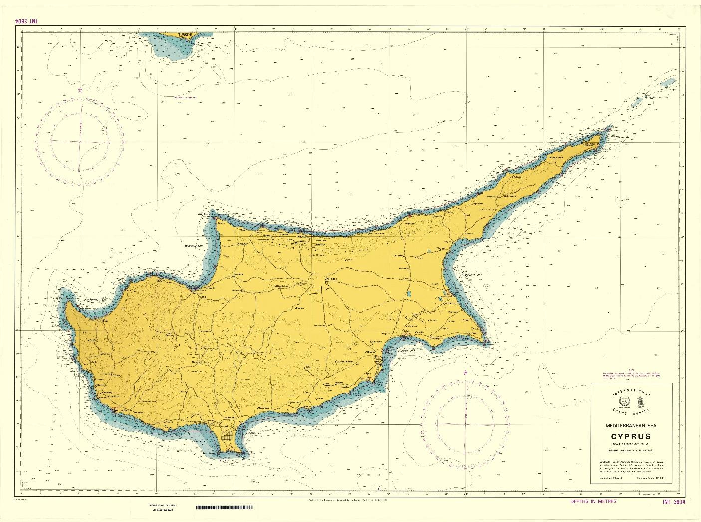
Figure 1:Bathymetry of Cyprus (United Nations, 1996).

There are four major water masses in the Levantine Basin, and all of these water bodies are present in Cyprus waters: 1. Levantine Surface Water (LSW), 2. Atlantic Water (AW), 3. Levantine Intermediate Water (LIW) and 4. Eastern Mediterranean Deep Water (EMDW). Physical oceanographic studies carried out by the Oceanographic Centre of the University of Cyprus in September 2005, demonstrated that LSW body had a thin surface layer (20 m thick) of very warm (26.9°C) and salty (39.51 psu) waters. Based on in-situ and remote sensing analysis, it was found that sea surface salinity and temperature ranges between 39-39.5 psu and 17-28°C, respectively (Samuel-Rhoads et al., 2008). The EMDW body is found at depths below 500 m. it’s a slow moving and relatively homogenous water mass, with its temperature and salinity ranging from 13.3-13.38°C and 38.66-38.8 psu.

The Levantine Basin surface circulation appears to be following a counter-clockwise direction (cyclonic) around the basin, with stronger flow during the winter months. Additionally, the Shikmona gyre system was identified in the region south and east of Cyprus (Fig.2) following a clockwise (anticyclonic) flow direction. The Shikmona gyre system carries cold AW. A second anticyclonic system is observed southwestern of Cyprus, known as the Mersa-Matruh gyre (Ozsoy et al., 1989). However, the general circulation in the Levantine Basin varies between years and seasonally. For instance, Zodiatis et al., (2005) observed that the warm core eddy shifted westwards during the period 2000-2001 and the Shikmona gyre was re-established during the summer period 2001-2003.

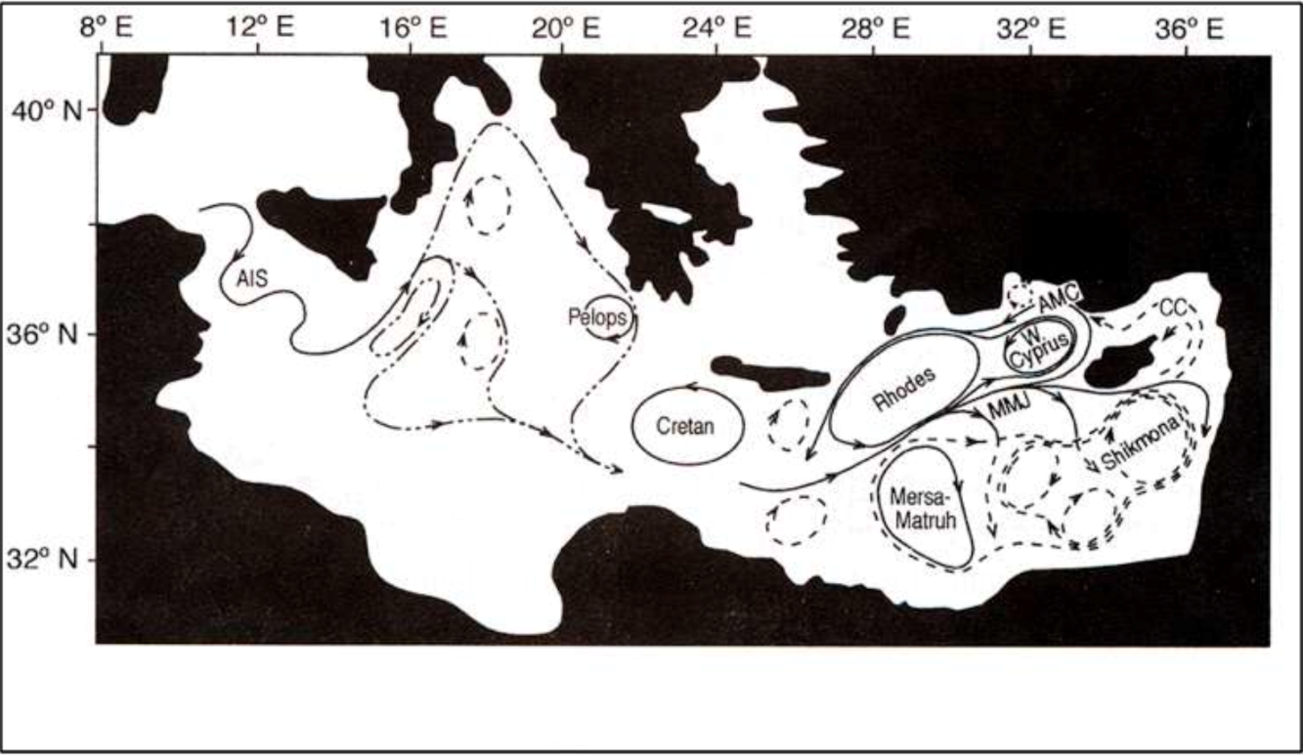
Figure 2: General water body circulation consisted of cyclonic and anticyclonic eddies (Robinson et al., 1992).

Regarding wave energy and wave characteristics, Cyprus can be described by its low wave energy and wave heights due to its shelter geomorphology in the Mediterranean Sea, allowing only for the development of weaker storms. Tides in the eastern Mediterranean are in the range of 0.3-0.4 m. Sea level fluctuations are expected due to changes in wind forcing, barometric air pressure, water density, tides and waves. In the Eastern Mediterranean, changes in sea level of several centimetres are common and are induced by ocean currents. Criado-Aldeanueva et al., (2008) estimated that sea level rise in the Mediterranean was at a rate of 10 mm/yr for 1992-2005 based on satellite altimetry and in situ observations.

Table 1 Nutrient concentrations for various water bodies found in the Southern Levantine Basin form 1989 to 1995 (Kress and Herut, 2001).
Water mass | Season | NO₃⁻ (μmol/kg) | PO₄³⁻ (μmol/kg) | Si(OH)₄ (μmol/kg)
LSW | Summer | 0.06 ± 0.11 | 0.02 ± 0.02 | 1.09 ± 0.36
 | Spring | 0.2 ± 0.15 | 0.02 ± 0.03 | 1.16 ± 0.41
 | Transition | 0.29 ± 0.18 | 0.02 ± 0.01 | 1.47 ± 0.2
 | Winter | 0.6 ± 0.5 | 0.01 ± 0.01 | 1.23 ± 0.48
AW | Summer | 0.23 ± 0.74 | 0.02 ± 0.03 | 1.16 ± 0.69
 | Spring | 0.33 ± 0.45 | 0.02 ± 0.02 | 1.35 ± 0.42
 | Transition | 0.38 ± 0.35 | 0.01 ± 0.02 | 1.58 ± 0.27
LIW | Summer | 0.55 ± 0.65 | 0.03 ± 0.02 | 1.2 ± 0.5
 | Spring | 1.99 ± 1.02 | 0.05 ± 0.03 | 1.81 ± 0.87
 | Winter | 1.19 ± 1.22 | 0.03 ± 0.04 | 1.7 ± 1.17
DW | All | 5.57 ± 0.30 | 0.23 ± 0.03 | 10.33 ± 0.60

The Levantine Basin is considered one of the most oligotrophic ocean bodies, with its nutrient levels in the euphotic zone being extremely low year-round (Krom, 1995). The Table 1 below gives the nutrient concentrations of various water masses in the Levantine Basin at different times of the year from 1989 until 1995. A more detailed Table 2 is given, with the average nutrient concentrations for the coastal surface waters of Cyprus between the years of 2004 and 2010. Additionally, concentrations of organic material, including particulate organic carbon (POC), particulate nitrogen (PN) and particulate phosphorus (PP) were also found low.

Table 2 Average nutrient concentrations of coastal surface waters of Cyprus for the years of 2004 to 2010 (Argyrou and Loizides, 2005; Argyrou 2006; 2008).
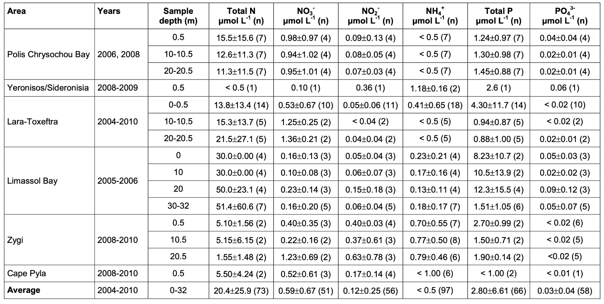

Hydrographic survey

- Purpose

The measurement of current speed and direction is not a strict monitoring activity as a result of aquaculture operations but is necessary to characterise to local water flow field in estimating and understanding how the fish cages will impact the site as well as how the conditions at the site could potentially impact aquaculture operations. As it previously discussed, the mean water current speeds and direction can influence the distribution of wastes around the fish cages and in extreme cases the fish wellbeing. Thus, according to FAO (2017) guidelines, the tidal current speed and direction should be measured at three different depths for a minimum of 15 days period along with the wind environment at site. This measurement would provide information on the physical characteristics of the water body and on surface water movements. Another important requirement should be information regarding the local topography prior to the establishment of the cages. This information is needed during the site application phase as specified in various environmental assessment process. Data recorded prior to the establishment of marine aquaculture cages would remain valid unless another survey is requested (FAO,2017). Changes in wind speeds and direction, only have the ability to influence surface ocean circulation, as the Coriolis force and the generated wind drift currents decay with depth (Bressan and Constantin, 2019).

- Field Data Collection

There are numerous different deployment techniques for measuring currents, with the most common being 1. The Acoustic Doppler Current Profiler (ADCP), 2. Discrete Measuring Devices, including acoustic current meters, electro-magnetic current meters (ECMs) and impeller-type current meters. All the options listed have a pressure gauge fitted, which is either attached or built into the unit. The pressure gauge will record changes in tidal height above the specific meters at each depth, thus giving an approximated value for depth changes.

Discrete current meters include mechanical, acoustic and electro-magnetic devices (Fig. 3-5). In all three cases, current velocity is determined by measuring the relationship between current speed and the device’s orientation in the water. The orientation of the deployed device is determined by an on-board electro-magnetic compass. Additionally, all meters should have a pressure sensor in estimating water pressure simultaneously with current speed.

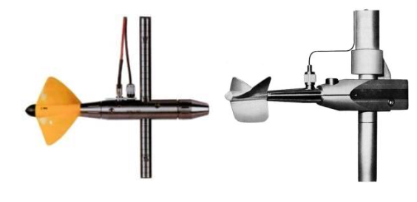
Figure 3 Mechanical Current Meter (Perzyna, 2016).

The principle of operation for a mechanical current meter is based on the proportionality between the velocity of the water and the resulting angular velocity of the meter propeller. Their impellers complete a calibrated number of revolutions during the sampling period, in response to water flow. Thus, returning an average of the flow speed during the pre-set sampling period. Each impeller has a minimum starting velocity value, set as the threshold, once water velocity exceeds this value, the impeller will turn on and current values will be recorded. Sampling period should be more than 30 seconds and less than 2 minutes, in minimizing the effects of short-term turbulence and in reducing the bias by sub-threshold speeds, in each case, respectively (Perzyna, 2019).

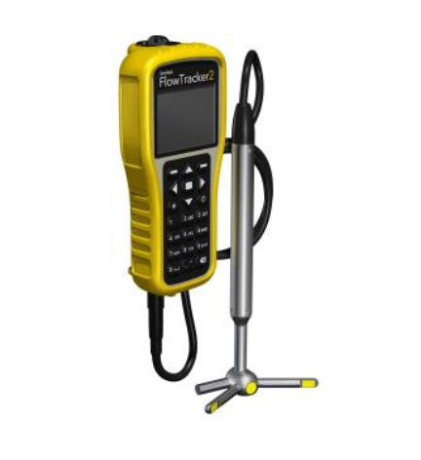
Figure 4 Acoustic Doppler Meter (Perzyna, 2016).

The acoustic current meter uses the Doppler Principle in estimating water velocities. Acoustic meters transmit sound pulses at a specific frequency into the flowing water. When a sound is reflected back due to a moving particle in the stream, its echo returns to the sensor at a different frequency. Orthological current components are determined by resolving the signals from two or more transducers aligned with specific divergent beam angles. The precision of these values reflects the number of estimates and the sampled volume of water. Returning signals are then analysed and processed to deliver flow velocities (FAO, 2017).

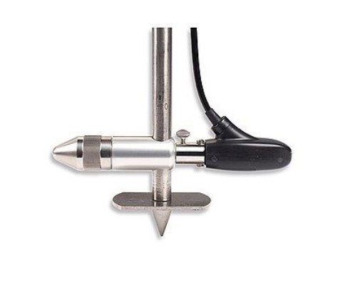
Figure 5 Electro-magnetic Current Meter (Perzyna, 2016).

The electromagnetic current meters function under the principles of Faraday’s law of electromagnetic induction. When the water moves through the magnetic field set by the device, the orthologically aligned electrodes of the water generate a voltage, which is then measured by the device. According to Faraday’s law, the voltage produced by the conductor, which in the given case will be the water, is proportionally linear to the water flow velocity (Perzyna, 2016).

Wind speed and direction, should also be recorded, as previously discussed. Wind characteristics can be measured using a suitable weather station, attached at a fixed location. Measurements should be taken at 2 m above the surface of water on three different occasions during daylight hours every time a current meter device is deployed, or for a minute every hour if an automated system is used (FAO, 2017).

Sediment and Benthic monitoring survey
- Purpose

Previous literature has highlighted the effects of marine aquaculture on the seabed. The farthest the cages are from the seabed, as in the case of open sea aquaculture, the effects are minimised. Depending on the flow regime of the area, the effects can be separated as short-lived at dynamic sites and long-lived at sites with lower energy. In determining the impact of fish cages on the benthic environment, a number of biological and physio-chemical parameters should be examined. Firstly, a sediment survey should be conducted annually, approximately at the same time each year. Sediment survey must coincide with the peak biomass period, when the level of biomass should normally be at its highest and thus, the waste deposition of particulate matter from fish cages is the heaviest.

Sediment surveys should consist of:

- Visual evaluation of sediment condition below and near the cages (approximately 1 km radius)
- Collection of sediment samples for macrofaunal composition analysis
- Measurement of sediment redox conditions
- Measurement of sediment grain size
- Measurement of sediment carbon, nitrogen and phosphorus concentrations
- Measurement of sediment copper concentration (only at sites where anti-fouling materials are used)

The final report should include results from the measurements outlined above prior to the establishment of the aquaculture, which will be later on used as the baseline conditions of the area. Thus, annual measurements will give an overall indication of the level of impact against normal/baseline conditions.

- Field Data Collection

Different benthic surveys are required at different aquaculture production levels. Fish tonnage production can be separated into small scale production for less than 250t, small to medium scale production units for 250t – 1000t of fish, and large-scale production for more than 1000t of fish produced.

For a small-scale production, that is less than 250t of fish produced, videographic or photographic survey can be conducted. The videographic/photographic surveys are physically carried out by divers, thus, this type of survey can only be conducted in water depths of less than 30 m, for safety reasons. In case that the site is located in depths that exceed the 30 m, then the site should be treated the same as small to medium scale production. For the open sea aquacultures where the depth is deeper than 30m a ROV must be used for safety.

Video or photographic data provide a rough estimation of sediment condition by providing a visual record of the conditions such as amount of fish feed and faeces, species composition etc, during the sampling time. In addition to the video/photo data, sediment samples should also be retrieved by the diver in assessing the physio-chemical nature of the sediments.

Videographic and photographic survey should be conducted for depths less than 30 meters by two divers, for safety reasons, using a suitable underwater video recorder or camera, ideally a panoramic, wide-angle camera should be used (Jonker et al., 2020). Firstly, a weighted line with approximately 10 kg attached on each site should be deployed by the divers. One end of the line should be located at the edge of the cage, and the other end is pulled away from the cage in the current prevailing direction, forming a straight line. Every 5 m, the line should be marked, giving the approximate distance from the cage. Adopted procedure should be used for surveys in deeper sampling areas. In those areas divers will be replaced by the ROVs.

The first transect of the survey, should be in the main current direction, as mentioned, and the second transect in the cross current direction. Underwater video camera should record the local environment and sediment species composition along the transects at approximately 1 m above the transect line. Photographic stills should be captured with a minimum of 5 repetitions at each station. When taking photographs, at least one of the five samples should contain the station number label, and a rule should be also placed on the sediment for scale reference.

Regarding the physio-chemical parameters, sediment samples must be obtained from the site. At each station on the transect lines laid out for videographic and photographic survey, one sediment core should be removed for particle size analysis. Cores should have a depth of 20 cm to cause the minimum possible disturbance to the sediment. Photographs should also be taken of each core, next to a rule for scale. All cores should be marked with the transect and station number. Additionally, at each station, the diver should use a 50 ml Sterillin universal container, that the 2 cm from the top sediment can be scooped. Samples in the sterile constrainers should be labelled with the transect and station number. Samples should be frozen as soon as possible after the collection and transported to the laboratory for the following analysis:

- Carbon analysis
- Nitrogen analysis
- Copper concentration (only in cases that anti-fouling materials are used)
- Redox potential (refer to Andoniadis et al., 2020 for techniques).

For cage aquaculture sites that are producing 250t to 1000t of fish, classified as small-medium scale production unites, the simple benthic survey is required in monitoring the effects on benthic communities. Simple benthic surveys are carried out annually $±$ 2 months and should ideally coincide with peak biomass at the site. The van Veen grab sampler should be utilized in the annual faunal monitoring analysis. Grab size influences the number of replicates needed per station, the bigger the size (m²) the fewer the replicates. (e.g. with a Van-veen Grab of 0.1m² surface at least three replicates and of 0.05 m² at least 5 replicate shall be collected) Similar sampling methodology will be followed here regarding distance from the fish cage as previously discussed. That is, samples should be taken at the edge of the fish cage, 50m and 100m away from the cage in the prevailing current direction and in cross-current direction. An additional sample should be taken from the control site, located approximately 1000-1200m away from the cages. Those sampling sites are according FAO(2017) guidelines for coastal units. For offshore aquaculture units, it is recommended to add more stations according to the distribution distance of food waste/fish faeces, in both cross current direction and in the prevailing current direction. Additionally, the control site should be moved further away outside the possible impact area. It’s important to note here that the control station should have a similar water depth and hydrodynamic conditions compared to the cage site. and be away of any human activities Small sediment samples will be transferred and sealed in a polyethene bag and transported directly to the laboratory. for faunal analysis Larger samples, that cannot be directly transported to the laboratory, need to be sieved directly on-site. The sample is washed on the sieving table until most of the unwanted sediment is removed, and then is transferred to a sealable container as described above. Once the samples are washed, sieved and stored, they are preserved by adding ethanolin seawater and then transported to the laboratory for faunal analysis.

For the physio-chemical annual monitoring analysis, sediment samples are collected by the Van Veen grab samplers as described for the faunal analysis above. Separated samples should be collected for physio-chemical analysis and for faunal analysis, no ethanol will be added in the samples used for physio-chemical analysis. The same methodology will be followed as the one presented for small-scale production aquaculture. Chemical and further analysis of the sample will be undertaken at the laboratory, and it should include the following:

- Redox potential
- Copper concentration
- Grain size analysis
- Carbon concentration
- Nitrogen concentration

For cage aquaculture sites that are producing more than 1000t of fish, classified as large-scale fish farms, an extended benthic survey is required. The extended benthic survey must be carried out annually $±$ 2 months and should ideally coincide with peak biomass at the site. The procedures regarding field data collection for the benthic sample and physio-chemical analysis are the same as the ones outlined above for Simple Benthic Survey. The difference between simple and extended benthic surveys relies on the number of stations. For the extended benthic surveys, there are eight collection stations, seven along the two transects and one at the control site. For the transect in the current prevailing direction, samples should be collected at the cage edge, 50 m, 100 m, and 200 m away from the cage. Whereas, in the cross-current direction samples are taken from the cage edge, 50 m and 100 m away from the cage edge. As mentioned those sampling sites are according FAO(2017) guidelines for coastal units. For offshore aquaculture units, it is recommended to add more stations according to the distribution distance of food waste/fish faeces, in both cross current direction and in the prevailing current direction.

Water quality survey
- Purpose

The Mediterranean Sea is an oligotrophic water system with a low level of primary productivity, thus, nutrients added by the fish farms would potentially have significant impacts considering the environmental setting of the area. Water quality needs to be measured daily regarding water temperature and dissolved oxygen concentrations. These two factors are important for the farm management site in establishing the water conditions, deciding the appropriate feeding amount, and conversely informing the farmer when the conditions are unsuitable for feeding. Additionally, the following parameters should be measured on a monthly basis:

- Ammonia
- Nitrate
- Nitrite
- Phosphorus
- Chlorophyll-a

Water quality surveys should be carried out in a monthly basis, starting prior to the initial stocking, thus, creating a baseline of the water quality of the area.

- Field Data Collection

Dissolved oxygen concentration and temperature should be measured on-site. Ideally, measurements will be taken twice a day (morning and afternoon), at approximately the same time ($±$2 hours) both inside and outside all the cages. This would provide an overall description of the dissolved oxygen conditions at each cage site. Taking into consideration the regularity of sampling, it is advised for an automated system of recording to be utilized. If the environmental conditions do not permit the use of an automated system an appropriate probe/meter (Fig.6) should be used. Measurements should be ideally taken at a depth of $-\frac{1}{2}⋅Net Depth$, and a minimum depth of three meters. Date, time, cage number, dissolved oxygen concentration (%), and temperature (°C) should be recorded daily.

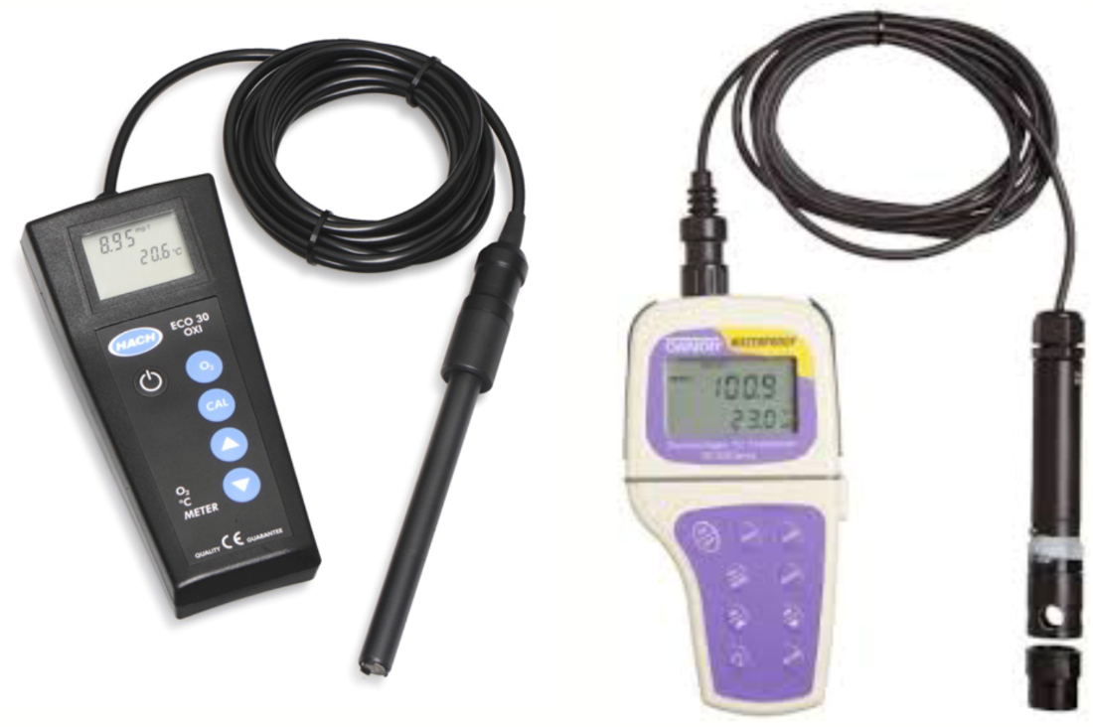
Figure 6 Example of dissolved oxygen and temperature probes (NOA, 2017).

Regarding the remaining parameters listed above (ammonia, nitrate, nitrite, chlorophyll-a, and total phosphorus) water sampling is needed. Water samples should be taken from four different locations per station for each sampling station. The four locations are, 1) cage edge, 2) 100 m away from the cage, 3) 200 m away from the cage and 4) 1000 – 1200 m away from the cages in the current prevailing direction. It is important to note that all samples should be collected twice for accuracy reasons. Appropriate water samplers such as Van Dorn and Niskin (Fig.7) are deployed at the required depths. When the water samplers have reached the appropriate depth, a weight, traveling down the rope and attaching the sampler with the station, would close the sampler. Then the sampler can be recovered to the surface. In a polyethylene bottle, transfer 1L of the water sample. Repeat the above procedure for the depths required per station at each sampling station(minimum sampling should include a sample from the surface layer, a sample from the middle layer and a sample from the bottom layer). The above procedure could also be replaced by an intergrader sampler which has the capability to collect samples from multiple depths. All samples should be kept in a cool box with ice and transported to a laboratory for water analysis.

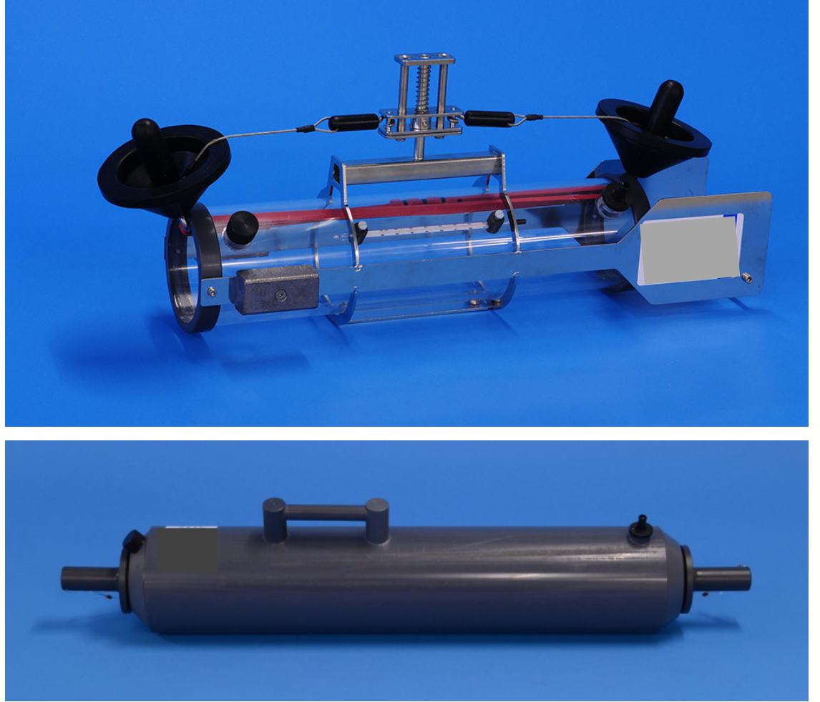
Figure 7 Van Dorn (top) and Niskin (bottom) water samplers (FAO,2017).

Survey Type and Timing

Marine cage aquaculture facilities will carry out monitoring surveys following the protocols listed below (See references attached to Table 3). Specific monitoring requirements will depend on the level of biomass production of the facilities, with the hydrographic survey being the only exception that is required at all levels of production.

Tonnage | Survey Type | Timing of Survey | Type of Collected Data
All sites | Hydrographic survey  (International Hydrographic Bureau, 2010) | Once during the application and licensing procedure | - Current speed and direction  - Water pressure  - Wind speed and direction
All sites | Baseline benthic survey  (Lang et al., 2015) | Once during the application and licensing procedure | - Sediment samples for fauna analysis  - Redox measurements  - Samples for particulate size analysis  - Samples for carbon analysis  - Samples for nitrogen analysis  - Samples for copper analysis (in cases where anti-fouling materials are used)
All sites | Water quality survey  (PHILMINAQ, 2016) | Data collected monthly¹ | - Temperature  - Dissolved Oxygen  - Ammonia  - Nitrate  - Nitrite  - Phosphorus  - Chlorophyll-a concentration
250t> | Videographics or photographic benthic survey  (Lang et al., 2015) | Annual on same date $±$ 1 month | - Video/photographs of the seabed  - Redox measurements  - Samples for particulate size analysis  - Samples for carbon analysis  - Samples for nitrogen analysis  - Samples for copper analysis (in cases where anti-fouling materials are used)
250-1000t | Simple benthic monitoring survey  (Lang et al., 2015) | Annual on same date $±$ 2 months² | - Sediment samples for fauna analysis  - Redox measurements  - Samples for particulate size analysis  - Samples for carbon analysis  - Samples for nitrogen analysis  - Samples for copper analysis (in cases where anti-fouling materials are used)
1000t< | Extended benthic monitoring survey  (Lang et al., 2015) | Annual on same date $±$ 2 months²  (Increased number of sample stations) | - Sediment samples for fauna analysis  - Redox measurements  - Samples for particulate size analysis  - Samples for carbon analysis  - Samples for nitrogen analysis  - Samples for copper analysis (in cases where anti-fouling materials are used)
¹ Collected at approximately the same date each month
² Actual date depends on species growth cycles and peak biomass period. For sea bream with a growth cycle of 12-14 months, sampling should take place 12 months after stocking, thus sampling and peak biomass periods will overlap.

Large Scale monitoring of Aquaculture sites
In addition to the in-situ monitoring guidelines described in the previous section, this deliverable also assesses the large-scale impact that aquaculture may have on the environment. Such impact is the leak of nutrition and the possibility of Harmful algae bloom development in the nearby coastlines(Schollaert et al,2020) . In order to assess this impact, there are more efficient techniques from in-situ monitoring.
Remote sensing is a technique for aquaculture monitoring due to its ability to provide comprehensive and near real-time information regarding the marine environment. The major advantages are its capacity to cover extensive geographical areas, allowing for efficient monitoring of different scales.
The capabilities of remote sensing instruments enable the assessment of key parameters such as water temperature, salinity, turbidity, and chlorophyll-a concentration, which directly affect the health of marine ecosystems(Schollaert et al,2020). Remote sensing data enables the tracking of changes over time, identification of trends, and detection of anomalies. This information is invaluable for identifying environmental impacts.
The usage of remote sensing data for an early warning system represents a transformative approach to proactive environmental management, particularly in aquaculture(Schollaert et al,2020). This near real-time data collection allows for the rapid detection of deviations from normal conditions, providing timely alerts about potential issues such as changes in water quality, temperature anomalies, or harmful algal blooms. These alerts can trigger prompt responses and interventions, minimizing the risk of adverse impacts on aquaculture operations, ecosystem health, and nearby communities. Remote sensing-driven early warning systems empower aquaculture managers and authorities to take preventive measures and implement adaptive strategies, safeguarding both economic interests and environmental sustainability.

Remote sensing is used for the identification of eutrophication and acts as an early warning system. The excess of nutrients leads to plankton overgrowth, which leads to harmful algal blooms, and oxygen depletion. This has negative impacts on aquatic biodiversity, fisheries, and recreational activities. Early detection of this phenomenon, eutrophication, is essential to prevent or mitigate its adverse effects. Satellite remote sensing offers a unique opportunity to monitor water quality parameters over large areas and provide timely information for effective management.

An effective early warning system for eutrophication using satellite datasets requires the integration of satellite data, water quality models, and data assimilation techniques. Below is a recommended procedure for setting up an early warning system.

Stages Developing an Early Warning System for Eutrophication:

Satellite Data Acquisition: Selection of suitable satellite sensors with optimal spectral bands for retrieving water quality parameters relevant to eutrophication, such as chlorophyll-a concentration and suspended sediment concentration. Examples of satellites are MODIS-AQUA, Sentinel 2, and Sentinel 3. For the retrieval of the satellite, datasets can be done manually and automated through Python, R, and other similar programming software.

Calibration and Validation: Establishing robust algorithms to convert satellite measurements into water quality parameters, accounting for atmospheric corrections and validation against in-situ measurements. Depending on the products downloaded atmospheric correction may or may not take place.

The implementation of an early warning system for eutrophication using satellite datasets offers various applications and benefits. These include:

HAM early Alerts: Satellite-based early warning systems can provide timely alerts to water resource managers and stakeholders about the onset and development of eutrophication, facilitating prompt response and mitigation actions.

Long-term Monitoring: Continuous satellite monitoring allows the assessment of long-term eutrophication trends, enabling the evaluation of management strategies and the effectiveness of remediation efforts.

The previous steps must be followed in each region in which remote sensing monitoring is required. Fine-tuning and calibration is a unique step that must be followed in every new region and to be adapted according the characteristics of the region used.
An early warning system for eutrophication using satellite datasets has the potential to revolutionize water quality management by providing timely and comprehensive information on eutrophication dynamics. By integrating satellite remote sensing, water quality models, and data assimilation techniques, this system can contribute to effective mitigation strategies, ensuring the sustainable management of water resources.

Intelligent Aquaculture solutions

Fish farming is entering a new, intelligent era, where decisions must be based on empirical data and analytics, instead of relying on past practices, intuition, and speculation (Mustapha et al 2021). To implement this data-driven approach successfully, it is crucial to have accurate information, which necessitates robust monitoring tools backed by powerful analytic capabilities. Advanced aquaculture intelligence solutions take environmental, biological, and physical monitoring to unprecedented levels, offering unmatched real-time visibility into every aspect of operation. With the adoption of modern tools and technologies to comprehend the intricacies of their operations, fish farmers can reduce costs, prevent fish mortality, and improve efficiency. These systems include several components. The first layer consists of high-end, state-of-the-art sensors[1], [2] and high-resolution cameras. Sensors and cameras then send data which are analysed through sophisticated algorithms and presented to operators as actionable items.
In an aquaculture pen, sensors can monitor dissolved oxygen level, temperature, salinity, chlorophyll-a, blue-green algae, turbidity and colored dissolved organic matter. As per the information above, these parameters link to water quality, fish health, and nutrient load. Current and weather stations offer information to protect the aquaculture stock and the infrastructure. Current profilers provide mean flow measurements and data about waves and currents are also part of this system measuring wind speed and direction, air temperature, barometric pressure, and relative humidity.
Fish physiological responses can be monitored directly through implantable data loggers, and indirectly through high-resolution underwater cameras. Data loggers can monitor depth (pressure), heart rate, salinity (conductivity), tilt angle, and magnetic field strength (compass) to detect stress, motion, and physiological responses to environmental conditions[3]. This information can improve welfare and decrease mortality rates. High-resolution cameras could also be used to monitor the state of the infrastructure and fish status. Going one step further, biomass cameras, combine stereoscopic imaging with artificial intelligence technology to instantly estimate the size and weight of fish stocks in real-time to help optimize production and reduce feeding costs. They also provide accurate growth projections to improve resource planning and sales forecasting and ultimately boost revenues.
Innovative IP cameras can also be used for feed optimization. The camera, in conjunction with machine learning, captures and identifies food pellets and asserts whether they are eaten, ignored, or sinking to the bottom of the pen. As feed is the costliest resource in aquaculture operations, the technology aims to eliminate lost feed days and improve feed conversion ratios (FCR) to lead to a profitable operation.
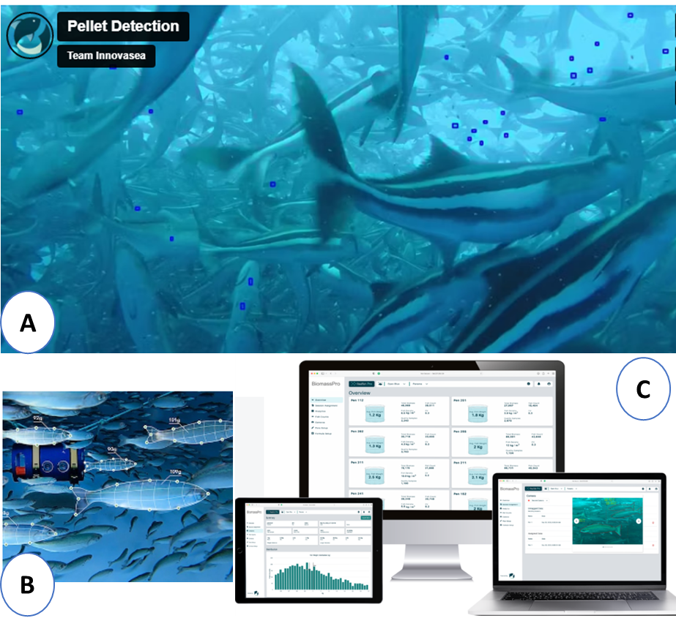
Figure 8 Examples of IoT aquaculture solutions regarding (a) pellet detection (b) biomass calculation and (c) data analysis and visualization tools.
Sensors and cameras require a way to communicate data to centralized repository designed to store, process, and secure large amounts of data. The system requires a communication system. Data could be communicated via cellular connection, Wi-Fi, LoRa, or Iridium satellite and sent to a secure cloud, base station, or other server. In isolated areas, a local area network can be used in combination with the aforementioned communication strategies. Access to remote data is particularly important in open sea and remote area aquaculture since it can aid in keeping costs low and operations running smoothly with minimum traveling to the site.
In IoT solutions data are funneled to a platform (e.g. Innovasea Realfish Pro, USA[4]) that uses powerful tools to optimize operations. These tools usually use machine learning and artificial intelligence to process and analyse data. Products are then presented to operators, who can then use them to make informed decisions. The information would include environmental status above and bellow sea level, the status of the cages and the health of the fish.

[1] Wireless Sensors for Aquaculture - Innovasea
[2] Aquaculture Monitoring System | Rika Sensors
[3] Archival tags for fish tagging (star-oddi.com)
[4] Realfish Pro Platform - Innovasea

References

Aguado-Gimenez, F., Garcia-Garcia, B., Hernandez-Lorente, M. D. and Cerezo-Valverde, J. (2006). Gross metabolic waste output estimates using a nutritional approach in Atlantic bluefin tuna (Thunnus thynnys) under intensive fattening conditions in the western Mediterranean Sea. Aquaculture research, 37, 1254-1258.

Alfonso, S., Gesto, M. and Sadoul, B. (2021). Temperature increase and its effects on fish stress physiology in the context of global warming. Journal of Fish Biology, 98(6), 1496-1508.

Argyrou, M. (2006). Programme for the assessment and control of pollution in the Mediterranean region: Report of the National Monitoring Programme of Cyprus – Year 2005. Department of Fisheries and Marine Research, Nicosia, Cyprus.

Argyrou, M. (2008). Programme for the assessment and control of pollution in the Mediterranean region: Report of the National Monitoring Programme of Cyprus – Years 2006 and 2007. Department of Fisheries and Marine Research, Nicosia, Cyprus.

Argyrou, M. and Loizides, L. (2005). Programme for the assessment and control of pollution in the Mediterranean region: Report of the National Monitoring Programme of Cyprus – Year 2004. Department of Fisheries and Marine Research, Nicosia, Cyprus.

Ashraf, P. M., Sasikala, K. G., Thomas, S. N. and Edwin, L. (2017). Biofouling resistant polyethylene cage aquaculture nettings: A new approach using polyaniline and nano copper oxide. Arabian Journal of Chemistry, 13, 875-882.

Belle, S. M. and Nash, C. E. (2008). Better management practises for net-pen aquaculture. In C. S. Tucker and Hargreaves, J., editors. Environmental Best Management Practices for Aquaculture. Blackwell Publishing, Ames, Iowa.

Benkhelil, J., Nguyen, L. and Mascle, J. (2000). Effects of the Africa-Europe collision on the seafloor morphology in eastern Mediterranean after the data of the PRISMED II Survey. Mediterranean Conference for Environment and Solar, Beirut Lebanon.

Beveridge, M. (2004). Cage aquaculture. Blackwell Publishing, Oxford, UK.

Bi, C. W., Chen, Q. P., Zhao, Y. P., Su, H. and wang, X. Y. (2020). Experimental investigation on the hydrodynamic performance of plane nets fouled by hydroids in waves. Ocean Engineering, 213.

Bressan, A. and Constantin, A. (2019). The Deflection Angle of Surface Ocean Currents From the Wind Direction. Journal of Geophysical Research Oceans, 124, 7412-7420.

Burridge, L. (2003). Chemical use in marine finfish aquaculture in Canada: A review of the current practices and possible environmental effects. Pages 97-131 in Canadian Technical Report of Fisheries and Aquatic Sciences 2450, Volume 1.

Burridge, L., Weis, J. S., Cabello, F., Pizarro, J. and Bostick, K. (2010). Chemical use in salmon aquaculture: A review of current practices and possible environmental effects. Aquaculture 306, 7-23.

Campbell, M. D. and Hall, S. G. (2018). Hydrodynamic effects on oyster aquaculture systems: a review. Reviews in Aquaculture, 11, 896-906.

Cole, R. (2002). Impacts of marine farming on wild fish populations. Final Research Report for Ministry of Fisheries Research Project ENV2000/08 Objective One. National Institute of Water and Atmospheric Research, New Zealand.

Cook, T., Folli, M., Klinck, J., Ford, S. and Miller, J. (1998). The relationship between increasing sea-surface temperature and the northward spread of Perkinisus marinus disease epizootics in oysters. Estuarine, Coastal and Self Science, 46(4), 587-597.

Criado-Aldeanueva, F., Vera, J. D. R. and Garcia-Lafuente, J. (2008). Steric and mass-induced Mediterranean sea level trends from 14 years of altimetry data. Global and Planetary Change, 60, 563-575.

Cromey, C. J., Nickell, T. D., and Black, K. D. (2002). DEPOMOD—modelling the deposition and biological effects of waste solids from marine cage farms. Aquaculture 214, 211–239.

Dalsgaard, T. and Krause-Jensen, D. (2006). Monitoring nutrient release from fish farms with macroalgal and phytoplankton bioassays. Aquaculture, 256, 302-310.

Dawood, M. A. O. (2021). Nutritional immunity of fish intestines: Important insights for sustainable aquaculture. Reviews in Aquaculture, 13(1), 642-663.

Delgado, O., Ruiz, J., Perez, M., Romero, J. and Ballesteros, E. (1999). Effects of fism farming on seagrass (Posidonia oceanica) in a Mediterranean Bay: seagrass decline after organic loading cessation. Oceanol. Acta, 22(1), 109-117.

FAO. (2006). Aquaculture Production: Quantities 1950-2004. FAO, Rome.

FAO. (2020). The state of world fisheries and Aquaculture 2020. Sustainability in action. Rome.

Fernandes, T. F., Eleftheriou, A., Ackefors, H., Eleftheriou, M., Ervik, A., Sánchez- Mata, A., et al. (2001). The scientific principles underlying the monitoring of the environmental impacts of aquaculture. J. Appl. Ichthyol. 17, 181–193.

Fredriksson, D. W., Swift, M. R., Irish, J. D., Tsukrov, I. and Celikkol, B. (2003). Fish cage and mooring system dynamics using physical and numerical models with field measurements. Aquaculture Engineering, 272: 117-146.

Gansel, L. C., Oppedal, F., Birkevold, J. and Tuene, S. (2018). Drag forces and deformation of aquaculture cages – full-scale towing tests in the field. Aquaculture Engineering, 81, 46-56.

Gowen, R. J., Weston, D. P., and Ervik, A. (1991). Aquaculture and the benthic environment: a review, in Proceedings of the 1st International Symposium on Nutritional Strategies in Management, Nutritional Strategies and Aquaculture Waste, eds C. B. Cowey, and C. Y. Cho, (Guelph: University of Guelph), 187–205.

Grosell, M., Blanchard, J., Brix, K. V. and Gerdes, R. (2007). Physiology is pivotal for interaction between salinity and acute coper toxicity to fish and invertebrates. Aquatic Toxicology 84, 162-172.

Guardiola, F. A., Cuesta, A., Meseguer, J. and Esteban, M. A. (2017). Risks of using antifouling biocides in aquaculture. International Journal of Molecular Sciences, 13, 1541-1560.

Holmer, M. (2010). Environmental issues of fish farming in offshore waters: perspective, concerns and research needs. Aquaculture Environmental Interact, 1, 57-70.

Holmer, M., Hansen, P. K., Karakassis, I., Borg, J. A. and Schembri, P. (2008). Monitoring of environmental impacts of marine aquaculture. In Holmen, M., Black, K., Duarte, C. M., Marbam N. and Karakassis, I., editors. Aquaculture in the Ecosystem. Springer, Dordrecht, London.

Holmer, M., Marbà, N., Díaz-Almela, E., Duarte, C. M., Tsapakis, M., and Danovaro, R. (2007). Sedimentation of organic matter from fish farms in oligotrophic Mediterranean assessed through bulk and stable isotope (δ13C and δ15N) analyses. Aquaculture 262, 268–280.

Holmer, M., Wildish, D. and Hargrave, B. (2005). Organic enrichment from marine finfish aquaculture and effects on sediment biogeochemical processes. In Hargrave, B. T., editor. Environmental effects of marine finfish aquaculture. Handbook of Environmental Chemistry, Volume 5M. Springer-Verlag, Berlin.

Hvas, M., Folkedal, O., Solstorm, D., Vagseth, T., Fosse, J. O., Gansel, L. C., and Oppedal, F. (2017). Assessing swimming capacity and schooling behaviour in farmed Atlantic salmon Salmo salar with experimental push-cages. Aquaculture, 473, 423-429.

International Hydrographic Bureau. (2010). Manual on Hydrography 1st Edition. International Hydrographic Bureau, Monaco.

Islam, S. (2005). Nitrogen and phosphorus budget in coastal and marine cage aquaculture and impacts of effluent loading on ecosystem: review and analysis towards model development. Marine Pollution Bulletin 50, 48-61.

Johansson, D., Juell, J. E., Oppedal, F., Stiansen, J. E., Ruohonen, K. (2007). The influence of the pycnocline and cage resistance on current flow, oxygen flux and swimming behaviour of Atlantic salmon (Salmo salar L.) in production cages. Aquaculture, 265, 271-287.

Johansson, D., Laursen, F., Ferno, A., Fosseidengen, J. E. et al. (2014). The interaction between water currents and salmon swimming behaviour in sea cages. Plos One 9.

Jonsdottir, K. E., Hvas, M., Alfredsen, J. A., Fore, M., Alver, M. O., Bjelland, H. V. and Oppedal, F. (2019). Fish welfare based classification method of ocean current speeds at aquaculture sites. Aquaculture environment interactions, 11, 249-261.

Jun, L. J., Jeong, J. B., Kim, J. H., Jeong, H. N., et al. (2009). Influence of temperature shifts on the onset and development of red sea bream iridoviral disease in rock bream Oplegnathus fasciatus. Diseased of Aquatic Organisms, 84, 201-208.

Keil, R. G., Montlucon, D. B., Prahl, F. G., and Hedges, J. I. (1994). Sorptive preservation of labile organic matter in marine sediments. Nature 370, 549–552.

Kirsch, B. (2006). Marine Aquaculture from a Mediterranean Perspective. PPT Presentation. Future Aquaculture meeting, September 2006, Duino, Italy. Eurofish, FAO.

Klebert, P., Patursson, O., Endresen, P. C., Rundtop, P., Birkevold, J., Rasmussen, H. W. (2015). Three-dimensional deformation of a large circular flexible sea cage in high currents: field experiment and modelling. Ocean Engineering, 104, 511-520.

Kress, N. and Herut, B. (2001). Spatial and seasonal evolution of dissolved oxygen and nutrients in the Southern Levantine Basin (Eastern Mediterranean Sea): chemical characterization of the water masses and inferences on the N:P ratios. Deep-Sea Research I, 48: 2347-2372.

Krom, M. (1995). The oceanography of the eastern Mediterranean Sea. Ocean Challenge, 5, 22-28.

Kutti, T., Hansen, P. K., Ervik, A., Hosaeter, T., and Johanessen, P. (2007). Effects of organic effluent from a salmon farm on a fjord system. II Temporal and spatial patterns in infauna community composition. Aquaculture 262, 355–366.

Lader, P., Dempster, T., Fredheim, A. and Jensen, O. (2008). Current induced net deformations in full-scale sea-cages for Atlantic salmon (Salmo salar). Aquaculture Engineering, 38, 52-65.

Lang, J. C., Marks, K. W., Kramer, P. R. and Ginsburg, R. N. (2015). A Guide to Methods and Training Materials. AGRRA.

Lin, J., Miller, P. I., Jönsson, B. F., & Bedington, M. (2021). Early Warning of Harmful Algal Bloom Risk Using Satellite Ocean Color and Lagrangian Particle Trajectories . In Frontiers in Marine Science (Vol. 8). https://www.frontiersin.org/articles/10.3389/fmars.2021.736262
Loschau, M. and Kratke, R. (2005). Efficacy and toxicity of self-polishing biocide-free antifouling paints. Environmental Pollution, 138, 260-267.

Lupatsch, I. and Kissil, G. W. (1998). Predicting aquaculture waste from gilthead seabream (Sparus aurata) culture using a nutritional approach. Aquatic Living Resources, 11(4), 265-268.

Mirto, S., Pusceddu, A., Gambi, C., Holmer, M. and Danovaro, R. (2007). Ecological assessment of aquaculture impact in the Mediterranean Sea. CIESM Workshop Monographs No.32, Monaco.

Mugwanya, M., Dawood, M. A. O., Kimera, F. and Sewilam, H. (2022). Anthropogenic temperature fluctuations and their effect on aquaculture: A comprehensive review. Aquaculture and Fisheries, 7, 223-243.

Mustapha, U. F., Alhassan, A. W., Jiang, D. N., & Li, G. L. (2021). Sustainable aquaculture development: a review on the roles of cloud computing, internet of things and artificial intelligence (CIA). Reviews in Aquaculture, 13(4), 2076-2091.
Nash, C. E., Burbridge, P. R. and Volkman, J. K. (2005). Guidelines for ecological risk assessment of marine fish aquaculture. U. S. Department of Commerce. NOAA Technical Memorandum.

Nobakht-Kolur, F. Zeinoddini, M. and Ghalebi, A. (2021). Hydrodynamic forces in marine-fouled floating aquaculture cages: Physical modelling under irregular waves. Journals of Fluids and Structures, 105.

Okuzawa, K. and Gen, K. (2013). High water temperature impairs ovarian activity and gene expression in the brain-pituitary-gonadal axis in female red seabream during the spawning season. General and Comparative Endocrinology, 194, 24-30.

Oppedal, F., Dempster, T., Stien, L. H. (2011). Environmental drivers of Atlantic salmon behaviour in sea-cages: a review. Aquaculture, 311, 1-18.

Ozsoy, E., Hecht, A. and Unluata, U. (1989). Circulation and hydrography of the Levantine Basin – results of POEM co-ordinated experiments 1985-1986. Progress in Oceanography, 22, 125-170.

Panchang, V. G., Jeong, C. and Dongcheng, L. (2008). Wave Climatology in Coastal Maine for Aquaculture and Other Applications. Estuaries and Coasts, 31, 289-299.

Panchang, V. G., Newell, C. and Cheng, G. (1997). Modelling hydrodynamics and aquaculture waste transport in coastal Maine. Estuaries, 201, 14-41.

Pankhurst, N. W. and King, H. R. (2010). Temperature and salmonid reproduction: implications for aquaculture. Journal of fish biology, 76, 69-85.

Pearson, T. H. and Black, K. D. (2001). The environmental impacts of marine fish cage culture. Pages 1-31 in Black, K. D., editor. Environmental Impacts of Aquaculture. CRC Press, Boca Raton, Florida.

PHILMINAQ. (2016). Water Quality Criteria and Standards for Freshwater and Marine Aquaculture. PHILMINAQ Mitigating Impact from Aquaculture in the Philippines, Water Network Research.

Piedecausa, M. A., Aguado-Gimenez, F., Cerezo-Valverde, J., Hernandez-Lorente, M. D., et al. (2010). Simulating the temporal pattern of waste production in farmed gilthead seabream (Sparus aurata), European seabass (Dicentrarchus Labrax) and Atlantic bluefin tuna (Thunnus thynnys). Ecological Modelling, 221, 634-640.

Plumb, J. A. (1999). Overview of Warmwater Fish Diseases. Journal of Applied Aquaculture, 9(2), 1-10.

Pohlenz, C. and Gatlin, D. M. (2014). Interrelationships between fish nutrition and health. Aquaculture, 431, 111-117.

Price, C. S. and Morris, J. A. (2013). Marine cage culture and the environment: Twenty-first century science informing a sustainable industry. NOAA Technical Memorandum NOS NCCOS 164.

Robinson, A. R., Malanotte-Rizzoli, P., Hecht, A., Michelato, A., Roether, W. et al. (1992). General circulation of the Eastern Mediterranean. Earth-Science Reviews, 32, 285-309.

Roth, O., Kurtz, J. and Reusch, T. B. H. (2010). A summer heat wave decreases the immunocompetence of the mesograzer, Idotea baltica. Marine Biology, 157(7), 1605-1611.

Samuel-Rhoads, Y., Zodiatis, G., Hayes, D. R., Gertman, I. and Georgiou, G. (2008). Sea surface temperature and salinity rise in the eastern Mediterranean. Geophysical Research Abstracts.
Science for Environment Policy. (2015). Sustainable Aquaculture. Future Brief 11. Brief produced for the European Commission DG Environment by the Science Communication Unit, UWE, Bristol.

Schollaert S. Uz et al., "Supporting Aquaculture in the Chesapeake Bay Using Artificial Intelligence to Detect Poor Water Quality with Remote Sensing," IGARSS 2020 - 2020 IEEE International Geoscience and Remote Sensing Symposium, Waikoloa, HI, USA, 2020, pp. 3629-3632, doi: 10.1109/IGARSS39084.2020.9323465.

Solberg, C. B., Saethre, L. and Julshamn, K. (2002). The effect of copper-treated net pens on farmed salmon (Salmo salar) and other marine organisms and sediments. Marine Pollution Bulletin 45, 126-132.

Strain, P. and Hargrave, B. (2005). Salmon aquaculture, nutrient fluxes and ecosystem processes in southwestern New Brunswick. Pages 29-57 in Hargrave, B. T., editor. Environmental effects of marine finfish aquaculture. Handbook of Environmental Chemistry, 5M, Springer Verlag, Berlin.

Sunda, W. G. and Lewis, J. M. (1978). Effect of complexation by natural organic ligands on the toxicity of copper to a unicellular alga, Monochrysis lutheri. Limnology and Oceanography, 23(5), 870-876.

Swift, M. R., Fredriksson, D. W., Unrein, A., Fullerton, B., Patursson, O. and Baldwin, K. (2006). Drag force acting on biofouled net panels. Aquaculture Engineering, 35, 292-299.

The Mediterranean Science Commission. (2007). Impact of mariculture on coastal ecosystems. CIESM Workshop Monographs No.32, Monaco.

Ticina, V., Katavic, I and Grubisic, L. (2020). Marine Aquaculture Impacts on Marine Biota in Oligotrophic Environments of the Mediterranean Sea – A Review. Frontiers in Marine Science, 7 (217).

United Nations. (1996). United Nations Convention on the Law of the Sea concluded at Montego Bay, Jamaica. United Nations.

Valdemarsen, T., Bannister, R. J., Hansen, P. K., Holmer, M., Ervik, A. (2012). Biogeochemical malfunctioning in sediments beneath a deep-water fish farm. Environmental Pollution, 170: 15-25.

Valdemarsen, T., Kristensen, E., and Holmer, M. (2009). Metabolic threshold and sulfide-buffering in diffusion controlled marine sediments impacted by continuous organic enrichment. Biogeochem 95, 335–353.

Wang, J., Lu, D. Q., Jiang, B., Mo, X. B., Du, J. J., and Li, A. X. (2020). Influence of temperature on the vaccine efficacy against Streptococcus agalactiae in Nile tilapia. Aquaculture, 521, 734943.

Wu, R. S. S. (1995). The environmental impact of marine fish culture: Towards a sustainable future. Marine Pollution Bulletin, 31, 159-166.

Zodiatis, G., Drakopoulos, P., Brenner, S. and Groom, S. (2005). Variability of the Cyprus warm core Eddy during the CYCLOPS projects. Deep-Sea Research II, 52: 2897-2910.

