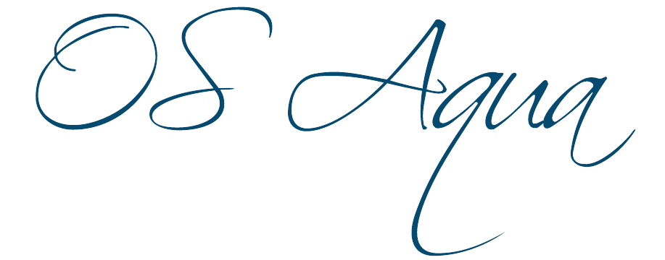

Open Sea Aquaculture
in the Eastern Mediterranean

The Project is co-financed with 800 K Euro by the European Regional Development Fund and the Republic of Cyprus through the Research and Innovation Foundation with grant number INTEGRATED/0918/0046

Work Package ID: WP3

Work Package Title: Ecosystem and oceanographic modelling for site selection

Deliverable ID: D12

Deliverable Title: Identification of sites where aquaculture will not affect the activities of other established users (tourists, fishermen, industry) of the coastal zone (Report, M36)

Status: Final

Dissemination Level: Public

Partner Leader: HCMR

Disclaimer
Use of any knowledge, information or data contained in this document shall be at the user's sole risk. Neither the OS Aqua Consortium nor any of its members, their officers, employees or agents accept shall be liable or responsible, in negligence or otherwise, for any loss, damage or expense whatever sustained by any person as a result of the use, in any manner or form, of any knowledge, information or data contained in this document, or due to any inaccuracy, omission or error therein contained.
The OS Aqua project (INTEGRATED/0918/0046) has been partially funded under the RESTART 2016-2020 Programme, Integrated Projects Call, of the Cyprus Research and Innovation Foundation. This publication reflects the views only of the authors, and the Funding Agency cannot be held liable or responsible for any use which may be made of the information contained herein or of any consequences thereof.
Copyright notice
© Copyright 2020-2024, The OS Aqua Consortium
This document contains information that is protected by copyright. All Rights Reserved. No part of this work covered by copyright hereon may be reproduced or used in any form or by any means without the permission of the copyright holders.

Executive Summary
D12 reflects progress of T3.4 using data from D10, D11, D13. Four (4) open sea areas (OSA’s) have been selected as potential OS AZAs for the modelling work at Xylofagou, Larnaca, Governor’s Beach South of Cyprus and Aphrodite Hills in southwest Cyprus.
The Hellenic Centre for Marine Research (HCMR) AIM model was applied with three nested intermediate resolution (~400m) and two additional finer resolution (~100m) sub-models to estimate the impact of aquaculture wastes on the Cypriot marine ecosystem in terms of good environmental status, using the model simulated outputs, by means of a Eutrophication Index (with PO₄, NO₃, NO₂, NH₄ in mmol/m³ and Chl-a in mg/m³) and the environmental scaling of <0.04 for very good, 0.04 - 0.38 as good, 0.38 - 0.85 for moderate, 0.85 - 1.51 for poor and > 1.51 for bad. Please see D10 (Development of an environmental assessment model for ecosystem and oceanographic modelling for site selection) and D11 (Identification of sites with less sensitive/important/rare habitats where the impact of the aquaculture on the environment can be minimized) for details.
Fine model scenario simulations indicated that the open sea aquaculture at Governor’s BBeach has a lower environmental impact, as compared to Xylofagou and particularly Larnaca sites that show a moderate impact during the spring period (not during the summer). Intermediate resolution model simulations over 2016-2018 period indicated an important inter-annual variability of the eutrophication index (E.I.), being higher in the more exposed to Open Sea ocean conditions Aphrodite’s hills area. The E.I. mean (2016-2018) value near open sea farms appears slightly higher in Xylofagou, followed by Larnaka, Governor’s Beach and Aphrodites Hills open sea aquaculture sites.
Contents
1 Introduction 9
2. Model Setup 12
2.1. The AIM Model and its sub-models in Cyprus 12
2.1.1. Uncertainty / Inter-annual variability 16
2.1.2. Fine-model scenario simulations 27
2.1.3. Conclusions 33
3. References 34

List of Figures

Figure 1: Domain and bathymetry of the nested models: Mediterranean Sea (~5Km horizontal resolution, top) and Cyprus Sea (~400m horizontal resolution, bottom). The three nested (~400m resolution, Sub-model 1,2, 3) and fine-resolution (~100m, Cyp-1fine and Cyp-2fine) sub-models in the Cyprus domain, existing (red dots) and open sea potential new (green dots) fish farms are also indicated. The red dots represent the existing licences (see Table 3 for existing site areas 1-11). 14
Figure 2: Simulated mean spring near surface current velocity and phosphates (PO4) fractional change (Sc2/Ref0-1) during 2016, 2017 and 2018. The scenario simulation (Sc2) includes the impact from existing coastal fish farms (see Fig.1) and also Governor’s beach (5kt) open sea aquaculture. The reference (Ref0) simulation has no fish farms. A fractional change=0.5 indicates an increase of +50%. 16
Figure 3: Simulated (left) and satellite (right) mean spring sea surface temperature (SST) over 2016 (top), 2017 (middle) and 2018 (bottom) period. 17
Figure 4: Simulated Eutrophication Index (E.I) with Cyp-1 sub-model, during spring 2016 (top), 2017 (middle) and 2018 (bottom), indicating environmental status (<0.04 very good, 0.04 - 0.38 good, 0.38 - 0.85 moderate, 0.85 - 1.51 poor, > 1.51 bad) in high impact scenario simulation (Sc2, see Table 1) with existing fish farms, Governor’s beach (5kt) and Larnaca (3kt) open sea farms. Existing (magenta dots) and new (black dots) OS farms locations are indicated. 18
Figure 5: Simulated Eutrophication Index (E.I) with Cyp-1, Cyp-2 and Cyp-3 sub-models, during spring 2016 (top), 2017 (middle) and 2018 (bottom), with the high impact scenario simulation (Sc2, see Table 1) with existing fish farms, Governor’s beach (5kt) and Larnaca (3kt) open sea farms. Existing (magenta dots) and new (black dots) OS farms locations are indicated. 19
Figure 6: Simulated mean spring near surface current velocity and phosphates (PO4) fractional change (Sc2/Ref0-1) during 2016, 2017 and 2018. The scenario simulation (Sc2) includes the impact of existing coastal fish farms (see Fig.1) and also Xylofagou-West (5kt) and Larnaca (3kt) open sea aquaculture. The reference (Ref0) simulation has no fish farms. A fractional change=0.5 indicates an increase of +50%. 20
Figure 7: Simulated Eutrophication Index (E.I) with Cyp-2 sub-model, during spring 2016 (top), 2017 (middle) and 2018 (bottom), indicating environmental status (<0.04 very good, 0.04 - 0.38 good, 0.38 - 0.85 moderate, 0.85 - 1.51 poor, > 1.51 bad) in high impact scenario simulation (Sc2, see Table 2) with existing fish farms, Xylofagou (5kt) and Larnaca (3kt) open sea farms. Existing (magenta dots) and new (black dots) OS farms locations are indicated. 21
Figure 8: Simulated seasonal mean near surface current velocity and phosphates (PO4) fractional change (Sc2/Ref-1) during 2016. The scenario simulation (Sc2) includes the impact from new open sea aquaculture (5kt) at Aphrodite’s hills site. In the reference (Ref) simulation there are no fish farms. A fractional change=0.5 indicates an increase of +50%. 22
Figure 9: Simulated Eutrophication Index (E.I) with Cyp-3 sub-model, during spring 2016 (top), 2017 (middle) and 2018 (bottom), indicating environmental status (<0.04 very good, 0.04 - 0.38 good, 0.38 - 0.85 moderate, 0.85 - 1.51 poor, > 1.51 bad) in high impact scenario simulation (Sc2, see Table 2) with Aphrodites (5kt) open sea farms. OS farms (black dots) locations are indicated. 23
Figure 10: Simulated current speed (m/s) and direction (degrees), SST (ºC), Chl-a (mg/m³) and Eutrophication Index (E.I), indicating environmental status (<0.04 very good, 0.04 - 0.38 good, 0.38 - 0.85 moderate, 0.85 - 1.51 poor, > 1.51 bad) in the vicinity of fish farms during spring for different scenario simulations: (Ref0: No fish farms and Sc2: high impact scenario, see Table 2), over 2016, 2017 and 2018 period. 25
Figure 11: Simulated current speed (m/s) and direction (degrees), SST (ºC), Chl-a (mg/m³) and Eutrophication Index (E.I), indicating environmental status (<0.04 very good, 0.04 - 0.38 good, 0.38 - 0.85 moderate, 0.85 - 1.51 poor, > 1.51 bad) in the vicinity of fish farms during summer for different scenario simulations: (Ref0: No fish farms and Sc2: high impact scenario, see Table 2), over 2016, 2017 and 2018 period. 26
Figure 12: Percentage variability (max/min⁻¹ x 100, top) and mean (2016-2018) value of the eutrophication index, simulated over 2016-2018 in different areas for spring and summer period. 27
Figure 13: Simulated seasonal mean near surface current velocity and phosphates (PO₄) fractional change (Sc2_fine/Ref0_fine⁻¹) during 2016. The high impact scenario simulation (Sc2_fine) includes the impact from existing coastal fish farms (see Fig.1) and also Governor’s beach (5kt) and Larnaca (3kt) open sea aquaculture. The reference (Ref0_fine) simulation is without any fish farms. A fractional change=0.5 indicates an increase of +50%. 27
Figure 14: Simulated seasonal mean near-surface current velocity and phosphates (PO₄) fractional change (Sc2_fine/Ref_fine⁻¹) during 2016. The high-impact scenario simulation (Sc2_fine) includes the impact from existing coastal fish farms (see Fig.1) and also Governor’s Beach (5kt) and Larnaca (3kt) open sea aquaculture. The reference (Ref_fine) simulation includes only existing fish farms. A fractional change=0.5 indicates an increase of +50%. 28
Figure 15: Simulated Eutrophication Index (E.I) with Cyp-1fine sub-model, during spring (left) and summer (right) 2016, indicating environmental status (<0.04 very good, 0.04 - 0.38 good, 0.38 - 0.85 moderate, 0.85 - 1.51 poor, > 1.51 bad) in different scenario simulations: no fish farms (top row), existing fish farms (second row), existing fish farms+Governor’s Beach (5kt) and Larnaca (3kt) open sea farms (third row), existing fish farms+Governor’s Beach (2kt) and Larnaca (2kt) open sea farms (bottom raw) (see Table 3). Existing (red dots) and new (black dots) OS farms are indicated. 29
Figure 16: Simulated seasonal mean near surface current velocity and phosphates (PO₄) fractional change (Sc2_fine/Ref0_fine-1) during 2016. The high impact scenario simulation (Sc2_fine) includes the impact from Xylofagou (5kt) and Larnaca (3kt) open sea aquaculture. The reference (Ref0_fine) simulation is without any fish farms. A fractional change=0.5 indicates an increase of +50%. 30
Figure 17: Simulated Eutrophication Index (E.I) with Cyp-2fine sub-model, during spring (left) and summer (right) 2016, indicating environmental status (<0.04 very good, 0.04 - 0.38 good, 0.38 - 0.85 moderate, 0.85 - 1.51 poor, > 1.51 bad) in different scenario simulations: no fish farms (top row), Xylofagou (2kt) and Larnaca (2kt) open sea farms (middle row), Xylofagou (5kt) and Larnaca (3kt) open sea farms (bottom row) (see Table 3). New (black dots) OS farms are indicated. 31
Figure 18: Simulated current speed (m/s, first row), SST (oC, second row), Chl-a (mg/m³, third row) and Eutrophication Index (E.I. forth row), indicating environmental status (<0.04 very good, 0.04 - 0.38 good, 0.38 - 0.85 moderate, 0.85 - 1.51 poor, > 1.51 bad) in the vicinity of fish farms for different scenario simulations: (Ref_fine, Sc1_fine, Sc2_fine, see Table 3), during spring (left) and summer (right) 2016. 32

List of Tables
Table 1. OS Areas, technologies and annual open sea farm capacity were tested in the model runs. 10
Table 2. Scenario simulations, performed with Cyp-1, Cyp-2, Cyp-3 sub-models (see Fig 1 for the sub-model areas). 15
Table 3. Scenario simulations, performed with Cyp-1fine, Cyp-2fine sub-models (see Fig 1 for the sub-model areas). 15

List of Abbreviations

Term | Description
AIM | Aquaculture Integrated Model
AZA | Allocated Zones for Aquaculture
Chl-a | Chlorophyll a
ERSEM | European Regional Seas Ecosystem Model
E.I. | Eutrophication index
OS | Open Sea
OSC AZAs | OS Cypriot allocated zones for aquaculture
POC | Particulate Organic Carbon
PON | Particulate Organic Nitrogen
POM | Princeton Ocean Model
POP | Particulate Organic Phosphorus
SST | Sea surface temperature

Introduction
Given that the environmental impact of fish farms depends significantly on the hydrodynamic regime of the wider region as well as on the location and characteristics of units (farmed species, capacity, etc.), within the project “OS-AQUA”, a modelling tool developed by the Hellenic Centre for Marine Research (HCMR) that has been customized and implemented in the Cyprus area to assess the environmental impact of existing and future Open Sea (OS) aquaculture. The modelling tool is a three-dimensional (3-D) coupled hydrodynamic-biogeochemical model (the Aquaculture Integrated Model -AIM, Tsagaraki et al., 2011; Tsiaras et al., 2022). AIM can be used to simulate the effect of aquaculture wastes from potentially Allocated Zones for Aquaculture (AZA) in Cyprus where either multiple cage farms are deployed and operated or in individual cage farms (point sources) (see D10 “Development of an environmental assessment model for ecosystem and oceanographic modelling for site selection” and D11 “Identification of sites with less sensitive/important/rare habitats where the impact of the aquaculture at the environment can be minimized”). In this approach, a series of nested models is used to consistently downscale the hydrodynamics and biogeochemistry from the coarse resolution (~few kilometres) model of the Mediterranean to an intermediate model (a few hundred meters) of the area south of Cyprus to the high-resolution model (~few tens of meters) of the fish farm areas. The amount of nutrients entering the environment from the fish cages is calculated using a mass balance approach (see D10 for details). The model produces maps of near-surface currents, Chl-a, dissolved inorganic nutrients (NH₄, PO₄ and particulate POC, PON, POP), plankton biomass and production that can be used to calculate different indicators describing the environmental status in the area, providing a tool for the sustainable management of the future OS Cypriot allocated zones for aquaculture (OSC AZAs).
A detailed data collection for marine spatial planning in WP4, revealed sites of potential interest for Open Sea (OS) Aquaculture (see D13), indicating areas with no direct conflicts with existing manmade operations and sufficient distance from sensitive/important/rare habitats. Four open sea areas (OSA’s) have been selected as potential OS AZAs for the modelling work (see also Table 1) at:
- Xylofagou West, Larnaca and Governor’s Beach (South of Cyprus) and
- Aphrodite Hills in Southwest Cyprus.
Preliminary simulations with the AIM model in D11, revealed that the addition of OS Aqua farms will have limited environmental impact on the coastal zone in the Aphrodite’s Hills and Governor’s beach areas. A slightly stronger (moderate) impact was simulated for Larnaca and Xylofagou areas during spring, combining 3,000 tonnes in Larnaca and 5,000 tonnes in Xylofagou. In this deliverable, additional simulations were performed for all areas to quantify the uncertainty in the simulated impact, based on the inter-annual variability in ocean circulation. Moreover, simulations with a finer model resolution (~100m) were performed in Governor’s Beach and Xylofagou/Larnaka areas to more accurately describe the OS Aqua farms' environmental impact on a local scale. Given the very high computational cost of the fine model simulations and the very limited environmental impact of OS Aqua farms in the more exposed Aphrodite’s Hills, this area was excluded from the fine-resolution analysis.
Table 1 summarises 33 combinations of OS areas, technologies, cages/structures needed in order to produce 2, 3 or 5 thousand tonnes per year of native Mediterranean marine species and the theoretical marine space that is needed for the cages and for the mooring system (for details, see D11).

Table 1. OS Areas, technologies and annual open sea farm capacity were tested in the model runs.
OS Area and average depth | Technology | Annual OS farm capacity (tonnes) | Cages needed | Marine space needed for the cages (Km²) | Marine space needed for mooring (Km²)
OS1. Xylofagou West  120m | Badinotti’s Oceanis1 | 2,000 | 30 | 0.12 | 3.25
 |  | 3,000 | 47 | 0.18 | 4.55
 |  | 5,000 | 78 | 0.30 | 6.71
 | Innova Sea | 2,000 | 10 | 0.10 | 1.95
 |  | 3,000 | 14 | 0.14 | 2.20
 |  | 5,000 | 24 | 0.24 | 4.16
 | OS Aqua design (scenario 2) | 2,000 | 10 | 0.01 | 0.26
 |  | 3,000 | 16 | 0.016 | 0.41
 |  | 5,000 | 24 | 0.024 | 0.61
OS2. Larnaca  160 m | Badinotti’s Oceanis1 | 2,000 | 30 | 0.12 | 5.22
 |  | 3,000 | 47 | 0.18 | 7.25
 |  | 5,000 | 78 | 0.30 | 10.58
 | Innova Sea | 2,000 | 10 | 0.10 | 3.07
 |  | 3,000 | 14 | 0.14 | 3.39
 |  | 5,000 | 24 | 0.24 | 6.46
 | OS Aqua design (scenario 2) | 2,000 | 10 | 0.01 | 0.46
 |  | 3,000 | 16 | 0.016 | 0.73
 |  | 5,000 | 24 | 0.024 | 1.09
OS3. Governor’s Beach  120 m | Badinotti’s Oceanis1 | 2,000 | 30 | 0.12 | 3.25
 |  | 3,000 | 47 | 0.18 | 4.55
 |  | 5,000 | 78 | 0.30 | 6.71
 | Innova Sea | 2,000 | 10 | 0.10 | 1.95
 |  | 3,000 | 14 | 0.14 | 2.20
 |  | 5,000 | 24 | 0.24 | 4.16
 | OS Aqua design (scenario 2) | 2,000 | 10 | 0.01 | 0.26
 |  | 3,000 | 16 | 0.016 | 0.41
 |  | 5,000 | 24 | 0.024 | 0.61
 | Conventional HDPE cages | 2,000 | 20 P100 | 0.13 | 2.90
 |  | 3,000 | 30 P100 | 0.19 | 3.90
 |  | 5,000 | 50 P100 | 0.32 | 5.63
OS4. Aphrodite Hills (near Paphos)  120 m | Badinotti’s Oceanis1 | 2,000 | 30 | 0.12 | 3.25
 |  | 3,000 | 47 | 0.18 | 4.55
 |  | 5,000 | 78 | 0.30 | 6.71

This report reflects the outcomes of Task 3.4. Identifying potential Allocated Zones for Offshore Aquaculture.

Model Setup

The AIM Model and its sub-models in Cyprus
The Aquaculture Integrated Model (AIM, Tsagaraki et al., 2011; Tsiaras et al., 2022), a modelling tool developed at the Hellenic Centre for Marine Research (HCMR), has been customized and implemented in the Cyprus area to assess the environmental impact of existing and future aquaculture. The model setup is briefly described below. More details may be found in D10.
The Aquaculture Integrated Model (AIM) consists of a comprehensive generic biogeochemical model, based on ERSEM (Baretta et al., 1995; Kalaroni et al., 2020), which is coupled with a three-dimensional (3-D) hydrodynamic model, based on Princeton Ocean Model (POM; Blumberg and Mellor, 1983). A series of nested models (see Fig. 1) is used to consistently downscale the hydrodynamics and biogeochemistry from the coarse resolution (~5 km horizontal resolution) model, covering the entire Mediterranean, to fine-resolution (100-400m resolution) models in the Cyprus coastal areas. First, the basin-scale Mediterranean model (MED20) is downscaled to a model with higher resolution (~400m), covering the Cyprus extended area (Cyp-All, see Fig. 1). This model provides boundary conditions to three nested sub-models (Cyp-1, Cyp-2, Cyp-3, see Fig.1) with the same resolution (~400m) that cover the Cyprus coastal regions and are used to evaluate the environmental impact of existing and future open sea aquaculture fish farms. 11 existing fish farm units (see red dots in Fig. 1) were parameterized in sub-models Cyp-1 and Cyp-2. Additionally, four open sea fish farms were parameterized in the selected areas (see green dots in Fig.1):

- Xylofagou West (point 2)
- Larnaca (point 3)
- Governor’s Beach (Center & East) (point 6)
- Aphrodite Hills (point 7)

Finally, two fine resolution (~100m) sub-models (Cyp-1fine, Cyp-2fine, see Fig.1), nested in Cyp-1 and Cyp-2 sub-models, are used to evaluate with better accuracy the environmental impact of existing and future open sea aquaculture farms in Governor’s Beach, Xylofagou and Larnaka selected areas.
Using satellite mean (2015-2018) monthly sea surface temperatures data and monthly data on supplied feed, the released dissolved (NH₄, PO₄) and particulate (POC, PON, POP) effluents from each fish farm location were estimated on a monthly basis, following mass balance calculations in the four selected areas (see D11 for more details). These effluents were parameterized in the model, adopting an input flux (phosphate, ammonium or particulate organic matter) at the surface layer of the specified model grid points.
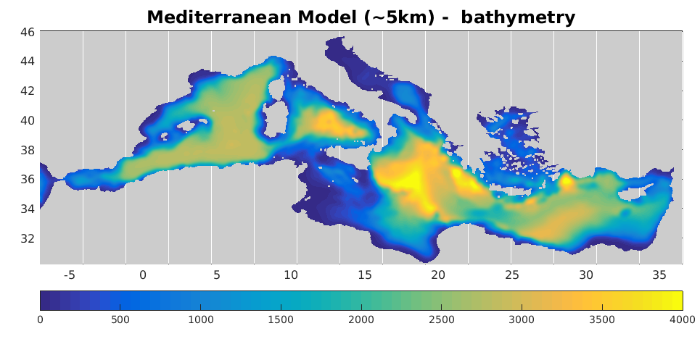
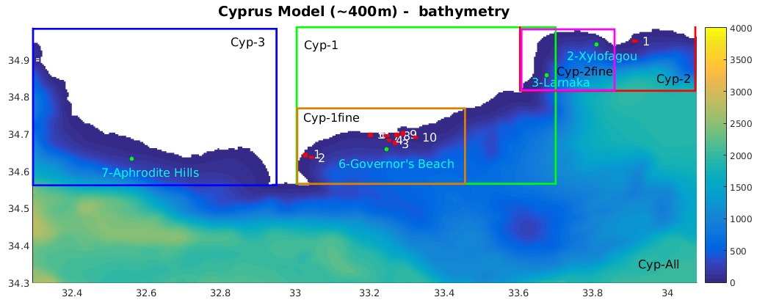
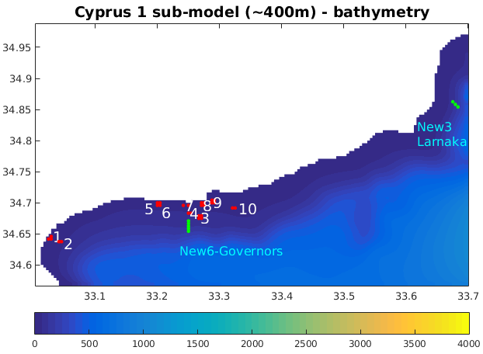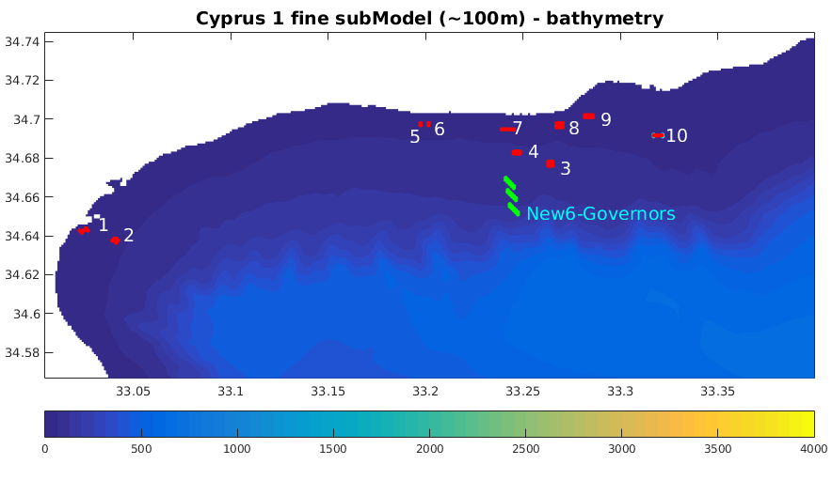

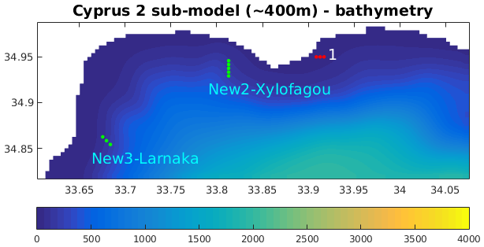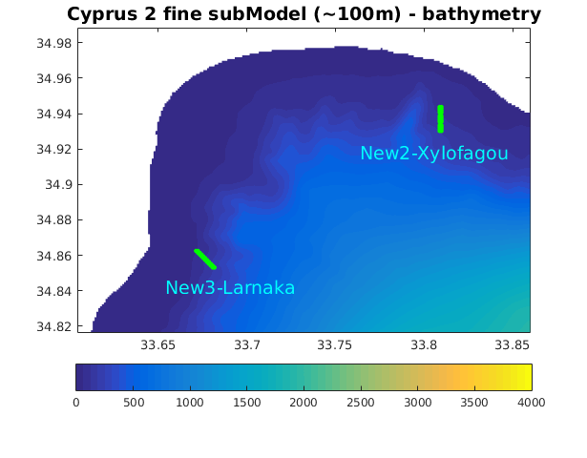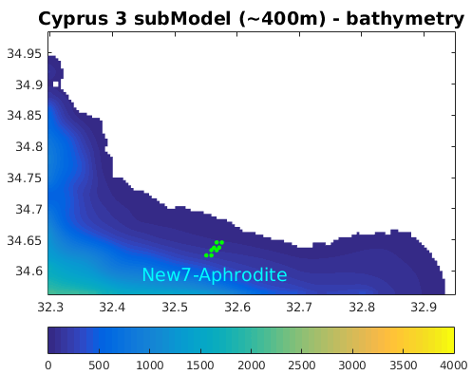
Figure 1: Domain and bathymetry of the nested models: Mediterranean Sea (~5Km horizontal resolution, top) and Cyprus Sea (~400m horizontal resolution, bottom). The three nested (~400m resolution, Sub-model 1,2, 3) and fine-resolution (~100m, Cyp-1fine and Cyp-2fine) sub-models in the Cyprus domain, existing (red dots) and open sea potential new (green dots) fish farms are also indicated. The red dots represent the existing licences (see Table 3 for existing site areas 1-11).
The impact of aquaculture wastes, in terms of good environmental status, is assessed using the model simulated outputs by means of Eutrophication Index (E.I., Primpas et al., 2010), an extensively used environmental indicator that is considered particularly suitable for coastal ecosystems (Pavlidou et al., 2015) :
E.I.=0.279*PO₄ + 0.261*NO₃+ 0.296*NO₂+ 0.275*NH₄+ 0.214*Chl-a
with PO₄, NO₃, NO₂, NH₄ in mmol/m³ and Chl-a in mg/m³) and the following environmental scaling:
<0.04 very good, 0.04 - 0.38 good, 0.38 - 0.85 moderate, 0.85 - 1.51 poor, > 1.51 bad.

    - Model simulations
A series of scenario simulations were performed with the intermediate (Cyp-1, Cyp-2, Cyp-3, see Table 2) and fine-resolution (Cyp-1fine, Cyp-2fine, see Table 3) sub-models, covering the selected areas (Xylofagou West, Larnaca, Governor’s Beach, Aphrodite Hills) for open sea aquaculture:

Table 2. Scenario simulations, performed with Cyp-1, Cyp-2, Cyp-3 sub-models (see Fig 1 for the sub-model areas).

Production (kt) | Cyp-1 | Cyp-2 | Cyp-3
Ref0  2016, 2017, 2018 | No fish farms | No fish farms | No fish farms
Sc2  2016, 2017, 2018 | Existing farms (8.5kt)  +  Governor (5kt)/ Larnaca (3kt) | Existing farms (0.5kt)  +  Xylofagou(5kt)/ Larnaca (3kt) | Aphrodite (5kt)

Table 3. Scenario simulations, performed with Cyp-1fine, Cyp-2fine sub-models (see Fig 1 for the sub-model areas).
Production (kt) | Cyp-1fine | Cyp-2fine
Ref0_fine-2016 | No fish farms | No fish farms
Ref_fine-2016 | Existing farms (8.5kt) | -
Sc1_fine-2016 | Existing farms (8.5kt)  +  Governor (2kt) | Xylofagou(2kt) / Larnaca (2kt)
Sc2_fine-2016 | Existing farms (8.5kt)  +  Governor (5kt) | Xylofagou(5kt) / Larnaca (3kt)

With the intermediate resolution sub-models (Cyp-1, Cyp-2, Cyp-3), reference simulations (Ref0) with no fish farms and high impact scenario simulations (Sc2), adopting the higher (5kt) production of the Open Sea aquaculture farms (along with existing farms) were performed for years 2016-2018. These simulations were performed to quantify the uncertainty in the simulated environmental impact, which is strongly related to inter-annual variability in ocean circulation. In the case of Larnaca selected area, a relatively lower production (3,000 tonnes) was adopted for the high-impact scenario, as in this area, there are geographical limitations and conflicts for deploying a higher production (see D11). Existing fish farms were included in Cyp-1 and Cyp-2 sub-models, as there no fish farms in the Cyp-3 sub-model area in Western Cyprus. In Aphrodite’s hills area, the layout of Badinotti’s submerged cages was adopted, as this area is more exposed and submerged technology is probably better suited to address adverse weather conditions prevailing in this area (see D11). In all other cases, the Open Sea aquaculture layout was based on the Cypriot design, as this requires less space compared to all the other technologies and, therefore, can be used to test the limits of the ecosystems and identify the carrying capacity in each selected area (see D11).

Uncertainty / Inter-annual variability
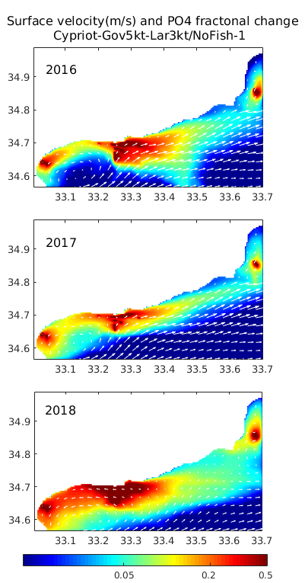
Figure 2: Simulated mean spring near surface current velocity and phosphates (PO4) fractional change (Sc2/Ref0-1) during 2016, 2017 and 2018. The scenario simulation (Sc2) includes the impact from existing coastal fish farms (see Fig.1) and also Governor’s beach (5kt) open sea aquaculture. The reference (Ref0) simulation has no fish farms. A fractional change=0.5 indicates an increase of +50%.
In Figure 2, the mean relative increase of phosphates, resulting from both existing and new open sea fish farms (Governor’s beach and Larnaca) in Cyp-1 area is shown over different years (2016-2018) for spring period, when the effect from fish farms is relatively stronger due to higher aquaculture effluents (see D11). The prevailing circulation during this period is characterized by a north-eastern current, as part of the dominant large-scale anti-cyclonic circulation in the southeast Cyprus open sea area and a smaller cyclonic eddy in Akrotiri Bay. A similar pattern may be seen in all three years, with the westward cyclonic coastal circulation being slightly intensified during 2018. Thus, effluents from existing farms and the open sea farm at Governor’s Beach area mainly follow a north-eastward pathway, partly directed to the west in Akrotiri Bay, particularly during 2018. The relatively stronger effect of fish farms during 2018, indicated by the higher fractional change of phosphates, may be attributed to the overall weaker currents (see Fig.2) and the relatively higher stratification/temperature (see Fig.3). However, this does not necessarily result in worse environmental conditions. The increased stratification results in an overall decrease in plankton productivity and dissolved inorganic nutrients concentrations in the area (also noticed in the simulation with no fish farms, not shown), as these are strongly related to vertical mixing processes and advection from offshore areas. Thus, as shown in Figure 4, the eutrophication index significantly decreased in spring 2018. The eutrophication index is slightly higher in 2017 overall, compared to 2016 (see also Fig.5), due to relatively stronger late winter vertical mixing (not shown).
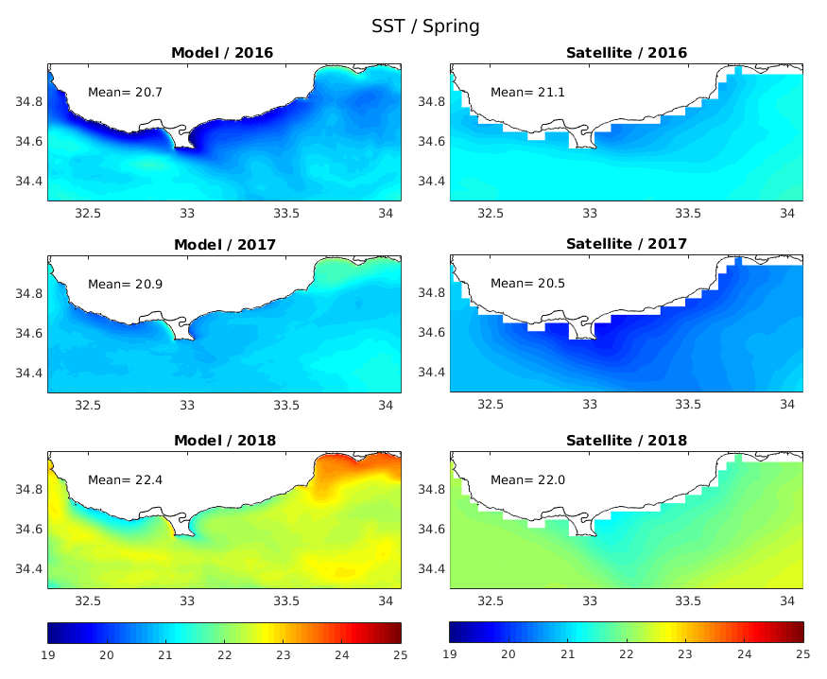
Figure 3: Simulated (left) and satellite (right) mean spring sea surface temperature (SST) over 2016 (top), 2017 (middle) and 2018 (bottom) period.

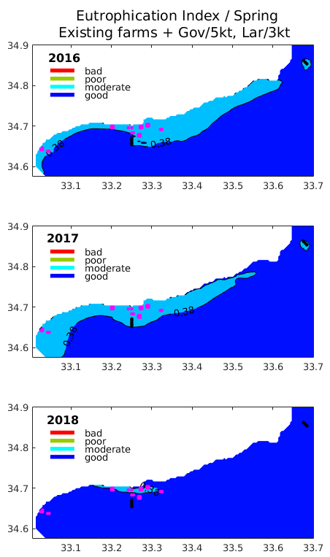
Figure 4: Simulated Eutrophication Index (E.I) with Cyp-1 sub-model, during spring 2016 (top), 2017 (middle) and 2018 (bottom), indicating environmental status (<0.04 very good, 0.04 - 0.38 good, 0.38 - 0.85 moderate, 0.85 - 1.51 poor, > 1.51 bad) in high impact scenario simulation (Sc2, see Table 1) with existing fish farms, Governor’s beach (5kt) and Larnaca (3kt) open sea farms. Existing (magenta dots) and new (black dots) OS farms locations are indicated.

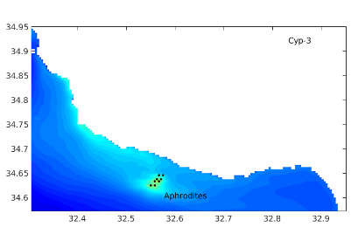 | 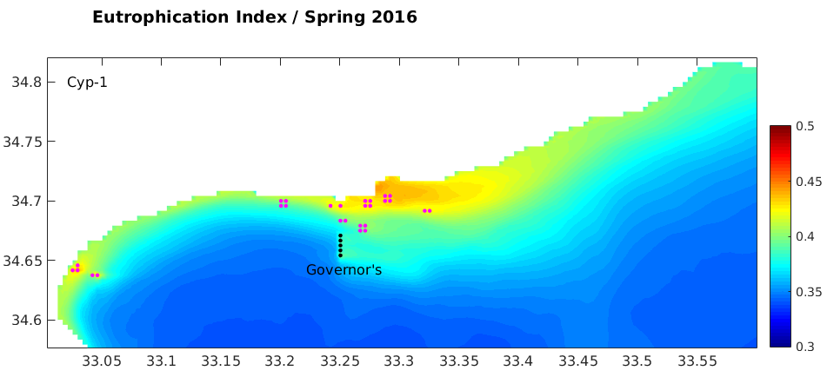 | 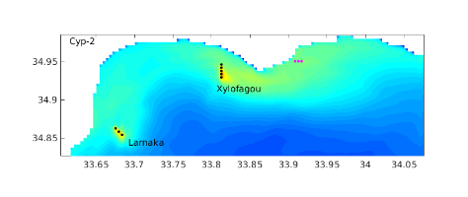
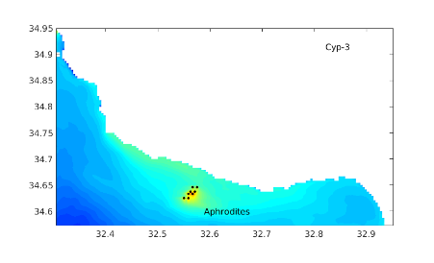 | 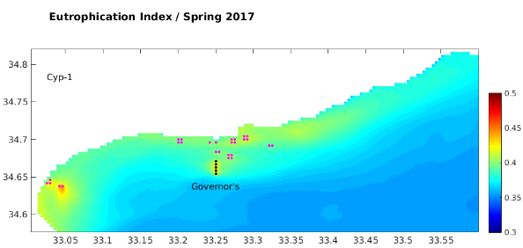 | 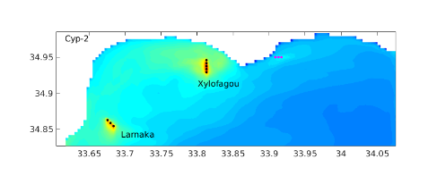
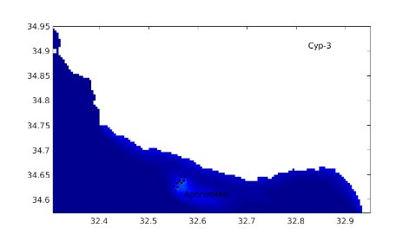 | 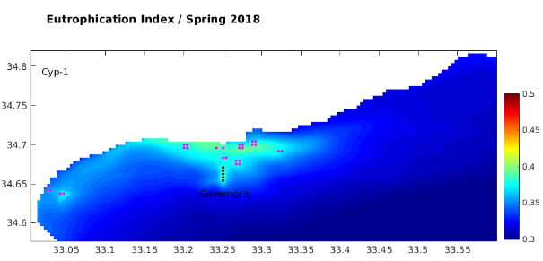 | 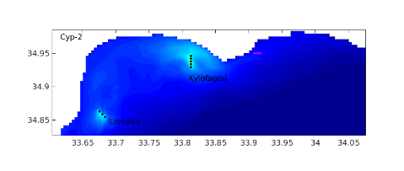
Figure 5: Simulated Eutrophication Index (E.I) with Cyp-1, Cyp-2 and Cyp-3 sub-models, during spring 2016 (top), 2017 (middle) and 2018 (bottom), with the high impact scenario simulation (Sc2, see Table 1) with existing fish farms, Governor’s beach (5kt) and Larnaca (3kt) open sea farms. Existing (magenta dots) and new (black dots) OS farms locations are indicated.

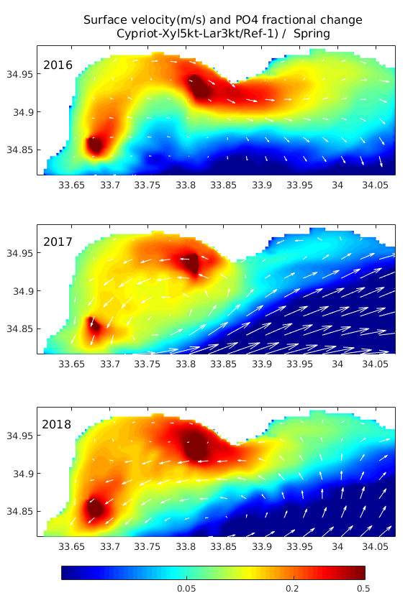
Figure 6: Simulated mean spring near surface current velocity and phosphates (PO4) fractional change (Sc2/Ref0-1) during 2016, 2017 and 2018. The scenario simulation (Sc2) includes the impact of existing coastal fish farms (see Fig.1) and also Xylofagou-West (5kt) and Larnaca (3kt) open sea aquaculture. The reference (Ref0) simulation has no fish farms. A fractional change=0.5 indicates an increase of +50%.

In Figure 6, the mean relative increase of phosphates, resulting from both existing and new open sea fish farms (Xylofagou and Larnaca) in Cyp-2 area is shown over different years (2016-2018) for the spring period, when the effect from fish farms is relatively stronger due to higher aquaculture effluents (see D11). As compared to Cyp-1 area, near-surface circulation presents a stronger inter-annual variability. Again, the prevailing offshore circulation is affected by the large-scale anti-cyclonic circulation, with a dominant north-eastern component. The circulation in Larnaca Bay is anti-cyclonic during 2016 and cyclonic during 2017 and 2018. Thus, the effluents from the open sea farm at Xylofagou area follow an offshore eastward pathway during 2016 and a westward pathway during 2017-2018, while the circulation at Larnaca open sea farm is south-westward during 2017-2018 and north-eastward during 2016. As in Cyp-1 area (Goverrnor’s beach, Fig. 4-5), the eutrophication index (E.I.) is significantly decreased during 2018 due to the increased stratification (Fig. 7, see also Fig.3 and Fig.5). The Eutrophication Index in the eastern coastal area (Ayia Napa) appears relatively higher during 2016, due to the eastward prevailing circulation, but, overall, in open sea areas and in the vicinity of OS aqua farms is slightly higher during 2017 (Fig.5), which is characterized by relatively stronger late winter vertical mixing.
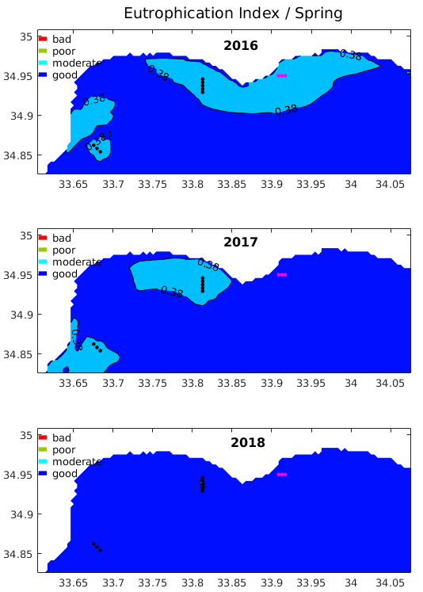
Figure 7: Simulated Eutrophication Index (E.I) with Cyp-2 sub-model, during spring 2016 (top), 2017 (middle) and 2018 (bottom), indicating environmental status (<0.04 very good, 0.04 - 0.38 good, 0.38 - 0.85 moderate, 0.85 - 1.51 poor, > 1.51 bad) in high impact scenario simulation (Sc2, see Table 2) with existing fish farms, Xylofagou (5kt) and Larnaca (3kt) open sea farms. Existing (magenta dots) and new (black dots) OS farms locations are indicated.

In Figure 8, the mean relative increase of phosphates, resulting from the new open sea fish farm at Aphrodite’s hills area in Cyp-3 area is shown over different years (2016-2018) for spring period, when the effect from fish farms is relatively stronger due to higher aquaculture effluents (see D11). The effluents from the open sea farm follow a north-westward pathway based on the large-scale cyclonic circulation in the area. As in Cyp-1/Cyp-2 areas, the Eutrophication Index is relatively lower during spring 2018 and relatively higher during 2017 (Fig.9).

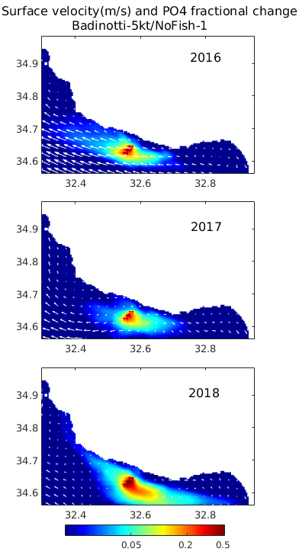
Figure 8: Simulated seasonal mean near surface current velocity and phosphates (PO4) fractional change (Sc2/Ref-1) during 2016. The scenario simulation (Sc2) includes the impact from new open sea aquaculture (5kt) at Aphrodite’s hills site. In the reference (Ref) simulation there are no fish farms. A fractional change=0.5 indicates an increase of +50%.

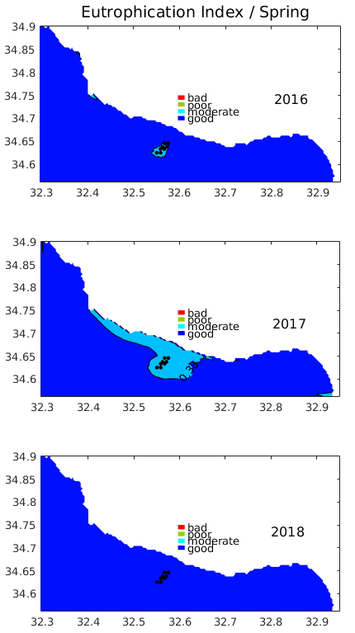
Figure 9: Simulated Eutrophication Index (E.I) with Cyp-3 sub-model, during spring 2016 (top), 2017 (middle) and 2018 (bottom), indicating environmental status (<0.04 very good, 0.04 - 0.38 good, 0.38 - 0.85 moderate, 0.85 - 1.51 poor, > 1.51 bad) in high impact scenario simulation (Sc2, see Table 2) with Aphrodites (5kt) open sea farms. OS farms (black dots) locations are indicated.

In all areas, the eutrophication index (E.I.) during spring period, when the stronger environmental impact is simulated due to higher aquaculture effluents, indicates good to moderate environmental conditions even in the vicinity of the fish farms, suggesting that aquaculture wastes are effectively dispersed by ocean currents (Fig.4, 7, 9). During summer, the E.I. indicates “good” conditions in the entire area (not shown), as the increased stratification results in decreased dissolved inorganic nutrients and plankton productivity.
In Figures 10-11, the mean current speed/direction, SST, Chl-a and E.I. value in the vicinity of different aquaculture areas is shown for different scenarios during spring and summer, respectively, for years 2016-2018. The E.I. value at Xylofagou and Larnaca sites appears slightly higher, on average, as compared to both Aphrodite’s Hills and Governor’s Beach areas, which may be probably attributed to the circulation patterns in the more enclosed Larnaca Bay. In almost all areas, E.I. appears to be relatively lower during 2018 and slightly higher during 2017, with 2016 found in between (Fig.10-11, see also Fig.5). This may be attributed to the inter-annual variability of the open sea plankton productivity, controlled by vertical mixing, as 2018 is characterized by stronger stratification (Fig.3), while late winter increased mixing during spring 2017 results in slightly higher phytoplankton (not shown). The only exception from the above E.I. inter-annual variability (min in 2018, max in 2017) may be seen in Governor’s beach area (Fig.5 and Fig.10), where the E.I. during 2018 is slightly higher as compared to 2016, which is due to the relatively weaker currents during 2018 and their westward direction (Fig.2 and Fig.10). But generally, the variability of the eutrophication index in different sites does not appear to be strongly related with the current speed/direction. During summer, the eutrophication index is decreased in all areas, following the decrease of phytoplankton due to nutrient depletion (Fig.11), also showing a weaker variability among different years.
The inter-annual variability of the eutrophication index, which may be used to quantify the uncertainty related to the ocean circulation variability may be seen in Figure 12. As mentioned above, relatively weaker variability may be seen for summer, while the variability during spring varies between ~9% in the coastal existing farms (Akrotiri bay) to ~28% in Aphrodite’s hills area, which is more exposed to open sea ocean conditions variability. Overall, we may see that all areas are significantly affected by open sea conditions, which are largely controlled by vertical mixing and larger-scale circulation variability. The E.I. mean (2016-2018) value in the vicinity of open sea farms appears slightly higher in Xylofagou, followed by Larnaka, Governor’s Beach and Aphrodites Hills sites.

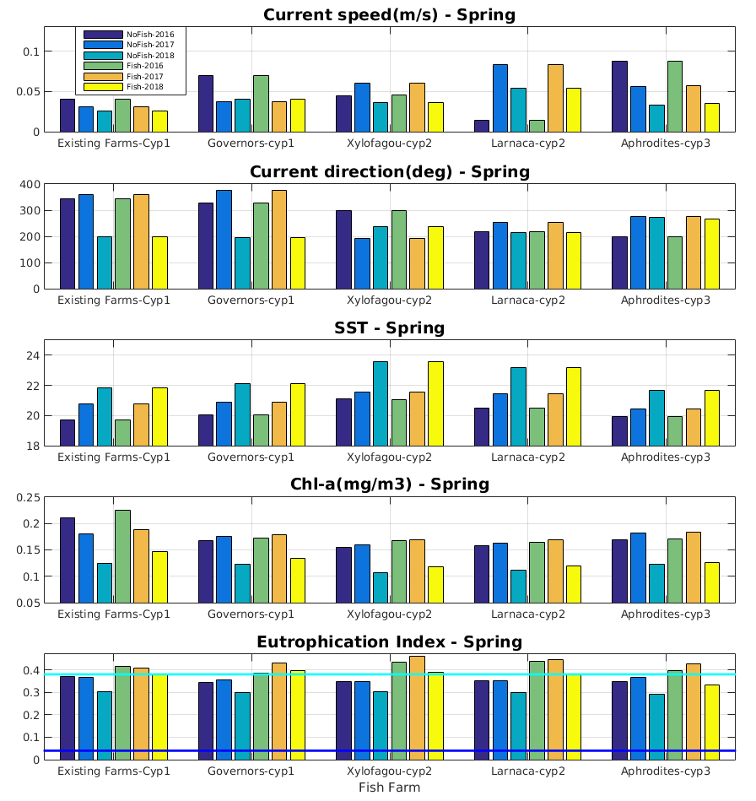
Figure 10: Simulated current speed (m/s) and direction (degrees), SST (ºC), Chl-a (mg/m³) and Eutrophication Index (E.I), indicating environmental status (<0.04 very good, 0.04 - 0.38 good, 0.38 - 0.85 moderate, 0.85 - 1.51 poor, > 1.51 bad) in the vicinity of fish farms during spring for different scenario simulations: (Ref0: No fish farms and Sc2: high impact scenario, see Table 2), over 2016, 2017 and 2018 period.

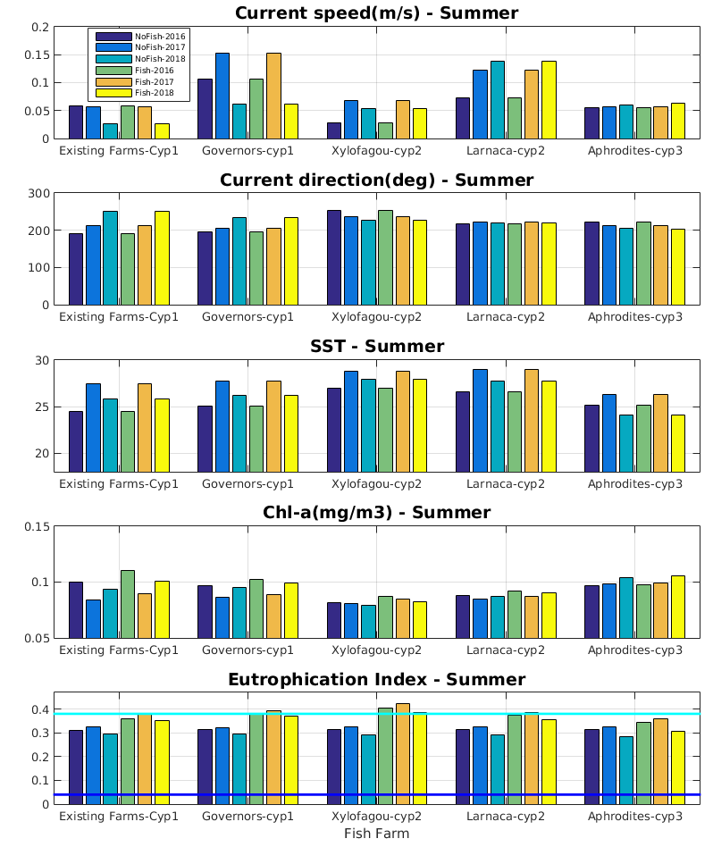
Figure 11: Simulated current speed (m/s) and direction (degrees), SST (ºC), Chl-a (mg/m³) and Eutrophication Index (E.I), indicating environmental status (<0.04 very good, 0.04 - 0.38 good, 0.38 - 0.85 moderate, 0.85 - 1.51 poor, > 1.51 bad) in the vicinity of fish farms during summer for different scenario simulations: (Ref0: No fish farms and Sc2: high impact scenario, see Table 2), over 2016, 2017 and 2018 period.

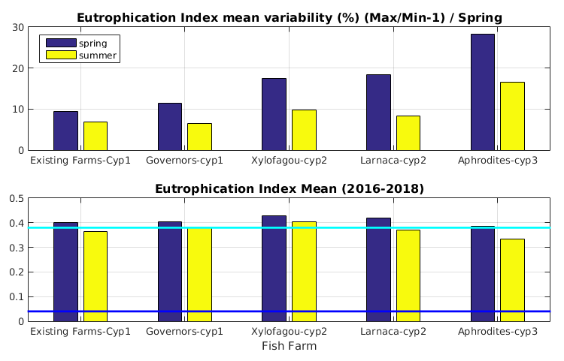
Figure 12: Percentage variability (max/min⁻¹ x 100, top) and mean (2016-2018) value of the eutrophication index, simulated over 2016-2018 in different areas for spring and summer period.

Fine-model scenario simulations
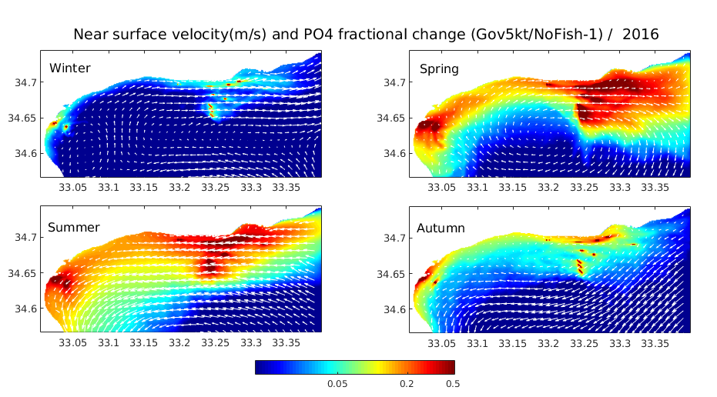
Figure 13: Simulated seasonal mean near surface current velocity and phosphates (PO₄) fractional change (Sc2_fine/Ref0_fine⁻¹) during 2016. The high impact scenario simulation (Sc2_fine) includes the impact from existing coastal fish farms (see Fig.1) and also Governor’s beach (5kt) and Larnaca (3kt) open sea aquaculture. The reference (Ref0_fine) simulation is without any fish farms. A fractional change=0.5 indicates an increase of +50%.

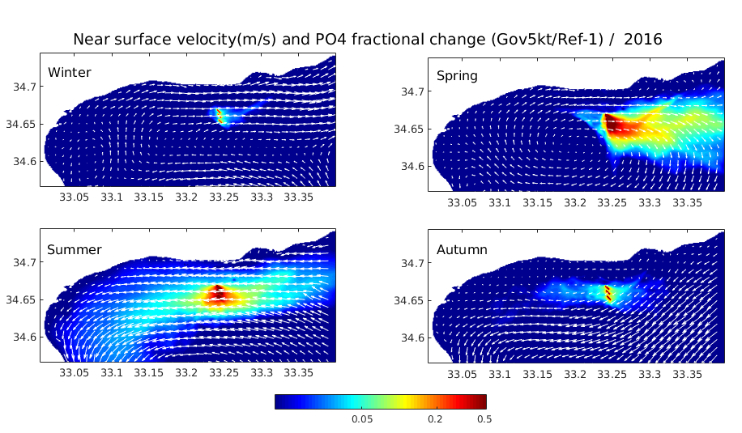
Figure 14: Simulated seasonal mean near-surface current velocity and phosphates (PO₄) fractional change (Sc2_fine/Ref_fine⁻¹) during 2016. The high-impact scenario simulation (Sc2_fine) includes the impact from existing coastal fish farms (see Fig.1) and also Governor’s Beach (5kt) and Larnaca (3kt) open sea aquaculture. The reference (Ref_fine) simulation includes only existing fish farms. A fractional change=0.5 indicates an increase of +50%.

The simulated with the fine model (resolution ~100m) in Cyp-1 area seasonal mean relative increase of phosphates, resulting from both existing and new open sea fish farm at Governor’s Beach, is shown in Figure 13. This relative increase is significantly reduced (Figure 14), considering the impact of only new open-sea farms. Results with the fine model appear quite similar to those simulated with the intermediate (~400m resolution) model (see D11). Apart from very fine details related to the better resolution of fish farms in the finer model grid, the only noticeable difference is a slight increase of phosphates in Akrotiri bay northern coastal area during spring. This similarity is probably expected, as this is an exposed area, significantly affected by open sea circulation. Fine model results are largely controlled by open boundary conditions obtained from the intermediate model simulation. As already discussed in D11, the effect from fish farms appears relatively stronger during the spring-summer period, which is related to the increase of stratification and the increase of fish feed and aquaculture effluents that peak during spring. The effluents from existing farms in Akrotiri Bay and the open sea farm at Governor’s Beach follow a north-eastward pathway during winter-spring, which reverses to south-west during summer-autumn (see also D11). In Figure 15, the simulated eutrophication index (E.I.) is shown for different scenario simulations (see Table 3) during spring and summer 2016. During spring, the E.I. indicates good to moderate environmental conditions even in the vicinity of the fish farms, suggesting that aquaculture wastes are effectively dispersed by ocean currents. The effect from open sea aquaculture at Governor’s beach appears relatively smaller, as compared to existing farms, particularly for the low-production scenario (2kt). During summer, the E.I. indicates “good” conditions in the entire area, as the increased stratification results in an overall decrease in dissolved inorganic nutrients and plankton productivity.
Figure 15: Simulated Eutrophication Index (E.I) with Cyp-1fine sub-model, during spring (left) and summer (right) 2016, indicating environmental status (<0.04 very good, 0.04 - 0.38 good, 0.38 - 0.85 moderate, 0.85 - 1.51 poor, > 1.51 bad) in different scenario simulations: no fish farms (top row), existing fish farms (second row), existing fish farms+Governor’s Beach (5kt) and Larnaca (3kt) open sea farms (third row), existing fish farms+Governor’s Beach (2kt) and Larnaca (2kt) open sea farms (bottom raw) (see Table 3). Existing (red dots) and new (black dots) OS farms are indicated.

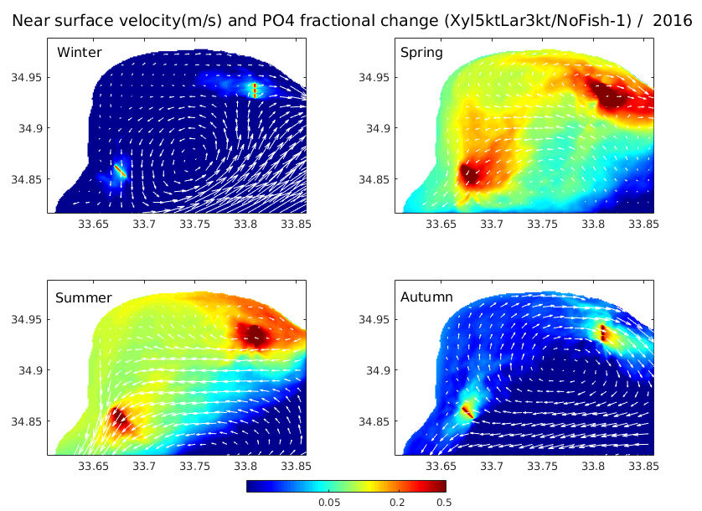
Figure 16: Simulated seasonal mean near surface current velocity and phosphates (PO₄) fractional change (Sc2_fine/Ref0_fine-1) during 2016. The high impact scenario simulation (Sc2_fine) includes the impact from Xylofagou (5kt) and Larnaca (3kt) open sea aquaculture. The reference (Ref0_fine) simulation is without any fish farms. A fractional change=0.5 indicates an increase of +50%.

The simulated with the fine model (resolution ~100m) in Cyp-2 area seasonal mean relative increase of phosphates, resulting from new open sea fish farm at Xylofagou and Larnaka areas, is shown in Figure 16. As in Cyp-1 area, the effect from fish farms is relatively stronger during spring-summer period. Results with the fine model appear quite similar to those simulated with the intermediate (~400m resolution) model (see D11), with the main noticeable difference being a slight decrease of phosphates fractional change in Larnaka bay during spring-summer period. The circulation in Larnaca bay is mostly anti-cyclonic, particularly in Xylofagou area, except during winter period, when a cyclonic eddy is formed under the influence of the offshore north-eastern current that is part the dominant large-scale anti-cyclonic circulation. Thus, effluents from Xylofagou open sea farm usually follow an eastward pathway, being occasionally redirected to the west inside Larnaka bay (e.g. during summer) by the anti-cyclonic circulation pattern (Figure 16). Effluents from Larnaka open sea farm generally follow a south-westward pathway, but may be partly also directed to the north-east towards Larnaka Bay following the anti-cyclonic circulation (e.g. spring).

Figure 17: Simulated Eutrophication Index (E.I) with Cyp-2fine sub-model, during spring (left) and summer (right) 2016, indicating environmental status (<0.04 very good, 0.04 - 0.38 good, 0.38 - 0.85 moderate, 0.85 - 1.51 poor, > 1.51 bad) in different scenario simulations: no fish farms (top row), Xylofagou (2kt) and Larnaca (2kt) open sea farms (middle row), Xylofagou (5kt) and Larnaca (3kt) open sea farms (bottom row) (see Table 3). New (black dots) OS farms are indicated.

In Figure 17, the eutrophication index (E.I.), simulated with the fine model in Cyp-2 area is shown for different scenario simulations (see Table 3) during spring and summer 2016, the periods with relatively stronger impact from aquaculture. During spring, the E.I. indicates good to moderate environmental conditions even in the vicinity of the fish farms, suggesting that aquaculture wastes are effectively dispersed by ocean currents. The E.I. near Larnaca open aquaculture area appears slightly higher, as compared to Xylofagou area and also as compared with the intermediate model resolution simulation (see Figure 7). This might be related to the relatively shallower depth in the southwestern coastal area, being better resolved with the fine model and thus resulting in slightly higher plankton productivity. One may notice the relatively higher E.I. in this area also in the simulation without any fish farms (Figure 17, NoFish). During summer, the E.I. indicates “good” conditions in the entire area, as the increased stratification results in an overall decrease of dissolved inorganic nutrients and plankton productivity.
In Figure 18, the E.I. value in the vicinity of different aquaculture areas is shown for different scenarios, along with the mean current speed, SST and Chl-a. During spring, Xylofagou and Larnaca sites present relatively weaker currents, which may explain the slightly higher E.I. values, as compared to Governor’s Beach. The E.I. is slightly higher in Larnaca site, which may be due to the shallower depth in nearby coastal areas, resulting in relatively higher Chl-a, as mentioned above. One may also notice the relatively lower E.I. values in both Xylofagou and Governor’s Beach open sea farms, as compared to the existing coastal fish farms in Cyp-1. During summer, a decreased E.I. is found in all fish farm areas, as the increased stratification results in the decrease of plankton productivity, indicated by the significant decrease of Chl-a.

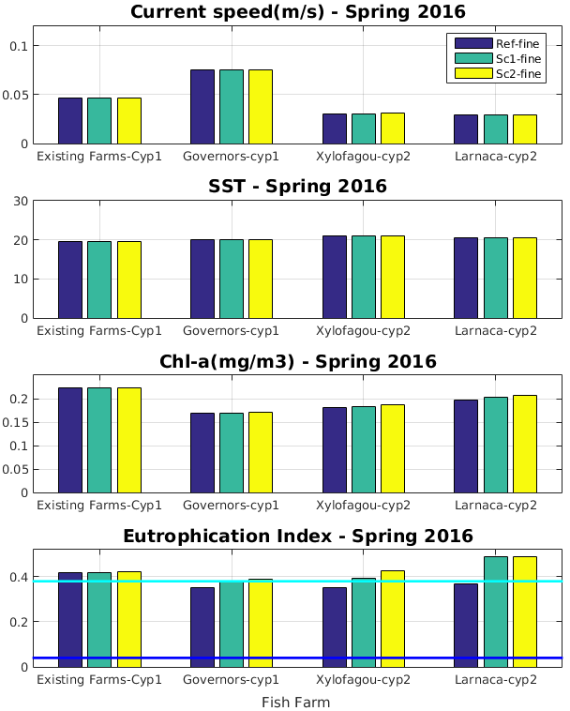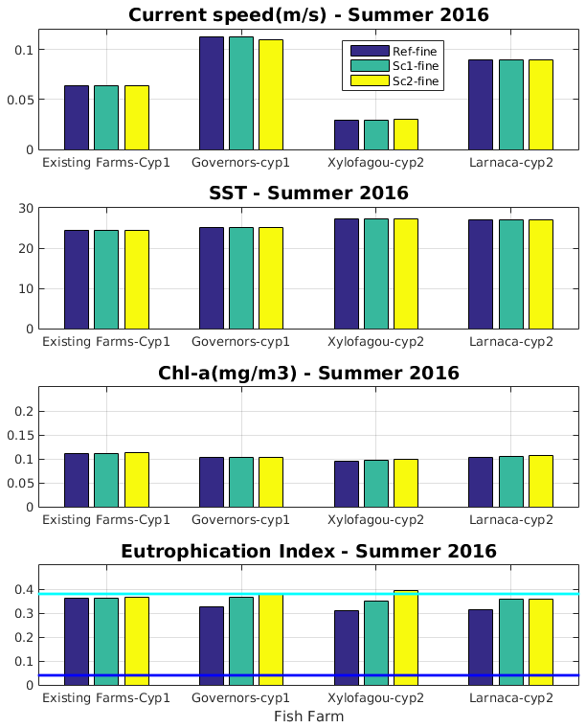
Figure 18: Simulated current speed (m/s, first row), SST (oC, second row), Chl-a (mg/m³, third row) and Eutrophication Index (E.I. forth row), indicating environmental status (<0.04 very good, 0.04 - 0.38 good, 0.38 - 0.85 moderate, 0.85 - 1.51 poor, > 1.51 bad) in the vicinity of fish farms for different scenario simulations: (Ref_fine, Sc1_fine, Sc2_fine, see Table 3), during spring (left) and summer (right) 2016.

Conclusions
Fine model scenario simulations indicate that the environmental impact of open sea aquaculture at Governor’s Beach area appears slightly weaker, as compared to Xylofagou and particularly Larnaca sites that show a moderate impact during spring period (not during the summer). This may be attributed to the relatively weaker currents and the anti-cyclonic pattern in the more enclosed Larnaca Bay. Intermediate resolution model simulations over 2016-2018 period indicated an important inter-annual variability of the eutrophication index, being higher in the more exposed to open sea ocean conditions Aphrodite’s Hills area. The E.I. mean (2016-2018) value in the vicinity of open sea farms appears slightly higher in Xylofagou, followed by Larnaka, Governor’s Beach and Aphrodites Hills open sea aquaculture sites.

References
Baretta, J.W., Ebenhöh, W., Ruardij, P., 1995. The European Regional Seas Ecosystem Model, A Complex Marine Ecosystem Model. Netherlands Journal of Sea Research, 33(3/4): 233-246.
Blumberg, A.F., Mellor, G.L., 1983. Diagnostic and prognostic numerical circulation studies of the South Atlantic Bight. Journal of Geophysical Research, 88(C8), 4579-4592.
Kalaroni, S., Tsiaras, K., Petihakis, Economou-Amilli, A., Triantafyllou, G., 2020a. Modelling the Mediterranean Pelagic Ecosystem using the POSEIDON ecological model. Part Ι: Nutrients and Chlorophyll-a dynamics. Deep-Sea Research Part II, doi:10.1016/j.dsr2.2019.104647.
Kalaroni S., Tsiaras K., Petihakis G., Economou-Amilli A., Triantafyllou G., 2020b. Modelling the Mediterranean Pelagic Ecosystem using the POSEIDON ecological model. Part II: Biological dynamics, Deep Sea Research Part II, 171, 104711, https://doi.org/10.1016/j.dsr2.2019.104711.
Pavlidou, A., Simboura, N., Rousselaki, E., Tsapakis, M., Pagou, K., Drakopoulou, P., Assimakopoulou, G., Kontoyiannis, H., Panayotidis, P., 2015. Methods of eutrophication assessment in the context of the water framework directive: Examples from the Eastern Mediterranean coastal areas. Cont. Shelf Res. 108, 156–168. https://doi.org/10.1016/j.csr.2015.05.013.
Primpas, I., Tsirtsis, G., Karydis, M., & Kokkoris, G. D., 2010. Principal component analysis: Development of a multivariate index for assessing eutrophication according to the European water framework directive. Ecological Indicators, 10, 178–183.
Tsagaraki, T.M., Petihakis, G., Tsiaras, K., Triantafyllou, G., Tsapakis, M., Korres, G., Kakagiannis, G., Frangoulis, C. and Karakassis. 2011. Beyond the cage: ecosystem modelling for impact evaluation in aquaculture. Ecological Modelling, 222(14): 2512-2523.
Tsiaras, K., Tsapakis, M., Gkanassos, A., Kalantzi, I. Petihakis, G., Triantafyllou, G., 2022. Modelling the impact of finfish aquaculture waste on the environmental status in an Eastern Mediterranean Allocated Ζone for Aquaculture, Continental Shelf Research 234 (2022) 104647, doi.org/10.1016/j.csr.2022.104647.

