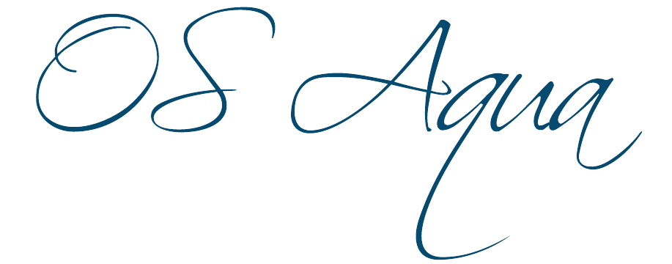
Open Sea Aquaculture
in the Eastern Mediterranean

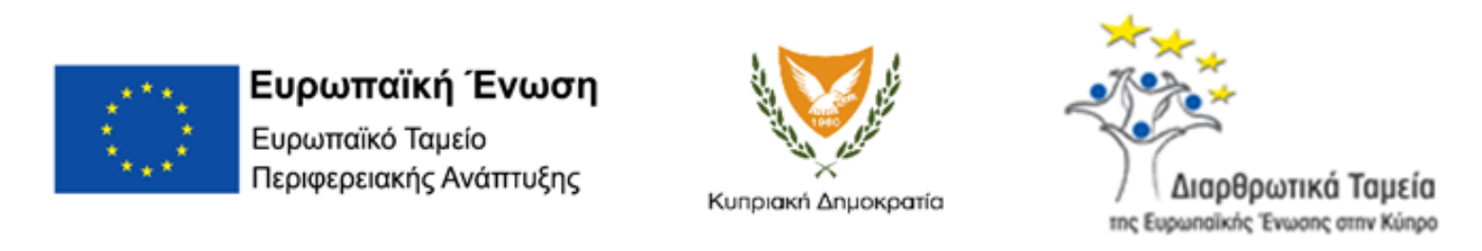
The Project is co-financed with 800 K Euro by the European Regional Development Fund and the Republic of Cyprus through the Research and Innovation Foundation with grant number INTEGRATED/0918/0046

Work Package ID: WP2

Work Package Title: Dissemination Activities

Deliverable ID: D4

Deliverable Title: Conference Presentations

Dissemination Level: Public
Partner Leader: OC - UCY
Disclaimer
Use of any knowledge, information or data contained in this document shall be at the user's sole risk. Neither the OS Aqua Consortium nor any of its members, their officers, employees or agents accept shall be liable or responsible, in negligence or otherwise, for any loss, damage or expense whatever sustained by any person as a result of the use, in any manner or form, of any knowledge, information or data contained in this document, or due to any inaccuracy, omission or error therein contained.
The OS Aqua project (INTEGRATED/0918/0046) has been partially funded under the RESTART 2016-2020 Programme, Integrated Projects Call, of the Cyprus Research and Innovation Foundation. This publication reflects the views only of the authors, and the Funding Agency cannot be held liable or responsible for any use which may be made of the information contained herein or of any consequences thereof.
Copyright notice
© Copyright 2020-2024, The OS Aqua Consortium
This document contains information that is protected by copyright. All Rights Reserved. No part of this work covered by copyright hereon may be reproduced or used in any form or by any means without the permission of the copyright holders.

Table of Contents

Summary 3
2nd International Scientific Conference on Design and Management of Port, Coastal and Offshore Works (DMPCO 2023) 4
Eastern Mediterranean Sea. 4th ICED 2023 International Conference 5
11th HELLENIC CONFERENCE OF ECOLOGY International Conference 6
AQUACULTURE EUROPE 2023 7

Summary

Overall, the consortium participated in 4 conferences with oral presentations. The presentation references are listed within this document. OS Aqua has participated in four conferences with presentations. The list of the participated conferences is shown below. A brief description of each conference follows. The individual presentations can be found in the following link https://drive.google.com/drive/folders/1-6s6huSdsHnDFL54ffLWbpcKRKg656By?usp=drive_link

- I. Kyriakides, F. Gavriel, P. Lemonaris, S. Charalambous, M. Menicou, M. Charalambides, R. Abu Alhaija, D. Hayes, O. Nisiforou, G. Nikolaidis, E. Hadjisolomou, G. Triantafyllou & G. Triantaphyllidis. Design of Coastal Aquaculture Structures and Allocated Zones for Aquaculture Development in Cyprus. (2nd International Conference, DESIGN AND MANAGEMENT OF PORT, COASTAL AND OFFSHORE WORKS, 24-27 MAY 2023)
- Hadjisolomou, E.; Antoniadis, K.; Rousou, M.; Vasiliades, L.; Abu-Alhaija, R.; Herodotou, H.; Michaelides, M.; Kyriakides, I. Predicting Coastal Dissolved Inorganic Nitrogen Levels by Applying Data-Driven Modelling: The Case Study of Cyprus (Eastern Mediterranean Sea. 4th ICED 2023 International Conference (20-22 October 2023, Athens Greece)
- Hadjisolomou, E.; Antoniadis, K.; Rousou, M.; Vasiliades, L.; Abu-Alhaija, R.; Kyriakides, I.; Herodotou, H.; Michaelides, M. Developing Artificial Neural Networks for seasonal modelling of Coastal Dissolved Oxygen in Cyprus. 11th HELECOS International Conference (4 -7 October 2023, Patras Greece)
- Marios Charalambides, Michalis Menikou, Ioannis Kyriakides, George Triantaphyllidis, Rana Abu Alhaija, Olia Nisiforou MARKET RESEARCH ANALYSIS FOR POSSIBLE EXPANSION OF CYPRUS AQUACULTURE(AQUACULTURE EUROPE 2023, September 18 - 21, 2023)

2nd International Scientific Conference on Design and Management of Port, Coastal and Offshore Works (DMPCO 2023)

The conference held in Thessaloniki, Greece at Aristotle University’s Research Dissemination Center (KEDEA) from 24 to 27 May 2023.

Conference Objective

The conference aims to present and stimulate comprehensive discussions on the contemporary and state-of-the-art scientific and technological advantages associated with the design, construction and management of harbor, coastal and offshore structures, emphasizing in supporting infrastructures for ships and floating structures of all kinds, the protection of coastal areas against erosion, the long lasting formation of coastal zone morphology, the protection of the environment and the assessment of the risks associated with the manmade harbor, coastal and offshore infrastructures, the wave propagation and the protection of the coastal zones against extreme environmental conditions, the climate change effects on harbor, coastal and offshore structures as well as on coastal areas and hydro-morphodynamic processes, the construction, installation and management of offshore structures (fixed and floating) for underwater mining and exploitation of hydrocarbons, their storage and transportation as well as to the high tech systems for sustainable energy conversion and exploitation (wind and wave).

Presentation Title

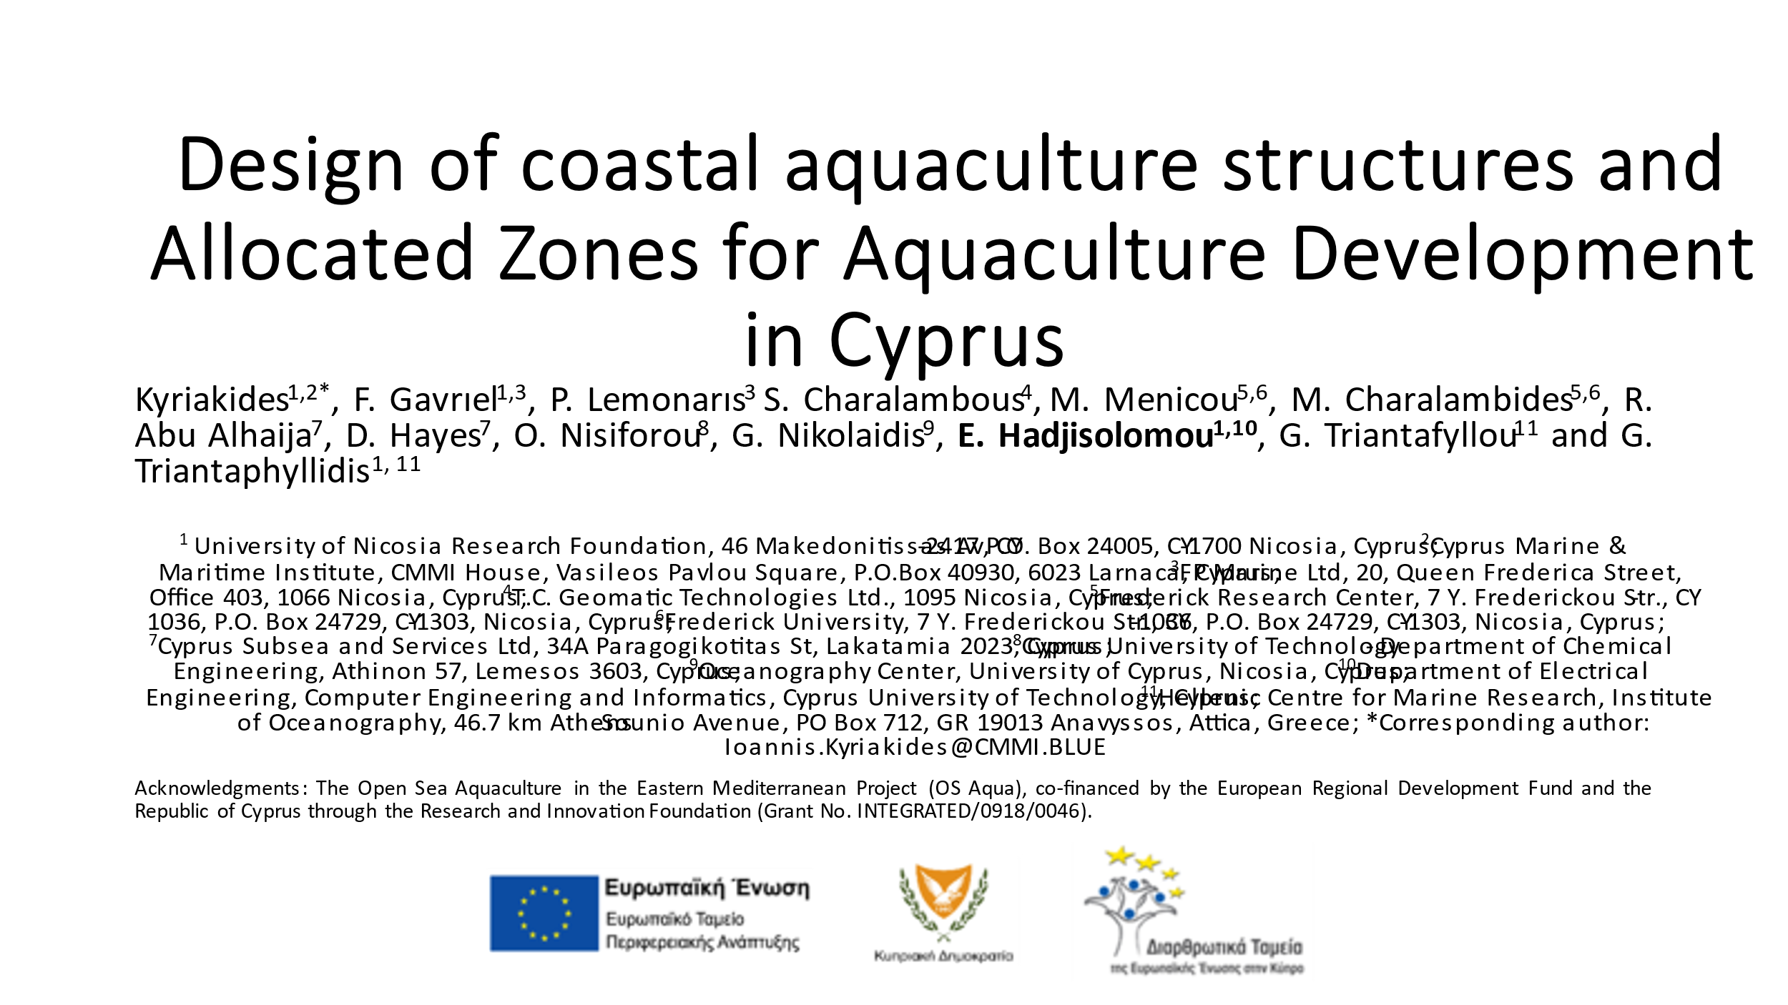
Design of Coastal Aquaculture Structures and Allocated Zones for Aquaculture Development in Cyprus
Figure SEQ Figure \* ARABIC 1: Screenshot from the first slide of the presenation presented at the conference

Eastern Mediterranean Sea. 4th ICED 2023 International Conference

The conference took place in Athens and virtual between 20 and 22 of October 2023

Conference objective

The conference combined the most recent scientific developments in Environmental Design (Sustainability / Pollution / Energy / Cities-Buildings / Transportation / Erosion / Climate Change / Policy / Social Acceptance / Health Impacts). It provided a unique opportunity for experts to interact and to apply their knowledge and latest research findings to the design and developments of environmental processes.

Presentation Title

Predicting Coastal Dissolved Inorganic Nitrogen Levels by Applying Data-Driven Modelling: The Case Study of Cyprus

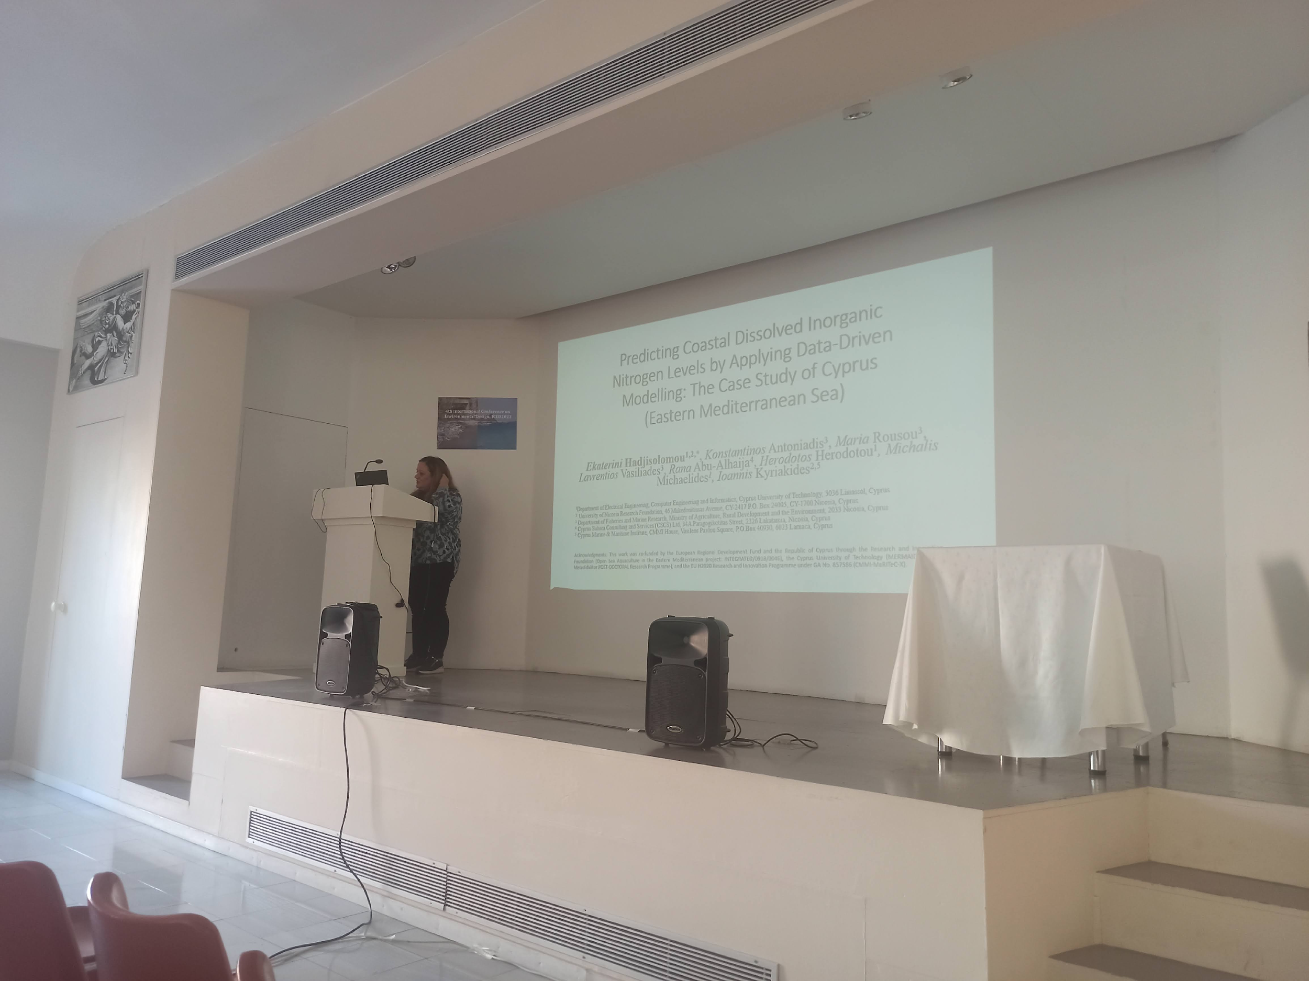
Figure 2: Photograph from the presenter at the conference

11th HELLENIC CONFERENCE OF ECOLOGY International Conference

The conference took place at the Conference and Cultural Center of the University of Patras, in Patras, from 4 to 7 October 2023.

Conference objective
The main objective of HELECOS is to gather scientists together and present new findings in the science of Ecology. Apart from Greek researchers, international researchers participate either as special guests or as members of Greek research teams. HELECOS conferences are open not only to Greek academic institutions but to all researchers who are actively working on ecological issues.
HELECOS, among others, aims to highlight the role of the science of Ecology in understanding and dealing with anthropogenic impacts on the environment, i.e. changes in the biophysical environment and ecosystems, biodiversity and natural resources caused directly or indirectly by the human.

Presentation tilte
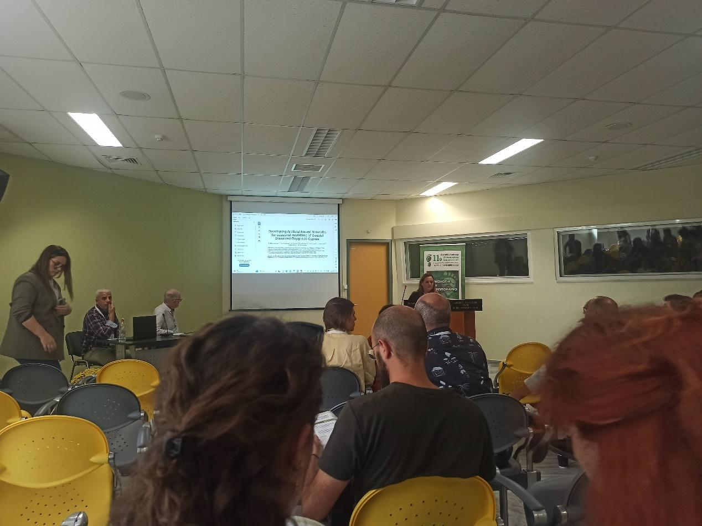
Developing Artificial Neural Networks for seasonal modelling of Coastal Dissolved Oxygen in Cyprus
Figure SEQ Figure \* ARABIC 3: Photograph from the presentation at the HELECOS-11 conference

AQUACULTURE EUROPE 2023

The conference took place in Vienna, Austria between 18th and 21st of September 2023
Conference aim
Aquaculture is the world’s most diverse farming practice in terms of number of species, farming methods, intensity level and environments used. Significant efforts have been made to promote species diversity since global aquaculture production is dominated by a few dozen species. The need for responsible use of resources, improved efficiency and increased resilience against future challenges such as diseases and climate change require further diversification in aquaculture beyond species level.

Presentation Title
MARKET RESEARCH ANALYSIS FOR POSSIBLE EXPANSION OF CYPRUS AQUACULTURE
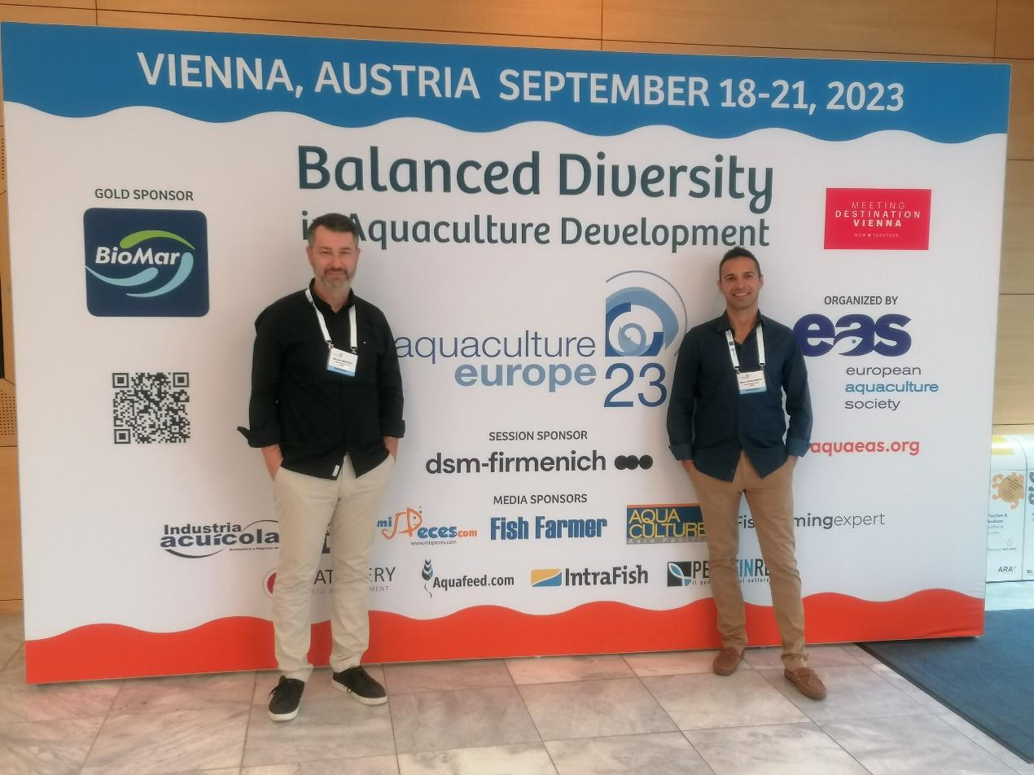
Figure SEQ Figure \* ARABIC 4: Image from the conference participation

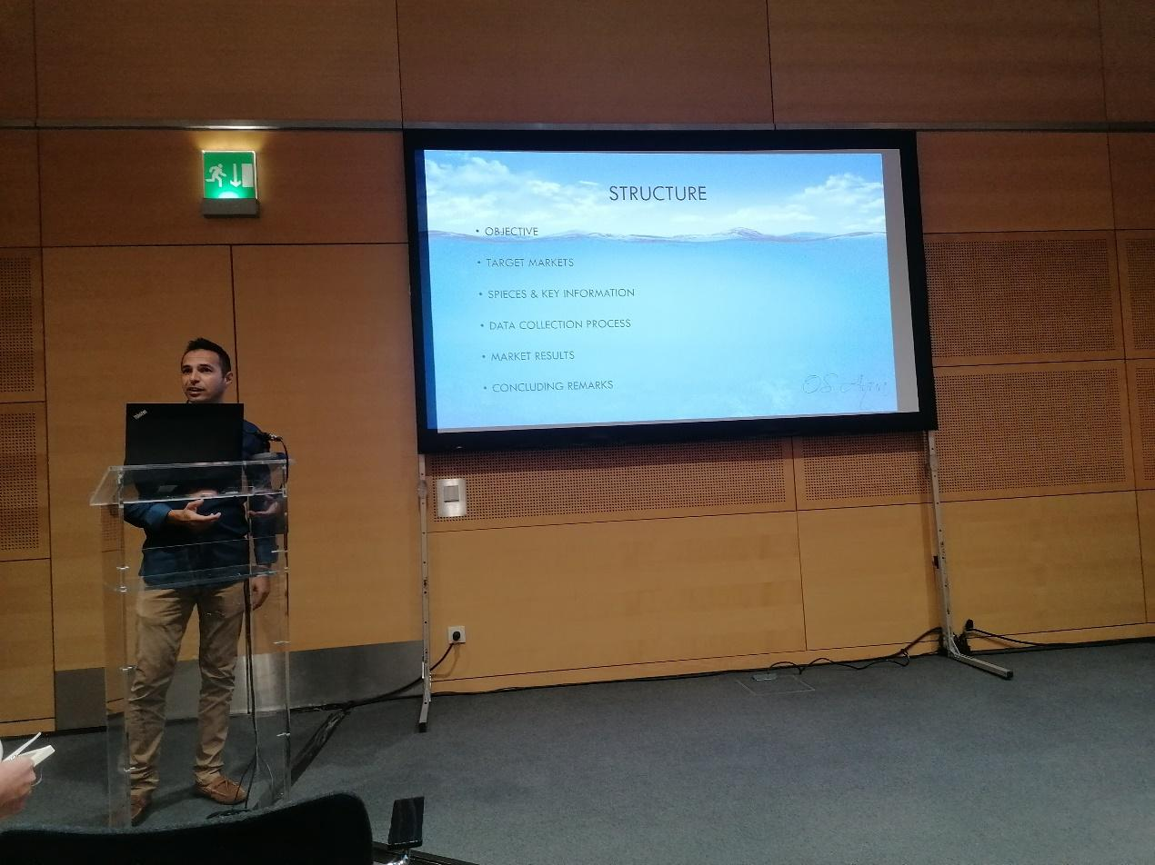
Figure SEQ Figure \* ARABIC 5: Photograph from the presenter during the oral presentation at the conference.

